POS Invoice Fill File: This file pulls information from the POS Invoice fill file.

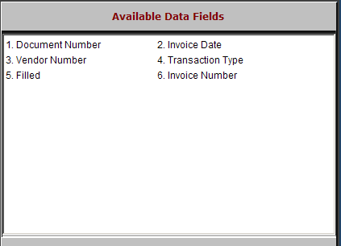

Document Number: This field holds the document number that was filled or not filled for the selected vendor(s).

Invoice Date: This field holds the invoice date for the invoice listed.

Vendor Number: This field shows the vendor number(s) referenced on the transaction.

Transaction Type: This field may show “P” for POS transactions.

Filled:
  - A “Y” in this field indicates that the invoice was filled from current stock.
  - An “N” in this field means that the invoice has one or more items on backorder and is not filled.

Invoice Number: This is the invoice number that was filled or not filled for the selected vendors.

