CRM Campaign: This file pulls information from the CRM Campaign file.

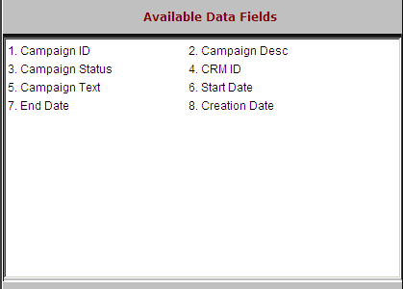

Campaign ID: This field holds the defined campaign ID.

Campaign Desc: This field holds any additional description of the campaign.

Campaign Status: This field holds the status of the campaign: open or closed.

CRM ID: This field identifies the person who created the campaign.

Campaign Text: This field is reserved for future use.

Start Date: This field holds the date the campaign starts.

End Date: This field holds the date the campaign ends.

Creation Date: This field holds the date the campaign was created.

