CRM Category: This file pulls information from the CRM Category file.

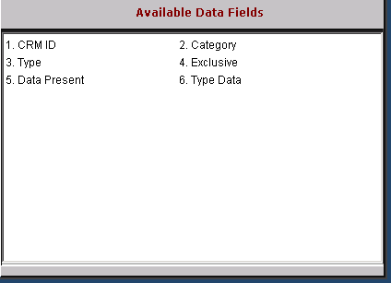

CRM ID: This field holds the CRM ID (customer number).

Category: This field holds the category name.

Type: This field identifies the type of category.

Exclusive: This field is reserved for future use.

Data Present: This field is reserved for future use.

Type Data: This field is reserved for future use.

