CRM Events: This file pulls information from the CRM Events file.

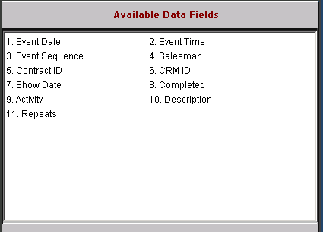

Event Date: This field holds the date of the event.

Event Time: This field holds the time of the event.

Event Sequence: This field is reserved for future use.

Salesman: This field holds the Salesman ID.

Contract ID: This field is reserved for future use.

CRM ID: This field holds the CRM ID (customer number or prospect ID).

Show Date: This field is reserved for future use.

Completed: This field identifies if the event is completed: Y/N.

Activity: This field holds a brief description of the event.

Description: This field holds a description of the event.

Repeats: This field is reserved for future use.

