CRM Contacts: This file pulls information from the CRM Contacts file.

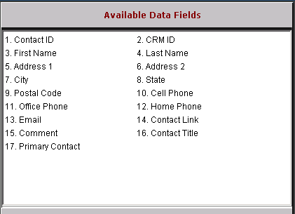

Contact ID: This field is reserved for future use.

CRM ID: This field holds the CRM ID (customer number or prospect ID).

First Name: This field holds the contact’s first name.

Last Name: This field holds the contact’s last name.

Address 1: This field holds the contact’s first address line.

Address 2: This field holds the contact’s second address line.

City: This field holds the contact’s city.

State: This field holds the contact’s state/province.

Postal Code: This field holds the contact’s zip code/postal code.

Cell Phone: This field holds the contact’s cell phone number.

Office Phone: This field holds the contact’s office phone number.

Home Phone: This field holds the contact’s home phone number.

Email: This field holds the contact’s email address.

Contract Link: This field is reserved for future use.

Comment: This field holds any additional contact comments.

Contact Title: This field holds the title of the contact.

Primary Contact: This field indicates if this is the primary contact: Y/N.

