CRM Customers: This file pulls information from the CRM Customers file.

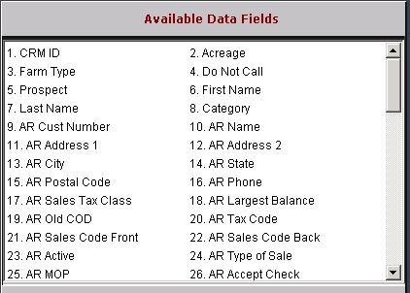

CRM ID: This field holds the CRM ID (customer number or prospect ID).

Acreage: This field shows information about the customer’s acreage.

Farm Type: This field shows information about the customer’s farm type.

Do Not Call: This field is reserved for future use.

Prospect: This field is reserved for future use.

First Name: This field holds the contact’s first name.

Last Name: This field holds the contact’s last name.

Category: This field shows information about the customer’s category.

AR Cust Number: This field holds the unique five-digit number for this customer.

AR Name: This field holds the customer name.

AR Address 1: This space holds the customer’s mailing address.

AR Address 2: This field provides an additional line for the customer’s address.

AR City: This field holds the city where the customer receives mail.

AR State: This holds the two-character abbreviation for the customer’s state or province.

AR Postal Code: The zip code field is nine positions and will accommodate both the expanded U.S. Zip Codes and Canadian Postal Codes.

AR Phone: This area holds the telephone number of the customer, including area code.

AR Sales Tax Class: This field may indicate if this is a California Ag customer.

If yes, the field will show “A.”

If no, the field will show a blank.

AR Largest Balance: This field holds the amount of the Largest Balance held by the customer.

AR Old COD: This field holds the customer COD information, which will be one of the following:
  - Y=Cash only
  - N=Not on COD
  - F=Farm Plan Customer
  - D=Discover Card
  - A=American Express
  - M=Mastercard
  - V=Visa
  - E=Case
  - P=Farm Plan Card–Purchase Plus
  - H=New Holland
  - G=AGCO Agricredit
  - Z=AGCO Agricard
  - O=Other point of sale form of payment
  - L=Polaris
  - K=Freedom Card
  - W=Warranty
  - I=Internal

AR Tax Code: This field shows the customer’s default tax code.

AR Sales Code Front: This field holds the default sales code used when the customer makes purchases at the parts counter. Sales codes provide the pointer to the general ledger account number to receive the dollars from the service sales transaction.

AR Sales Code Back: This field holds the default sales code used when the customer makes purchases in the Service Department (on a repair order). Sales codes provide the pointer to the general ledger account number to receive the dollars from the service sales transaction.

AR Active?: This field shows if the customer is active or inactive.

AR Type Of Sale: This field indicates if there are special circumstances that apply to this customer. It designates if this is:

A general customer number (C)

Internal Customer Number (I)

A Warranty customer number (W)

An “other” customer number (O)

A Cash Customer ($).

AR MOP: This field shows the preferred or typical method of payment for the customer.

AR Accept Check: This field is reserved for future use.

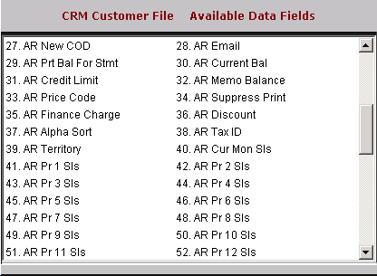

AR New COD Status: This field shows if the customer has A/R charging privileges.

AR E-Mail: This field provides space to enter the customer’s email address.

AR Print Bal for Stmt: The choice entered in this field determines the type of detail shown on the customer’s statement.

“Y” means the statement preference is balance forward.

“N” means the statement preference is open item.

AR Current Bal: This is a system-maintained field where the posted balance for this customer is displayed. It includes only transactions that have been posted from the Parts, Service Units, and Rental invoicing routines and payments on account from Cash Applications and GLED/ARDI.

AR Credit Limit: This field refers to the maximum amount of credit extended to this customer.

AR Memo Bal: This is a system-maintained field where the total balance for this customer is displayed. This balance consists of the posted balance (Current Bal) plus the unposted entries made through POS and SMS invoicing or Cash Applications

AR Price Code: This field holds the basis for pricing for the customer. It works with the Discount Rate field to determine the selling prices for pre-priced items in POS and SMS. The choices for this field are:
  - 1=Cost
  - 2=List
  - 3=Dealer Defined Pricing Level
  - 4=Dealer Defined Pricing Level
  - 5=Dealer Defined Pricing Level
  - 6=MSRP (Manufacturer’s Suggested)

AR Suppress Print: This field offers the choice of whether or not to print a statement for this customer.

“Y” means the statement is suppressed.

“N” means it will print.

AR Finance Charge: This field holds the code for the finance charge rate for this customer dealership. It can be 00–09.

AR Discount: A percentage shown here provides a discount on all pre-priced items in POS and Service.

Positive numbers are discounts.

Negative numbers are a bump to the price.

AR Alpha Sort: This field is used to provide the look-up feature for customer names/numbers and to sort customer information alphabetically for reports. It is an 8-character field.

AR Tax ID #: This field stores the tax exempt number for this customer.

AR Territory: This field can be used to categorize customers by any grouping that is appropriate for the dealership.

AR Cur Mon Sls: This field shows the amount of charge and credit card purchases made for the month.

AR Pr 1 Sls - Pr 12 Sls: This is a series of 12 fields that show the amount of charge and credit purchases made by the month. Pr1 Sls is last month, Pr2 Sls is two months ago, etc.

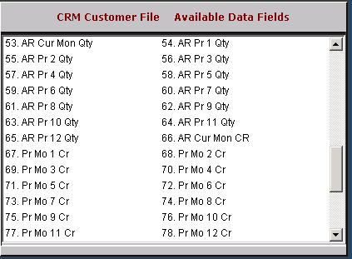

AR Cur Mon Qty: This field shows the number of charge and credit transactions for this month.

Pr 1 Qty – Pr 12 Qty: This series of 12 fields shows the number of charge and credit card transactions by the month. Pr 1 Qty is last month, Pr 2 Qty is two months ago, etc.

Cur Mon CR: This is the customer’s credit rating for this month.

Pr Mo 1 CR – Pr Mo 12 CR: This series of 12 fields shows the credit rating for the month. Pr Mo 1 CR is last month, Pr Mo 2 CR is two months ago, etc.

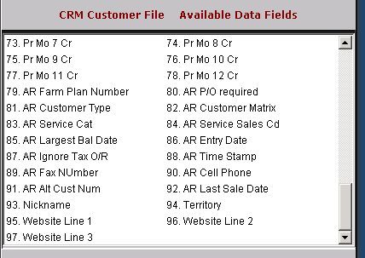

AR Farm Plan Number: This field is valid only for Farm Plan customers. It holds the customer’s full Farm Plan account number.

AR P/O required: This field shows if the customer requires a purchase order number on an invoice.

AR Customer Type: For Case dealers, this field defines the customer type of this customer record. This information is used for the Case Salesmaker Customer Extract program. The definitions are as follows:
  - S=Sole Proprietary
  - I=Individual
  - C=Corporation
  - G=Government
  - P=Partnership
  - R=Rental Yard

AR Price Matrix: This field is used to point to a defined price matrix code

AR Service Category: This field is used by the Service Management System to classify the typical sales tax category that this customer uses. SMS typically defines:

The taxable customers as 01.

The nontaxable customers as 02.

AR Service Sales Code: This field shows the service sales code (Netview Service only).

AR Largest Balance Date: This field holds the date corresponding to the Largest Balance shown in the Largest Balance field.

AR Entry Date: This field holds the date the customer record was added or when the customer first starting doing business with the dealership.

AR Ignore Tax O/R: This field indicates the customer’s sales tax code to overrides any codes found on part numbers.

AR Time Stamp: This field is reserved for future use.

AR Fax #: This field shows a fax number for the customer.

AR Cell #: This field holds the customer’s cell phone number.

AR Alt Cust No.: This field is reserved for future use.

AR Last Sale Date: This field is reserved for future use.

Nickname: This field holds the customer’s nickname.

Territory: This field holds the customer’s territory.

Website Line 1-3: This field is reserved for future use.

