CRM Description: This file pulls information from the CRM Description file.

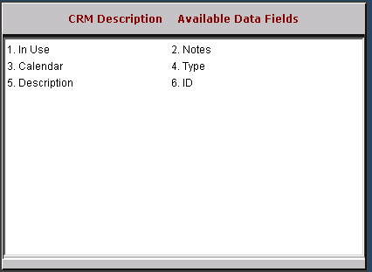

In Use: This field is reserved for future use.

Notes: This field is reserved for future use.

Calendar: This field is reserved for future use.

Type: This field is reserved for future use.

Description: This field shows the description.

CRM ID: This field holds the CRM ID (customer number or prospect ID).

