CRM Notes Header: This file pulls information from the CRM Notes Header file.

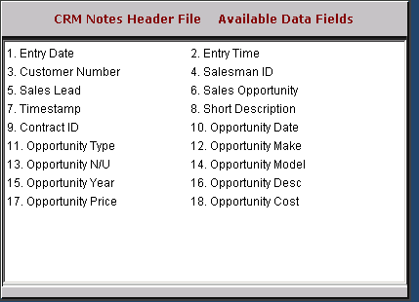

Entry Date: This field holds the date the note/opportunity was added.

Entry Time: This field holds the time the note/opportunity was added.

Customer Number: This field holds the CRM ID (customer number or prospect ID).

Salesman ID: This field holds initials or ID of the salesman who added the opportunity.

Sales Lead: This field indicates if the note is a sales lead: Y/N.

Sales Opportunity: This field indicates if the note is a sales opportunity: Y/N.

Timestamp: This field shows the physical date and time the entry was added.

Short Description: This field shows a brief description of the note.

Contract ID: This field is reserved for future use.

Opportunity Date: If the note is for an opportunity, then this field shows the date of the opportunity.

Opportunity Type: This field is reserved for future use.

Opportunity Make: This field shows the Make specified on the opportunity.

Opportunity N/U: This field shows the status (N/U) specified on the opportunity.

Opportunity Model: This field shows the model specified on the opportunity.

Opportunity Year: This field shows the Model Year specified on the opportunity.

Opportunity Description: This field shows the additional info entered in the description specified on the opportunity.

Opportunity Price: This field shows the Price specified on the opportunity.

Opportunity Cost: This field shows the Cost specified on the opportunity.

