CRM Notes Detail: This file pulls information from the CRM Notes Detail file.

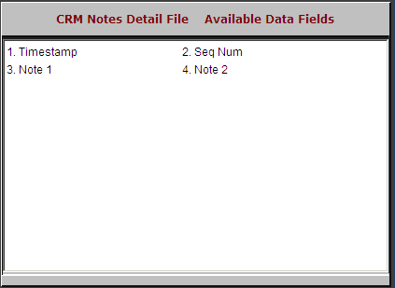

Timestamp: This field shows the physical date and time the entry was added.

Seq Num: This field holds a numeric sequence number generated by the system.

Note 1: This field holds the comments entered on Note line 1.

Note 2: This field holds the comments entered on Note line 2.

