CRM Territory File: This file pulls information from the CRM Territory file.

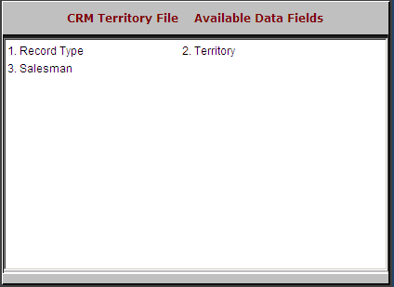

Record Type: This field is reserved for future use.

Territory: This field holds the territory name/ID.

Salesman: This field holds the initials/ID of the salesman who entered the territory.

