CRM Touch File: This file pulls information from the CRM Touch file.

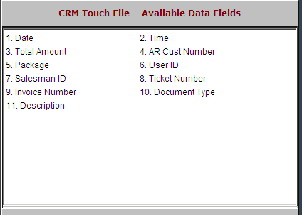

Date: This field holds the date the record was added.

Time: This field holds the time the record was added.

AR Cust Number: This field holds the customer of the touch record

Package: This field is reserved for future use.

User ID: This field shows the login for the person creating the record of the activity.

Salesman ID: This field shows the initials/ID of the salesman who initiated the activity.

Ticket Number: This field holds picking ticket number for the activity.

Invoice Number: This field is reserved for future use.

Document Type: This field is reserved for future use.

Description: This field is reserved for future use.

