Salesman File: This file pulls information from the CRM Salesman file.

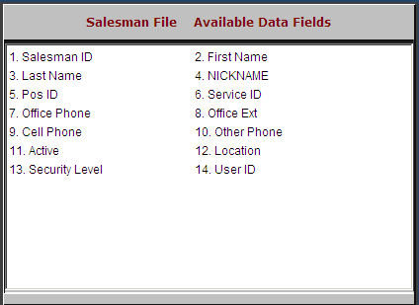

Salesman ID: This field holds the initials/ID of the salesman.

First Name: This field holds the salesman’s first name.

Last Name: This field holds the salesman’s last name.

NICKNAME: This field holds the nickname of the salesman.

Pos ID: This field shows the initials/ID used by the salesman in POS.

Service ID: This field indicates if the salesman is also a service writer.

Office Phone: This field holds salesman’s office phone number.

Office Ext: This field holds the extension of the salesman at his office.

Cell Phone: This field is holds the salesman’s cell phone number.

Other Phone: This field holds an additional phone number for the salesman.

Active: This field indicates if the salesman is active: Y/N.

Location: This field holds a location indicator for the salesman.

Security Level: This field holds the security level for the salesman:

S=Salesman

M=Manager

O=Other

User ID: This field holds user ID (login) for the salesman.

