Invamax File: This field pulls information from the Invamax File

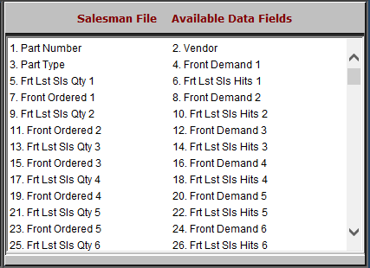

- Part Number: This field shows the part number.
- Vendor: This field shows the vendor.
- Part Type: This field shows the part type.
- Front Demand 1-25: These 25 fields show the front counter demand for the part over the past two years. Front Demand 1 is the current month, Front Demand 2 is the past month, etc.
- Frt Lst Sls Qty 1-25: These 25 fields show the front listed sales quantity for the part over the past two years. Frt Lst Sls Qty 1 refers to the current month, Frt Lst Sls Qty 2 is the past month, etc.
- Frt Lst Sls Hits 1-25: These 25 fields show the front listed sales hits for the part over the past two years. Frt Lst Sls Hits 1 is the current month, Frt Lst Sls Hits 2 is the past month, etc.
- Front Ordered 1-25: These 25 fields show the quantity of the parts ordered by the front counter over the past two years. Front Ordered 1 is the current month, Front Ordered 2 is the past month, etc.

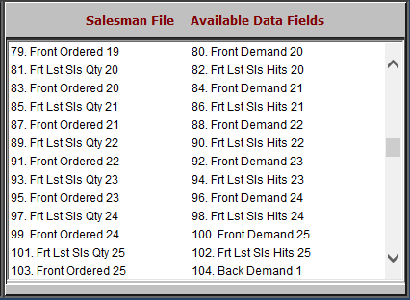

- Front Demand 1-25: These 25 fields show the front counter demand for the part over the past two years. Front Demand 1 is the current month, Front Demand 2 is the past month, etc.
- Frt Lst Sls Qty 1-25: These 25 fields show the front listed sales quantity for the part over the past two years. Frt Lst Sls Qty 1 refers to the current month, Frt Lst Sls Qty 2 is the past month, etc.
- Frt Lst Sls Hits 1-25: These 25 fields show the front listed sales hits for the part over the past two years. Frt Lst Sls Hits 1 is the current month, Frt Lst Sls Hits 2 is the past month, etc.
- Front Ordered 1-25: These 25 fields show the quantity of the parts ordered by the front counter over the past two years. Front Ordered 1 is the current month, Front Ordered 2 is the past month, etc.
- Back Demand 1-25: These 25 fields show the back counter demand for the part over the past two years. Front Demand 1 is the current month, Front Demand 2 is the past month, etc.

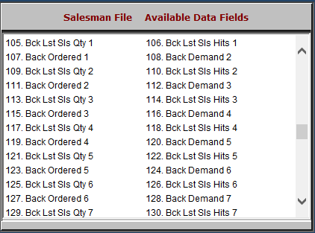

- Back Demand 1-25: These 25 fields show the back counter demand for the part over the past two years. Front Demand 1 is the current month, Front Demand 2 is the past month, etc.
- Bck Lst Sls Qty 1-25: These 25 fields show the back listed sales quantity for the part over the past two years. Bck Lst Sls Qty 1 refers to the current month, Bck Lst Sls Qty 2 is the past month, etc.
- Bck Lst Sls Hits 1-25: These 25 fields show the back listed sales hits for the part over the past two years. Bck Lst Sls Hits 1 is the current month, Bck Lst Sls Hits 2 is the past month, etc.
- Back Ordered 1-25: These 25 fields show the quantity of the parts ordered by the back counter over the past two years. Back Ordered 1 is the current month, Back Ordered 2 is the past month, etc.

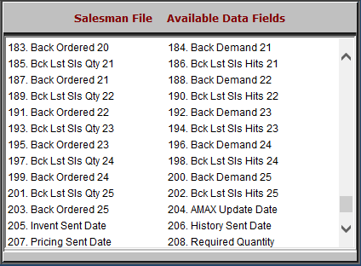

- Back Demand 1-25: These 25 fields show the back counter demand for the part over the past two years. Front Demand 1 is the current month, Front Demand 2 is the past month, etc.
- Bck Lst Sls Qty 1-25: These 25 fields show the back listed sales quantity for the part over the past two years. Bck Lst Sls Qty 1 refers to the current month, Bck Lst Sls Qty 2 is the past month, etc.
- Bck Lst Sls Hits 1-25: These 25 fields show the back listed sales hits for the part over the past two years. Bck Lst Sls Hits 1 is the current month, Bck Lst Sls Hits 2 is the past month, etc.
- Back Ordered 1-25: These 25 fields show the quantity of the parts ordered by the back counter over the past two years. Back Ordered 1 is the current month, Back Ordered 2 is the past month, etc.
- AMAX Update Date: This field shows the AMAX update date.
- Invent Sent Date: This field shows the inventory sent date.
- History Sent Date: This field shows the history sent date.
- Pricing Sent Date: This field shows the pricing sent date.

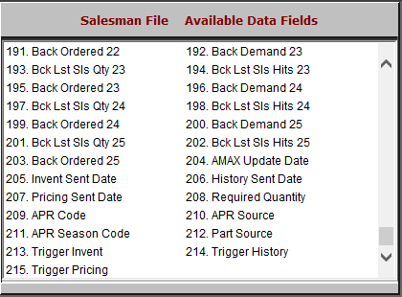

- Required Quantity: This field is reserved for future use.
- APR Code: This field shows the APR code.
- APR Source: This field shows the APR source.
- APR Season Code: This field shows the APR season code.
- Part Source: This field shows the part source.
- Trigger Invent: This field is reserved for future use.
- Trigger History: This field is reserved for future use.
- Trigger Pricing: This field is reserved for future use.

