Inventory Alias File: This file pulls information from the Inventory Alias File.

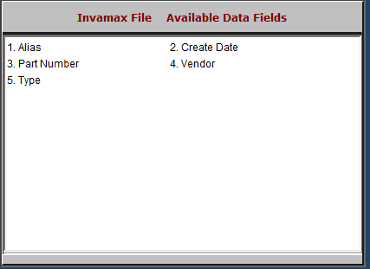

- Alias: This field lists the part alias, a shorthand for identifying the part aside from the part number.
- Create Date: This field lists the date the part alias was created.
- Part Number: This field lists the original part number.
- Vendor: This field lists the vendor who created the alias.
- Type: This field lists the part type.

