Service Time Slip File: This file pulls information from the Service Time Slip File.

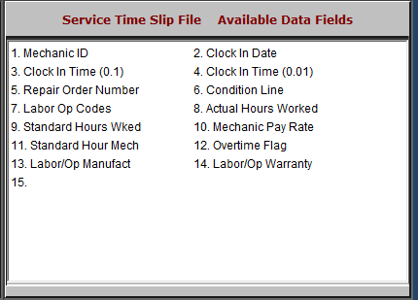

- Mechanic ID: This field lists the mechanic ID
- Clock In Date: This field lists the clock-in date.
- Clock In Time (0.1): This field lists the clock-in time, to the nearest 0.1 of a second.
- Clock In Time (0.01): This field lists the clock-in time, to the nearest 0.01 of a second.
- Repair Order Number: This field lists the repair order number.
- Condition Line: This field shows the condition, as denoted by a number.
- Labor Op Codes: This field lists the labor operation codes.
- Actual Hours Worked: This field lists the actual hours the mechanic worked.
- Standard Hours Wked: This field is an optional field that shows flat rate hours.
- Mechanic Pay Rate: This field lists the mechanic’s pay rate.
- Standard Hour Mech: This field is reserved for future use.
- Overtime Flag: This field indicates whether or not the mechanic is due overtime pay.
- Labor/Op Manufact: This field is reserved for future use.
- Labor/Op Warranty: This field shows the labor/operation warranty.

