Service System Mechanic Time: This file pulls information from the Service System Mechanic Time file.

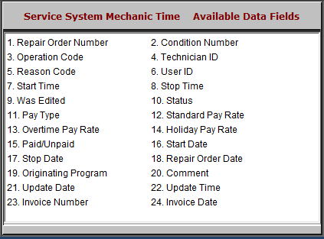

- Repair Order Number: This field lists the repair order number.
- Condition Number: This field shows the repair order condition number.
- Operation Code: This field shows the operation code for the service.
- Technician ID: This field shows the technician ID.
- Reason Code: This field shows the reason code.
- User ID: This field shows the service writer’s user ID.
- Start Time: This field shows the time the technician started working on the service.
- Stop Time: This field shows the time the technician stopped working on the service.
- Was Edited: This field indicates whether or not this file was edited.
- Status: This field lists the report order status.
- Pay Type: This field lists the technician’s pay type: Regular, Overtime, or Holiday.
- Standard Pay Rate: This field lists the technician’s standard pay rate.
- Overtime Pay Rate: This field lists the technician’s overtime pay rate.
- Holiday Pay Rate: This field lists the technician’s holiday pay rate.
- Paid/Unpaid: This field is reserved for future use.
- Start Date: This field shows the technician’s clock-in date.
- Stop Date: This field shows the technician’s clock-out date.
- Repair Order Date: This field shows the repair order date.
- Originating Program: This field is reserved for future use.
- Comment: This field shows any comments made on the repair order.
- Update Date: This field shows the date the file was last updated.
- Update Time: This field shows the time the last file was updated.
- Invoice Number: This field shows the invoice number.
- Invoice Date: This field shows the invoice date.

