Purchase Order Header File: This file pulls information from the Purchase Order Header File.

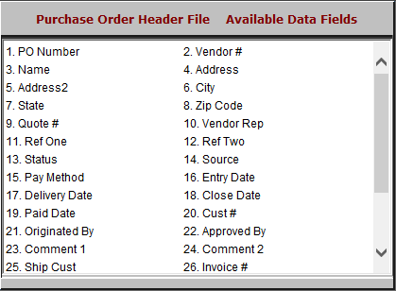

- PO Number: This field lists the purchase order number.
- Vendor #: This field lists the vendor number.
- Name: This field lists the name of the vendor.
- Address: This field lists the vendor’s address.
- Address2: This field provides an extra line for the vendor’s address, should it require one.
- City: This field lists the vendor’s city.
- State: This field lists the vendor’s state.
- Zip Code: This field lists the vendor’s zip code.
- Quote #: This field lists the quote number of the purchase.
- Vendor Rep: This field shows the vendor representative’s name.
- Ref One: This field is available for comments on the purchase order.
- Ref Two: This field is available for comments on the purchase order.
- Status: This field shows the purchase order’s status.
- Source: This field shows the program the purchase order came from, which could be:
  - Parts
  - Service
  - Units
  - Rental
  - Other
- Pay Method: This field shows the intended payment type.
- Entry Date: This field shows the date the purchase order was entered.
- Delivery Date: This field shows the date the order was delivered.
- Close Date: This field shows the date the purchase order is closed.

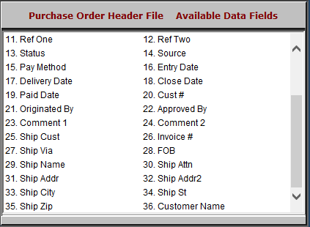

- Paid Date: This field shows the date the purchase order was paid.
- Cust #: This field shows the customer number.
- Originated By: This field lists the employee who created the order.
- Approved By: This field lists the employee or supervisor who approved the order.
- Comment 1: This field is available for any comments on the order.
- Comment 2: This field is available for any comments on the order.
- Ship Cust: This field lists the customer the order is being shipped to.
- Invoice #: This field lists the invoice number.
- Ship Via: This field shows how the order is to be shipped.
- FOB: This field shows the freight amount.
- Ship Name: This field lists the name of the person the order is to be shipped to.
- Ship Attn: This field lists the individual the order should be shipped to specifically, if it is being shipped to a business.
- Ship Addr: This field lists the shipping address.
- Ship Addr2: This field provides an extra line for the shipping address, should it require one.
- Ship City: This field lists the shipping city.
- Ship St: This field lists the shipping state.
- Ship Zip: This field lists the shipping zip code.
- Customer Name: This field lists the customer’s name.

