Purchase Order Detail File: This file pulls information from the Purchase Order Detail File.

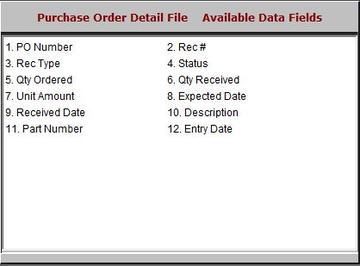

- PO Number: This field shows the purchase order number.
- Rec #: This field is reserved for future use.
- Rec Type: This field is reserved for future use.
- Status: This field shows the order’s status.
- Qty Ordered: This field lists the quantity ordered.
- Qty Received: This field lists the quantity received.
- Unit Amount: This field lists the unit amount.
- Expected Date: This field lists the expected delivery date.
- Received Date: This field lists the date the order was actually received.
- Description: This field shows a description of the order.
- Part Number: This field shows the part number.
- Entry Date: This field shows the date the order was created.

