Customer License/ID File: This file pulls information from the Customer License/ID File.

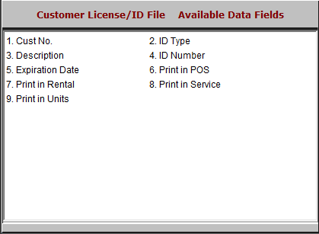

- Cust No.: This field shows the customer number.
- ID Type: This field shows the ID type.
- Description: This field shows the ID’s description.
- ID Number: This field shows the ID number.
- Expiration Date: This field shows the ID’s expiration date.
- Print in POS: This field shows a flag if the ID information can print in POS.
- Print in Rental: This field shows a flag if the ID information can print in Rental.
- Print in Service: This field shows a flag if the ID information can print in Service.
- Print in Units: This field shows a flag if the ID information can print in Units.

