Order History File: This file pulls information from the Order History File.

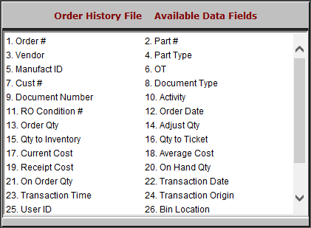

- Order #: This field shows the order number.
- Part #: This field shows the part number.
- Vendor: This field shows the vendor.
- Part Type: This field shows the part type.
- Manufact ID: This field shows the manufacturer ID.
- OT: This field shows the order type.
- Cust #: This field shows the customer number.
- Document Type: This field shows the document type.
- Document Number: This field shows the document number.

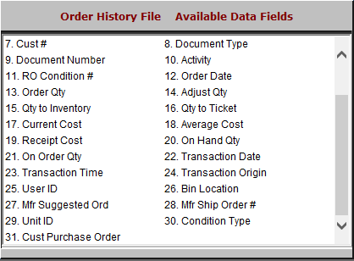

- Activity: This field is reserved for future use.
- RO Condition #: This field shows the repair order condition number.
- Order Date: This field shows the order date.
- Order Qty: This field shows the order quantity.
- Adjust Qty: This field shows the quantity adjusted.
- Qty to Inventory: This field shows the quantity added to the inventory.
- Qty to Ticket: This field shows the quantity added to the ticket.
- Current Cost: This field show the current cost.
- Average Cost: This field shows the average cost.
- Receipt Cost: This field shows the receipt cost.
- On Hand Qty: This field shows the quantity on hand.
- On Order Qty: This field shows the quantity on order.
- Transaction Date: This field shows the transaction date.
- Transaction Time: This field shows the transaction time.
- Transaction Origin: This field shows the program where the transaction occured.
- User ID: This field shows the user ID.
- Bin Location: This field shows the part’s bin location.
- Mfr Suggested Ord: This field is reserved for future use.
- Mfr Ship Order #: This field shows the manufacturer’s ship order number.
- Unit ID: This field shows the unit ID.
- Condition Type: This field shows the condition type.
- Cust Purchase Order: This field shows the customer’s purchase order.

