Unit Special ID Status: This file pulls information from the Unit Special ID Status file.

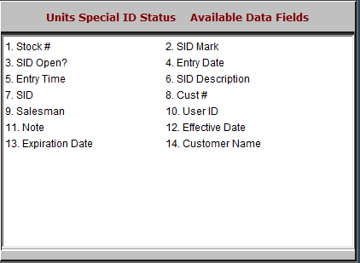

- Stock #: This field shows the stock number.
- SID Mark: This field is reserved for future use.
- SID Open?: This field shows whether or not the SID is open.
- Entry Date: This field shows the entry date of the SID.
- Entry Time: This field shows the entry time of the SID.
- SID Description: This field shows the SID description.
- SID: This field shows the special ID itself.
- Cust #: This field shows the customer number.
- Salesman: This field shows the salesman.
- User ID: This field shows the user ID of the added SID.
- Note: This field shows any notes made in the file.
- Effective Date: This field shows the effective date.
- Expiration Date: This field shows the expiration date.
- Customer Name: This field shows the customer’s name.

