Unit Transaction History: This file pulls information from the Unit Transaction History file.

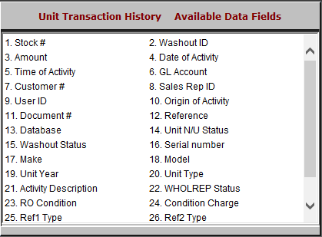

- Stock #: This field shows the stock number.
- Washout ID: This field shows the washout ID.
- Amount: This field shows the amount of the transaction.
- Date of Activity: This field shows the date of activity.
- Time of Activity: This field shows the time of activity.
- GL Account: This field shows the General Ledger account number.
- Customer #: This field shows the customer number.
- Sales Rep ID: This field shows the salesperson ID.
- User ID: This field shows the ID of the user who performed the activity.

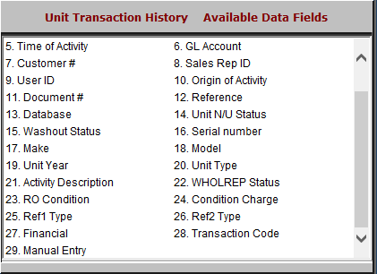

- Origin of Activity: This field shows the origin of the activity.
- Document #: This field shows the document number.
- Reference: This field is reserved for future use.
- Database: This field is reserved for future use.
- Unit N/U Status: This field shows the unit’s status.
- Washout Status: This field shows the washout status.
- Serial Number: This field shows the unit’s serial number.
- Make: This field shows the unit’s make.
- Model: This field shows the unit’s model.
- Unit Year: This field shows the unit’s year.
- Unit Type: This field shows the unit type.
- Activity Description: This field gives a description of the activity.
- WHOLREP Status: This field shows whether the transaction is:
  - Open
  - Closed
  - History
- RO Condition: This field lists the repair order condition number.
- Condition Charge: This field lists the condition charge.
- Ref1 Type: This field is reserved for future use.
- Ref2 Type: This field is reserved for future use.
- Financial: This field shows one of the following:
  - “Y” if there is accounting of the unit number
  - “N” if there isn’t.
- Transaction Code: This field shows the transaction code.
- Manual Entry: This field is available for manual entry.

