Unit Invoice Header File: This file pulls information from the Unit Invoice Header File.

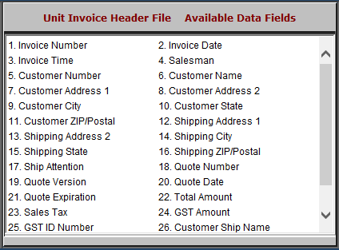

- Invoice Number: This field shows the invoice number.
- Invoice Date: This field shows the invoice date.
- Invoice Time: This field shows the invoice time.
- Salesman: This field shows the salesman’s initials or number.
- Customer Number: This field shows the customer number.
- Customer Name: This field shows the customer’s name.
- Customer Address 1: This field shows the customer’s address.
- Customer Address 2: This field provides an extra line for the customer’s address, should it require one.
- Customer City: This field shows the customer’s city.

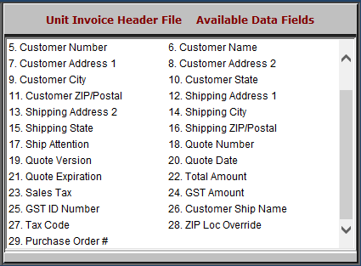

- Customer State: This field shows the customer’s state.
- Customer ZIP/Postal: This field shows the customer’s zip or postal code.
- Shipping Address 1: This field shows the shipping address.
- Shipping Address 2: This field provides an extra line for the shipping address, should it need one.
- Shipping City: This field shows the shipping city.
- Shipping State: This field shows the shipping state.
- Shipping ZIP/Postal: This field shows the shipping zip or postal code.
- Ship Attention: This field shows who specifically the invoice is to be shipped to, if it’s being delivered to a business.
- Quote Number: This field shows the quote number.
- Quote Version: This field shows the quote version.
- Quote Date: This field shows the quote date.
- Quote Expiration: This field shows the quote expiration.
- Total Amount: This field shows the total amount of the invoice.
- Sales Tax: This field shows the sales tax.
- GST Amount: This field shows the GST amount.
- GST ID Number: This field shows the GST ID number.
- Customer Ship Name: This field shows the customer’s shipping name.
- Tax Code: This field shows the tax code.
- ZIP Loc Override: This field shows the zip code location override.
- Purchase Order #: This field shows the purchase order number.

