Unit Invoice Detail File: This file pulls information from the Unit Invoice Detail File.

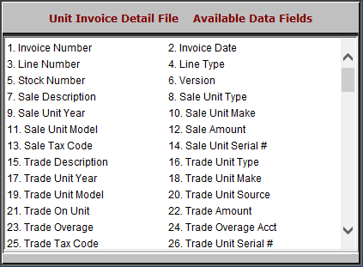

- Invoice Number: This field shows the invoice number.
- Invoice Date: This field shows the invoice date.
- Line Number: This field shows the line number.
- Line Type: This field shows the line type.
- Stock Number: This field shows the stock number.
- Version: This field shows the version.
- Sale Description: This field shows a description of the sale.
- Sale Unit Type: This field shows the sale unit’s type.
- Sale Unit Year: This field shows the sale unit’s year.
- Sale Unit Make: This field shows the sale unit’s make.
- Sale Unit Model: This field shows the sale unit’s model.
- Sale Amount: This field shows the sale amount.
- Sale Tax Code: This field shows the sale tax code.
- Sale Unit Serial #: This field shows the sale unit’s serial number.
- Trade Description: This field gives a description of the trade.
- Trade Unit Type: This field shows the trade unit’s type.
- Trade Unit Year: This field shows the trade unit’s type.
- Trade Unit Make: This field shows the trade unit’s make.
- Trade Unit Model: This field shows the trade unit’s model.
- Trade Unit Source: This field shows the trade unit’s source.
- Trade On Unit: This field shows the stock number where the trade was applied.
- Trade Amount: This field shows the trade’s amount.
- Trade Overage: This field shows the trade over-allowance amount.
- Trade Overage Acct: This field shows the account where the trade over-allowance was applied.
- Trade Tax Code: This field shows the trade tax code.
- Trade Unit Serial #: This field shows the trade unit’s serial number.

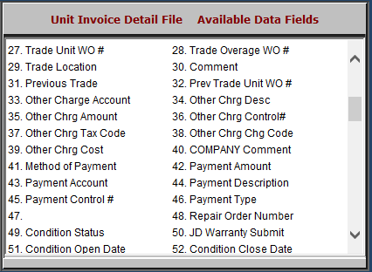

- Trade Unit WO #: This field shows the trade unit’s washout number.
- Trade Overage WO #: This field shows the over-allowance for the washout number.
- Trade Location: This field shows the location where the trade resides.
- Comment: This field shows any comments.
- Previous Trade: This field is reserved for future use.
- Prev Trade Unit WO #: This field is reserved for future use.
- Other Charge Account: This field shows the other charge account.
- Other Chrg Desc: This field shows the other charge description.
- Other Chrg Amount: This field shows the other charge amount.
- Other Chrg Control#: This field shows the other charge control number.
- Other Chrg Tax Code: This field shows the other charge tax code.
- Other Chrg Chg Code: This field is reserved for future use.
- Other Chrg Cost: This field shows the other charge cost.
- COMPANY Comment: This field is reserved for future use.
- Method of Payment: This field shows the payment method.
- Payment Amount: This field shows the payment amount.
- Payment Account: This field shows the ledger where the account is applied.
- Payment Description: This field shows the payment’s description.
- Payment Control #: This field shows the payment control number.
- Payment Type: This field shows the payment type.
- Repair Order Number: This field shows the repair order number.
- Condition Status: This field shows the repair order condition status.
- JD Warranty Submit: This field shows a flag if the warranty has been submitted to John Deere.
  - This field can be used for manual entry by other companies.
- Condition Open Date: This field shows the date the condition was opened.
- Condition Close Date: This field shows the date the condition was closed.

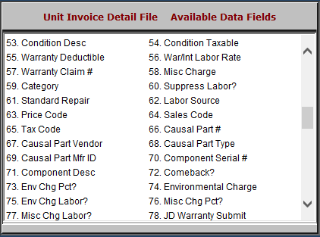

- Condition Desc: This field shows a description of the condition.
- Condition Taxable: This field shows if the condition is taxable or not.
- Warranty Deductible: This field shows the warranty deductible amount.
- War/Int Labor Rate: This field shows one of the following:
  - The warranty labor rate
  - The internal labor rate
- Warranty Claim #: This field shows the warranty claim number.
- Misc Charge: This field shows any miscellaneous charges.
- Category: This field is reserved for future use.
- Suppress Labor?: This field shows one of the following:
  - “Y” if the labor detail is suppressed.
  - “N” if all details are shown.
- Standard Repair: This optional field can show the standard repair code.
- Labor Source: This field is reserved for future use.
- Price Code: This field shows the price code.
- Sales Code: This field shows the sales code.
- Tax Code: This field shows the tax code.
- Causal Part #: This field shows the causal part number.
- Causal Part Vendor: This field shows the causal part vendor.
- Causal Part Type: This field shows the causal part type.
- Causal Part Mfr ID: This field shows the causal part manufacturer ID.
- Component Serial #: This field shows the component serial number.
- Component Desc: This field shows the component’s description.
- Comeback?: This field shows one of the following:
  - “Y” if the repair is a comeback.
  - “N” if it’s not.
- Env Chg Labor?: This field shows whether or not there is an environmental charge for the labor.
- Misc Chg Pct?: This field shows one of the following:
  - “Y” if there is a miscellaneous charge percentage.
  - “N” if there isn’t.
- Misc Chg Labor?: This field shows one of the following:
  - “Y” if the miscellaneous charges apply to the labor.
  - “N” if the charges do not apply.
- JD Warranty Submit: This field shows a flag if the warranty has been submitted to John Deere.
  - This field can be used for manual entry by other companies.

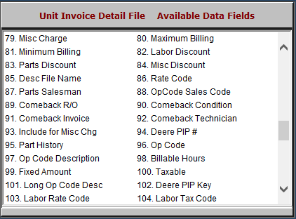

- Misc Charge: This field shows any miscellaneous charges.
- Maximum Billing: This field shows the maximum billing amount.
- Minimum Billing: This field shows the minimum billing amount.
- Labor Discount: This field shows any labor discounts.
- Parts Discount: This field shows any parts discounts.
- Misc Discount: This field shows any miscellaneous discounts.
- Desc File Name: This field shows a description of the file name.
- Rate Code: This field shows the rate code.
- Parts Salesman: This field shows the parts salesman’s number or initials.
- OpCode Sales Code: This field shows the Op Code sales code.
- Comeback R/O: This field shows the repair order number if the repair is a comeback.
- Comeback Condition: This field shows the condition number if the repair is a comeback.
- Comeback Invoice: This field shows the comeback invoice number.
- Comeback Technician: This field shows the technician who worked on the comeback.
- Include for Misc Chg: This field is to be included for miscellaneous charges.
- Deere PIP #: This field shows the PIP number for John Deere.
  - It can be used for manual entry by other companies.
- Part History: This field shows one of the following:
  - “Y” if the invoice shows in Part History.
  - “N” for “No” if it does not.
- Op Code: This field shows the Op code.
- Op Code Description: This field shows the Op code’s description.
- Billable Hours: This field indicates the billable hours.
- Fixed Amount: This field shows the fixed amount.
- Taxable: This field is reserved for future use.
- Long Op Code Desc: This field shows the Long Op code description.
- Deere PIP Key: This field holds the PIP key for John Deere.
  - It can be used for manual entry by other companies.
- Labor Rate Code: This field shows the labor rate code.
- Labor Tax Code: This field shows the labor tax code.

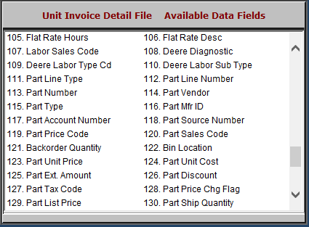

- Flat Rate Hours: This field shows the flat rate hours.
- Flat Rate Desc: This field shows the flat rate’s description.
- Labor Sales Code: This field shows the labor sales code.
- Deere Diagnostic: This field shows the diagnostic code for John Deere.
  - It can be used for manual entry by other companies.
- Deere Labor Type Cd: This field shows the labor type code for John Deere.
  - It can be used for manual entry by other companies.
- Deere Labor Sub Type: This field shows the labor sub type for John Deere.
  - It can be used for manual entry by other companies.
- Part Line Type: This field shows the part line type.
- Part Line Number: This field shows the part line number.
- Part Number: This field shows the part number.
- Part Vendor: This field lists the part vendor.
- Part Type: This field lists the part type.
- Part Mfr ID: This field lists the part manufacturer ID.
- Part Account Number: This field lists the part account number.
- Part Source Number: This field lists the part source number.
- Part Price Code: This field lists the part price code.
- Part Sales Codes: This field lists the part sales codes.
- Backorder Quantity: This field lists the backorder quantity.
- Bin Location: This field lists the bin location.
- Part Unit Price: This field shows the part unit price.
- Part Unit Cost: This field shows the part unit cost.
- Part Ext. Amount: This field shows the part’s extended list price.
- Part Discount: This field shows the part discount amount.
- Part Tax Code: This field shows the part tax code.
- Part Price Chg Flag: This field is reserved for future use.
- Part List Price: This field shows the part list price.
- Part Ship Quantity: This field shows the part ship quantity.

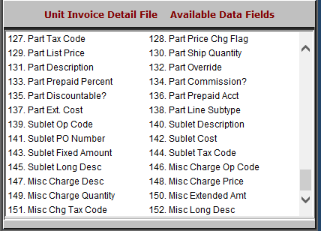

- Part Description: This field shows the part’s description.
- Part Override: This field shows the part tax override.
- Part Prepaid Percent: This field lists the percent of the part’s price that was prepaid.
- Part Commission?: This field lists if the part is a commission or not.
- Part Discountable?: This field lists if the part is discountable or not.
- Part Prepaid Acct: This field is reserved for future use.
- Part Ext. Cost: This field shows the part’s extended cost.
- Part Line Subtype: This field shows the part line subtype.
- Sublet Op Code: This field shows the sublet op code.
- Sublet Description: This field shows the sublet’s description.
- Sublet PO Number: This field shows the sublet purchase order number.
- Sublet Cost: This field shows the sublet cost.
- Sublet Fixed Amount: This field shows the sublet fixed amount.
- Sublet Tax Code: This field shows the sublet tax code.
- Sublet Long Desc: This field shows an extended description of the sublet.
- Misc Charge Op Code: This field is reserved for future use.
- Misc Charge Desc: This field describes miscellaneous charges.
- Misc Charge Price: This field shows the selling price of the miscellaneous charges.
- Misc Charge Quantity: This field shows the quantity of the miscellaneous charges.
- Misc Extended Amt: This field shows the extended selling miscellaneous price.
- Misc Chg Tax Code: This field shows the tax code for the miscellaneous charges.
- Misc Long Desc: This field shows an extended description of the miscellaneous charges.

