PER: Credit Limit Status Report

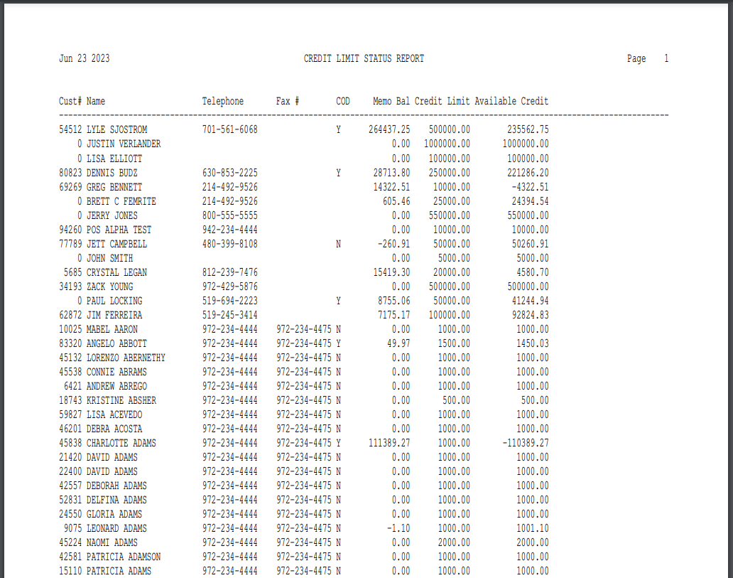

This Report Writer report is a good one to run when you need to review the customers’ credit limits. The information is sorted in alphabetical order based on the Alpha Sort field in the Customer Master.

To access this report:

- Select “Report Writer” from the menu and click “Print an Established Report.” Choose the report from the selection in the application.
- Type “PER” in the Shortcuts Bar and select the report.

Columns Include:

Cust #: This column shows the Customer Number assigned to this customer.

Name: This column shows the customer name.

Telephone: This column shows the customer’s telephone number.

Fax #: This column shows the customer’s fax number.

COD: This column tells you if the customer is on COD or not.

Memo Bal: This column shows the Memo Balance of the customer. This balance consists of the posted balance from Current Balance plus the unposted entries made through POS invoicing, SMS Invoicing or Cash Applications.

Credit Limit: This column displays the customer’s current credit limit from the Customer Master.

Available Credit: This column displays the customer’s remaining available credit limit (Credit Limit minus A/R balance).

