PER: A/R Ship To Address List

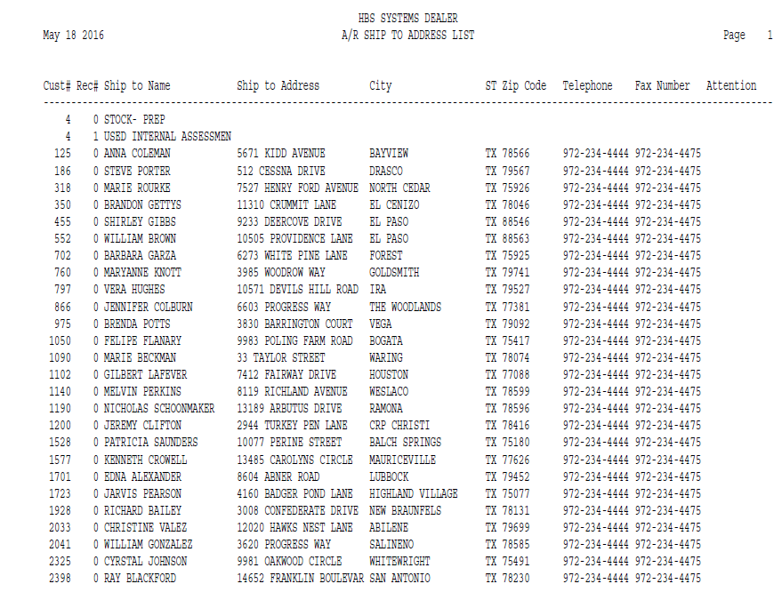

This Report Writer report provides an alphabetical list of the Ship To Addresses defined on your system. It can be run from the Report Writer Menu. The report sorts in Customer Number order.

- To access this report:
  - Select “Report Writer” from the menu and click on “Print an Established Report.” Choose the report from the selection in the application.
  - Type “PER” in the Shortcuts Bar and select the report

Columns Include:

Cust #: This column shows the Customer Number.

Rec #: This column shows the record number of the Ship To Address. 0 is the first record, 1 is the second, and so on.

Ship To Name: This column shows the Customer or Business name for the Ship To Address.

Ship To Address: This column shows the Ship To Address itself.

City: This column lists the City for the Ship To Address.

St: This column lists the State or Province for the Ship To Address.

Zip Code: This column shows the Zip/Postal Code for the Ship To Address.

Telephone: This column shows the Telephone Number for the Ship To Address.

Fax Number: This column shows the Fax Number for the Ship To Address.

Attention: This column shows the name of a contact person at the Ship To Address.

