PER: A/R Ship To Address Info

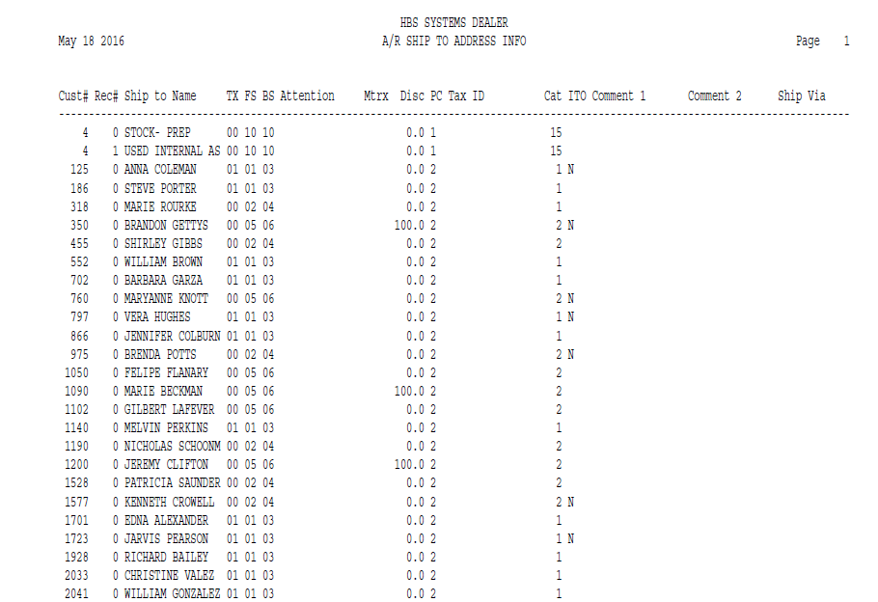

This Report Writer report provides an alphabetical list of the details that have been entered for the Ship To addresses defined on your system. It can be run from the Report Writer Menu. The report sorts in Customer Number order.

- To access this report:
  - Select “Report Writer” from the menu and click “Print an Established Report.” Choose the report from the selection in the application.
  - Type “PER” in the Shortcuts Bar and select the report

Columns Include:

Cust No.: This column shows the Customer Number.

Rec #: This column shows the record number of the Ship To Address. 0 is the first record, 1 is the second, and so on.

Ship To Name: This column shows the Customer or Business Name for the Ship To Address.

TX: This column holds the primary or typical tax code for the Ship To Address. This selection is made from the tax codes set-up on the system. The code may be any of the available tax codes 00 through 99. While this is the code to show the most frequently used taxable nature of the customer, the code may be changed in the POS invoicing program to apply to the entire invoice or to specific items.

Typical choices are:

00 for non-tax customers

01 for taxable customers

FS: This column holds the default sales code used when someone from this Ship To Address purchases parts at the Parts Counter. Typical selections reflect the distinction between taxable and non-taxable codes. Sales codes provide the pointer to the general ledger account number to receive the dollars from the parts sales transaction.

BS: This column holds the default sales code used when someone from the Ship To Address purchases parts in the Service Department (on a repair order). Typical selections distinguish between taxable and non-taxable codes. Sales codes provide the pointer to the general ledger account number to receive the dollars from the service sales transaction.

Attention: This column shows the name of a contact person at the Ship To Address.

Mtrx: This column points to a defined price matrix code for this Ship To Address. Price matrix codes can be defined to indicate a special pricing structure based on a specific source code. If a price matrix is appropriate, the number of that matrix should be entered here.

Disc: This column offers the ability to provide a permanent discount from the stated price code for this Ship To Address. A percentage entered here will apply to all purchases of pre-priced items made in POS and SMS.

PC: This column holds the basis for pricing for the Ship To Address. It works with the Discount Rate field to determine the selling prices for pre-priced items in POS and SMS. The choices for this field are:

- 1=Cost
- 2=List
- 3=Dealer Defined Pricing Level
- 4=Dealer Defined Pricing Level
- 5=Dealer Defined Pricing Level
- 6=MSRP (Manufacturer’s Suggested)

Tax ID: This column contains the tax exemption number for the Ship To Address.

Cat: This column is for future use for shipping addresses in the Service Management (SMS) program.

ITO: This column can be used to single out those customers whose taxable status has to match the one set in the Ship To Address, regardless of any part tax overrides present on your system.

Y in this field indicates that the tax code in the Ship To Address takes priority over all taxing scenarios and locks in the taxable status for all items regardless of any part tax overrides.

N or blank in this field means the parts will generally follow the Ship To Address’ taxable status except when the part tax override is in place, and in that case, the Ship To Address’ tax code surrenders to the one coded on the part.

Comment 1: This column holds additional information about the Ship To Address.

Comment 2: This column holds additional information about the Ship To Address.

Ship Via: This column holds the shipping preference for the Ship To Address.

