Handling Price Files—Case (PF198)

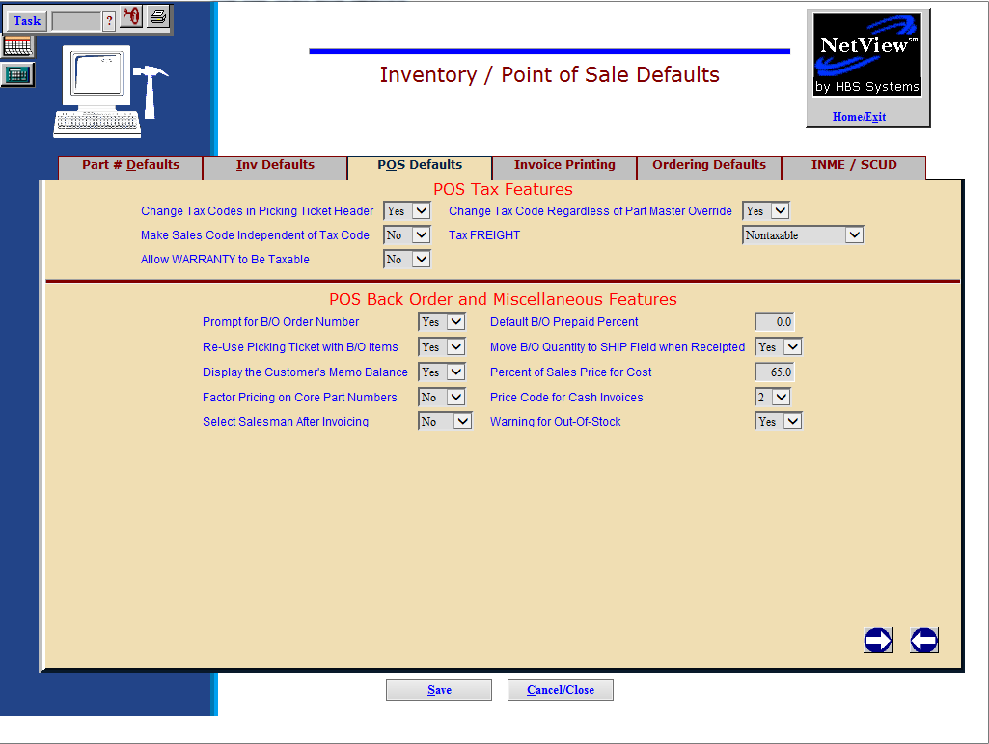

POS Defaults Tab

Setup for Case Core Part Handling: Before using the new core parts feature, you must decide how to price the core parts. You can price the cores according to price file’s price for the parts (no mark-up) or have them factored like the other parts in the source (i.e. 110.0% of price file’s amount). A setup prompt in Inventory and Point of Sale Defaults (IPOS) provides this choice.

- To open IPOS, you can:
  - Select “System Maintenance” from the menu. Choose the “Company File” submenu and click “Inventory POS Defaults.”
  - Type “IPOS” in the Shortcuts Bar

Factor Core Part # Pricing: This field determine if the system will mark up core pricing according to the price levels in the source master.

- Select Yes to have Parts Inquiry and POS use the source file’s price factoring percentages to calculate the core charge on the original part number and core part number records. A choice of “Yes” means that both the core credit given to a customer when he returns a core as well as the core charge you charge a customer when they don’t return a good core will be marked up according to the price levels you have setup in the Parts Source Master for the affected parts.
- Choose No to use only the price file’s data for calculating core charges and ignore the source file’s pricing scheme. A choice of “No” means that you prefer not to mark up the core credit given to the customer or the core charge you charge to a customer if they don’t return a good core.
- If you make a change in this field, be sure to save your changes.

DS01 Pricing: The Case price file includes DS01 (direct ship) pricing for selected Case parts. Pricing for Case parts will have one of these pricing characteristics:

- Parts with List and Cost. This is the most common pricing characteristic. These parts have both the Mfr List and Mfr Cost fields, and do not have any DS01 (direct ship) pricing. This group of parts has a PMC (parts marketing code) of S.
- Parts with List and DS01. This group of parts has ONLY the Mfr List and DS01 pricing, and indicates that these items can only be ordered as direct ship. In this case, the DS01 value indicates your cost for these items. This group of parts has a PMC (parts marketing code) of V.
- Parts with List, Cost, and DS01. This group of parts has a Mfr List, Mfr Cost, AND DS01 pricing, which means they can be ordered as “regular” parts as well as direct ship items. Parts with this characteristic potentially will have all three values shown in the part master. This group of parts has a PMC (parts marketing code) of B.

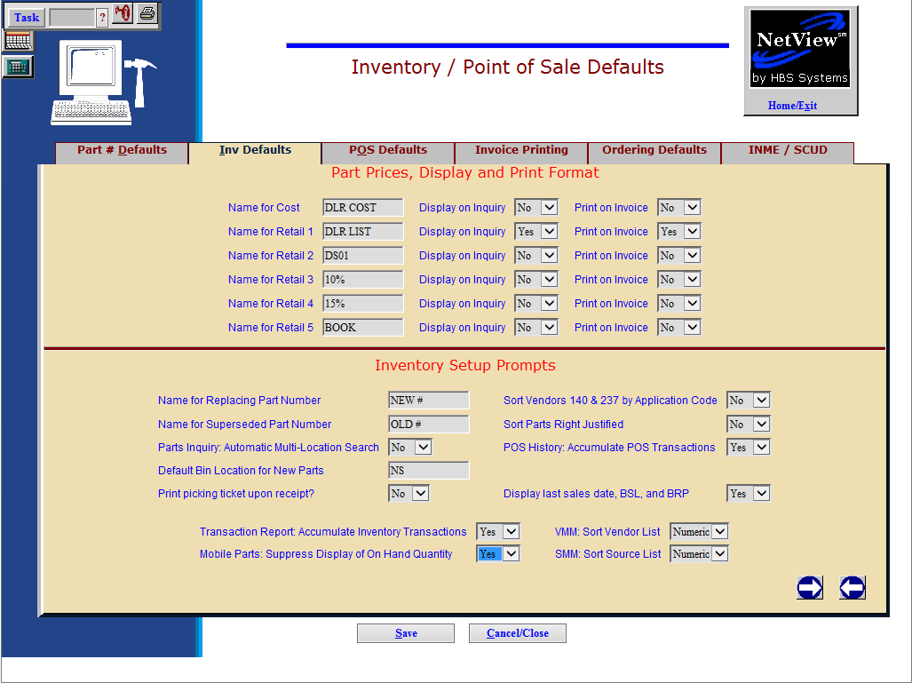

Inv Defaults Tab: Choose the Inv Defaults Tab to display the Price Code field definitions. The six price codes are defined in the rows that show Cost, Retail 1, Retail 2, Retail 3, Retail 4, and Retail 5. They are defined as follows:

IPOS Definition |  | Price Code |  | Common Definition
Cost |  | 1 |  | COST (Manufacturer’s cost)
Retail 1 |  | 2 |  | LIST (Your selling price)
Retail 2 |  | 3 |  | DS01 (or other dealer defined code)
Retail 3 |  | 4 |  | Dealer defined code
Retail 4 |  | 5 |  | Dealer defined code
Retail 5 |  | 6 |  | BOOK or MSRP (Manufacturer’s list price)

These fields set your preferences for prices, and for the names shown in the Inquiry programs and on POS Invoices. All lines include three fields:

- The name of the price code
- The choice of displaying the price for that code in Parts Inquiry/Price File Inquiry
- The choice of printing the price for that code on the invoice.

You must decide which of these price codes will hold the new DS01 pricing for Case Parts. You may choose any of the price codes to hold this field. However, we do not allow choosing 2, as that is typically reserved for your selling price. Some dealers use price code 3 as shown in the example. You will NOT want to use this code if you are already using it for another pricing definition. In that case, you will want to use another available price code.

You MUST choose a price code on this screen to hold your DS01 pricing, and then enter the name DS01 in the field provided for it. You may also choose to display it on the Inquiry screens, or even have it print on an invoice with choices in the remaining fields for the price code you select.

Another possible way for you to use the DS01 cost is to have it “replace” the traditional cost for the parts where it is applicable. In this case, you would select Price Code 1 to receive the DS01 value. The system would then place the DS01 figures in the price code where your traditional cost had previously been. Remember, this would mean that the cost for each part with DS01 pricing would be the DS01 cost, not the traditional cost. If you choose this method, the value of your Case parts inventory will be based on DS01 cost for parts with DS01 cost and traditional part cost for the parts without DS01 pricing.

If you use this approach, the current settings in your Source Masters and Price Tiers for Case sources should work as they are provided the cost flag points to Price Code 1. Be sure to carefully review the following examples of Source Master configurations.

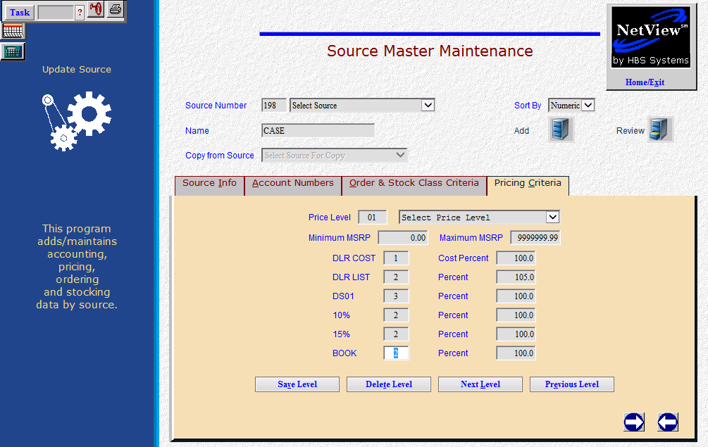

Pricing Criteria Tab

Define your DS01 Pricing in ALL Case parts sources: You need to review the settings for ALL price tiers in ALL your Case parts sources. Access the Source Master for each one.

- To access this program, you can:
  - Select “Inventory” from the menu. Choose the “Parts Source Update” submenu and click “Source Master Maintenance.”
  - Type “SMM” in the Shortcuts Bar
- Select the Pricing Criteria Tab to reach the Source Master where price levels are defined.

For EACH price level defined for EACH Case source, examine the value shown for the price code you selected to hold your DS01 pricing. For example, if you have five price levels defined for source 198, you must examine EACH level of the 198 source to make sure an appropriate price code and percentage is shown the DS01 pricing.

The example above shows a price code of 3 for DS01 pricing and a 100 % factor indicating it is not marked up from its original value.

Price Flag Column: This column refers to the Price Fields (1-Mfr Cost, 2-YOUR List, 3-Dealer Defined, 4-Dealer Defined, 5-Dealer Defined, and 6-Mfr List) you defined in IPOS. These numbers are the base of how the price for this level will be calculated. This column works with the Price Factor Percent Column to determine the actual value. In the example above, 1 is used for the definition of Cost, 2 for the basis of List (your selling price), 3 for the definition of DS01, and 2 for MSRP.

Price Factor Percent Column: This column creates the pricing structure by applying a percentage to the value in the Price Flag Column. For example, if the Price Flag Column shows Cost (1), this column could say 100.0 if the pricing for this line was to be straight Cost. Likewise, if it shows 2 for the List calculation and shows a percentage of 105.0, that means that the Mfr list is multiplied by 105% to get the selling price. For the DS01 line, it could show 3,if that’s the one you selected to hold the pricing, and a percentage of 100.0.

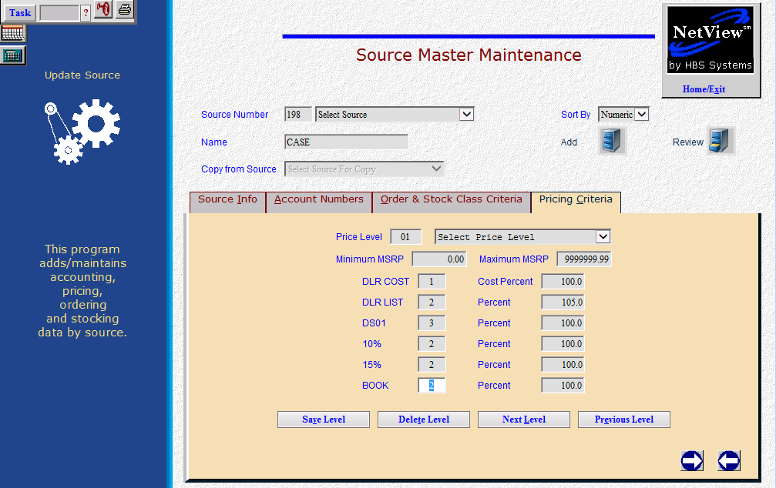

Here are some examples to help you decide how to use the price levels of the parts sources in the best ways:

Parts with List and Cost: These parts can use the price levels as they currently are. They have both the Mfr List and Mfr Cost fields, and do not have any DS01 (direct ship) pricing. This example will work for parts with list and cost.

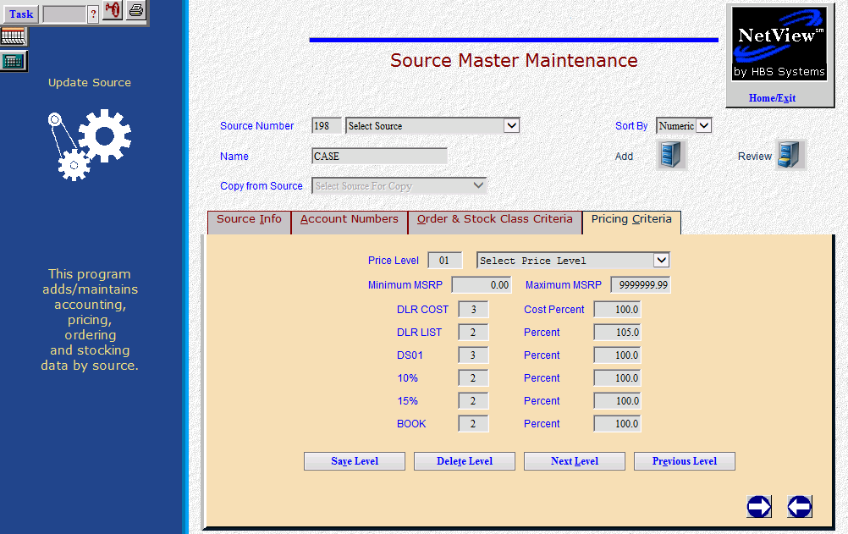

Parts with List and DS01: This group of parts has ONLY the Mfr List and DS01 pricing, and indicates that these items can only be ordered as direct ship. In this case, the DS01 value indicates your cost for these items. Parts with this characteristic are probably best handled if they are moved to separate source. Since there is no traditional cost for these parts, they should use the provided DS01 price as the cost. Failure to recognize a cost for these parts will potentially result in sales with no cost, orders without a cost, and inventory values/reporting with understated values. A special utility is available to help you move the parts with List and DS01 pricing only to a new parts source. This example will work for parts with list and DS01 cost only.

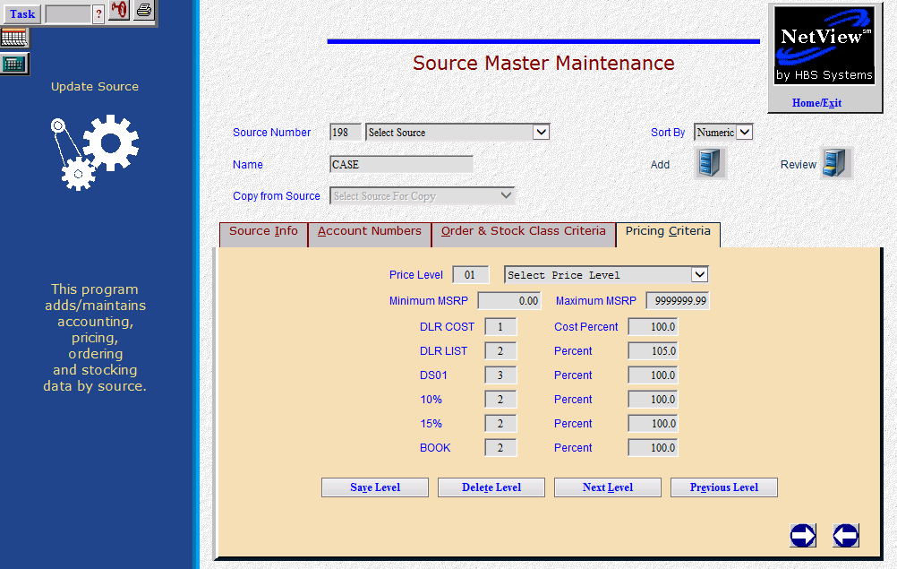

Parts with List, Cost, and DS01. This group of parts has an Mfr List, Mfr Cost, AND DS01 pricing, which means they can be ordered as “regular” parts as well as direct ship items. These could default their “cost” value to your choice of the original cost or the DS01 cost. If you decide to have the cost for these parts point to the original or Mfr cost, then they could remain in their current Part Source. This example would work for parts with List, Cost, AND DS01 pricing, and you decided to use the original cost for the cost value.

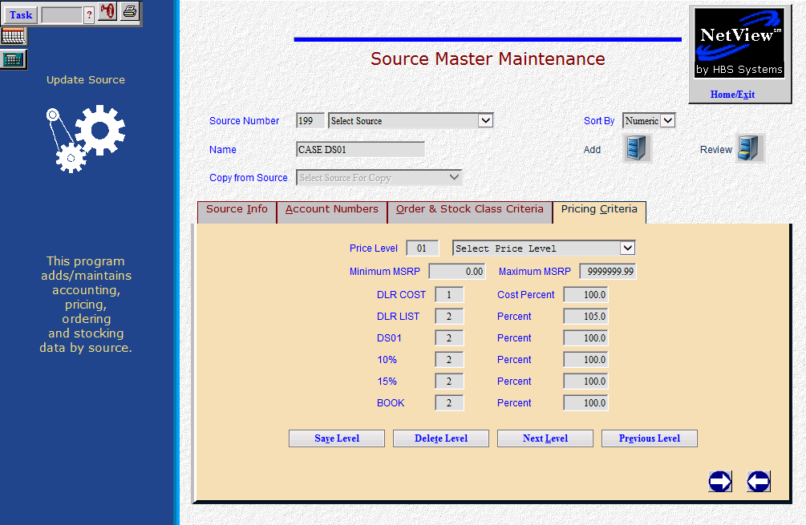

If you decide to have the cost for these parts point to the DS01 cost, then they should be moved to another Parts Source with a price levels like the above example. This example would work for parts with List, Cost, AND DS01 pricing, and you decided to use the DS01 cost for the cost value.

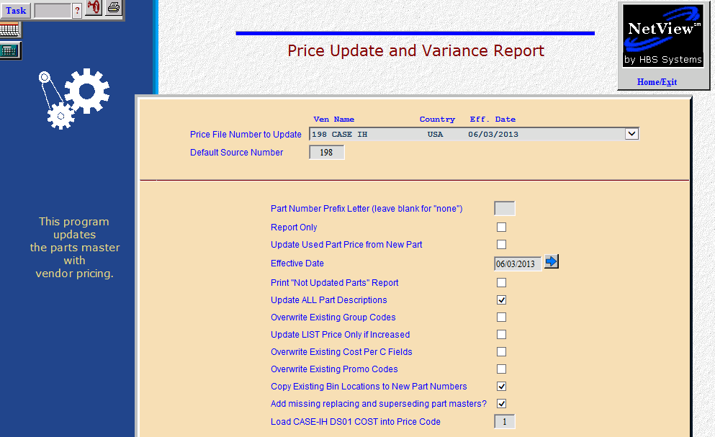

DS01 Pricing and Price Update and Variance Reports: When you run Price Update and Variance (PUV) after loading the Case Price File, you will notice a new question on the screen. This question asks about your choice of price codes for the DSO1 cost.

Load Case DS01 COST into PR CODE (1-6): This field asks where to load DS01 figures in your parts masters affected by this price file. Enter the Price Code (1-6) where you have chosen to identify DS01 cost. The first time you run this program, you must select the price code you defined in IPOS (POS defaults) and coded in your Parts Source price levels. When you load Case price files in the future, it will pre-fill with the Price Code you previously chose.

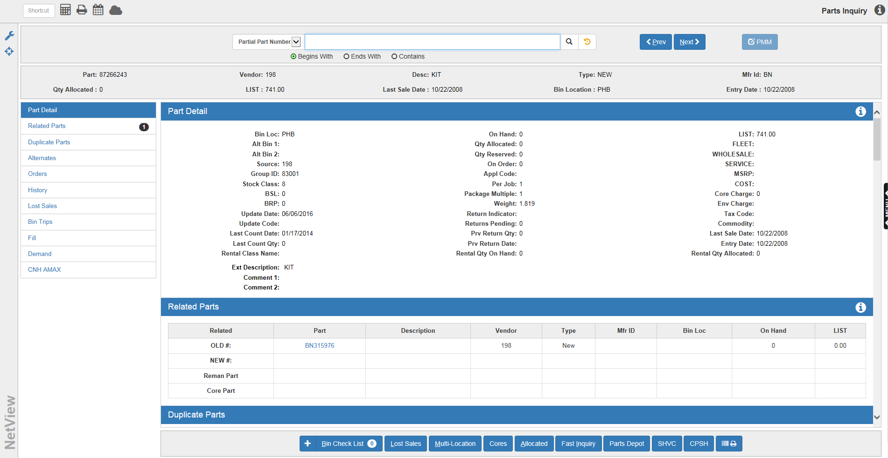

Parts Inquiry: The Parts Inquiry (PI) and POS Invoicing (POS) programs handle Case core part numbers. Some of the capabilities include:

- View multiple cores in Parts Inquiry.
- Distinguish between REMAN and CORE part numbers in Parts Inquiry and POS.
- Select the desired core from a pop-up window in POS.
- Select a REMAN number if a new part number is entered on the picking ticket.

The Mfr ID is available for the Case part numbers. This three-character identification is supplied from the price file.

To access Parts Inquiry, type either “PI” or Hotkey “I” in the Shortcuts Bar.

Related Parts: If the part number you enter or select has old and new part numbers, core and remanufactured part numbers, or alternate numbers, the Related tab will be highlighted.

Core parts may be added to inventory through the Parts Inquiry screen.

- If you type the core number in as a part number, the message “Part not found. Search manufacturer price file for Vendor: 198” is displayed.
- Click the vendor number to have the screen display the price file information for the part.
- Click on the button to add the core part to inventory.
- You’ll see the message “Part xxxxxxxxxxxx added,” and the system will access Custom Parts Maintenance (CPM) to let you add or change the part number information.

Core parts may also be added to inventory by one of the following methods:

- Manufacturer Price File Inquiry (PFI, Hotkey F)
- Custom Parts Maintenance (CPM, Hotkey E)
- In POS when selecting the core part for the original part number entry.

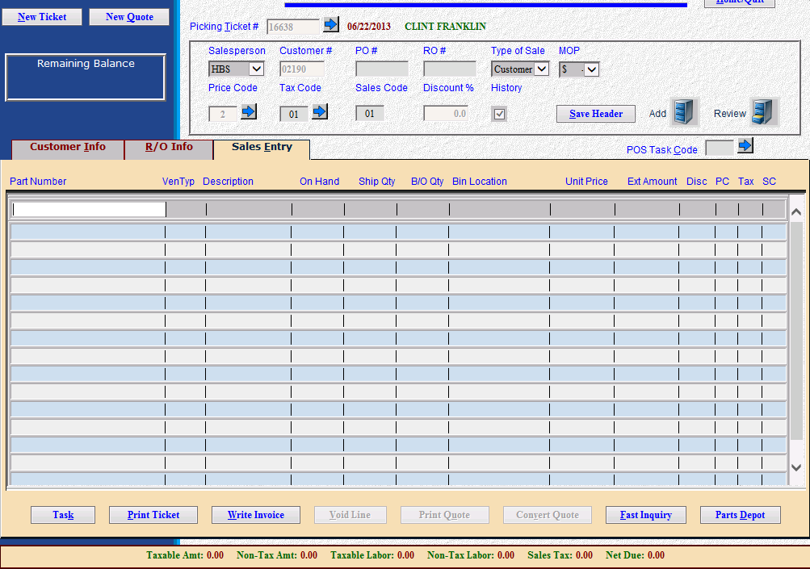

POS Invoicing: To open the program, type either “POS” or Hotkey “P” in the Shortcuts Bar.

If the customer is purchasing a Case part with a core, type the original Case part number that you are selling on the picking ticket screen and the sales quantity in the ship field. The system automatically tells you what the core charge is and includes this charge on the picking ticket. You are then asked for the quantity of cores being returned. Enter “1” or more depending on what is being returned and the customer will receive that amount of credit against the purchase of the original part number.

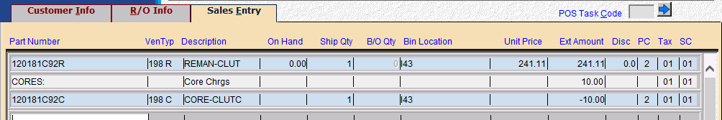

If you enter “0” here, the core charge shown will be added to the amount the customer owes.

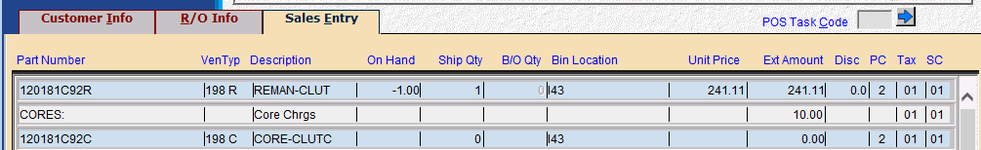

If there is a single core number associated with the part, that number is added to your invoice. When you enter the quantity and there are multiple cores present, the system will search for the cores and their charges, and provide a list. Select the one that applies in this case and it will be used to credit the customer.

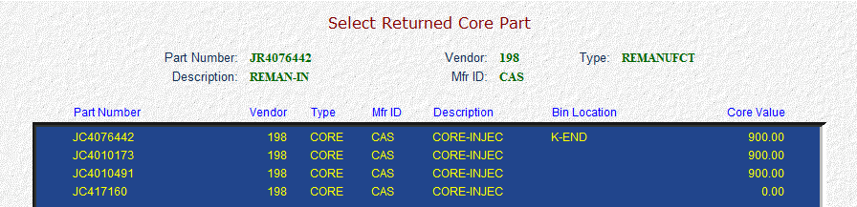

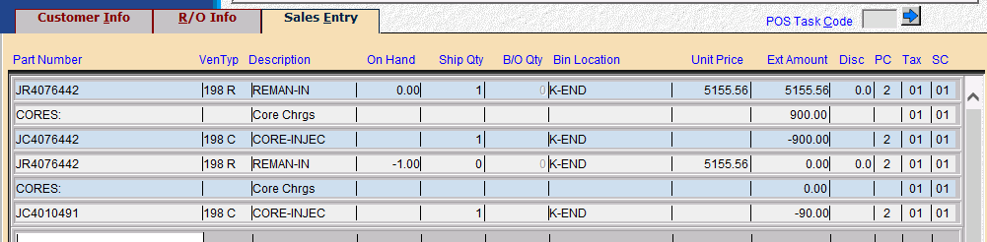

If the customer is returning multiple cores associated with the part being purchased, process the first one and then enter the original part number again on a sale line. This time, be sure to enter a ship quantity of “0” and then enter the number of cores being returned. Choose the next core number being returned and that credit will be added to the invoice.

Voiding Parts with Core Entries: You can void sale lines in POS with core numbers the same way you void regular parts lines. However you can only void the original part number lines. When you void that line, it voids the core charge line too.

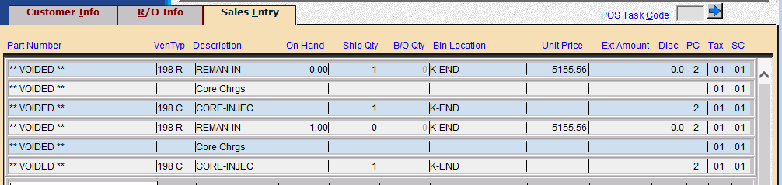

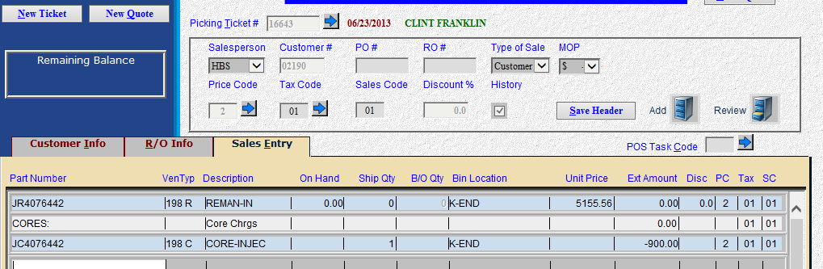

Handling Cores Returns at a later time: If the customer brings in the core later for credit, type the original part number on a sale line in POS and put “0” in the ship field. Then show the number of cores returned and select from the list of cores shown, if any. This creates a credit invoice to refund the core charge to the customer.

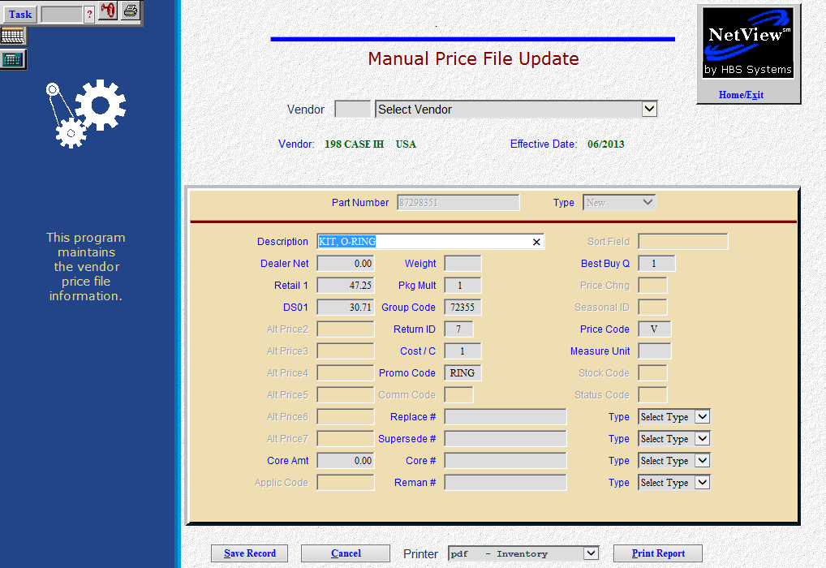

Manual Price File Updates: Manual Price File Updates (MPFU) lets you change the price file information for any Case part number. This program can be used to update the information on the price file itself, and ultimately the parts in inventory when it is followed up with Price Update and Variance. You can see the DS01 cost included with the information above.

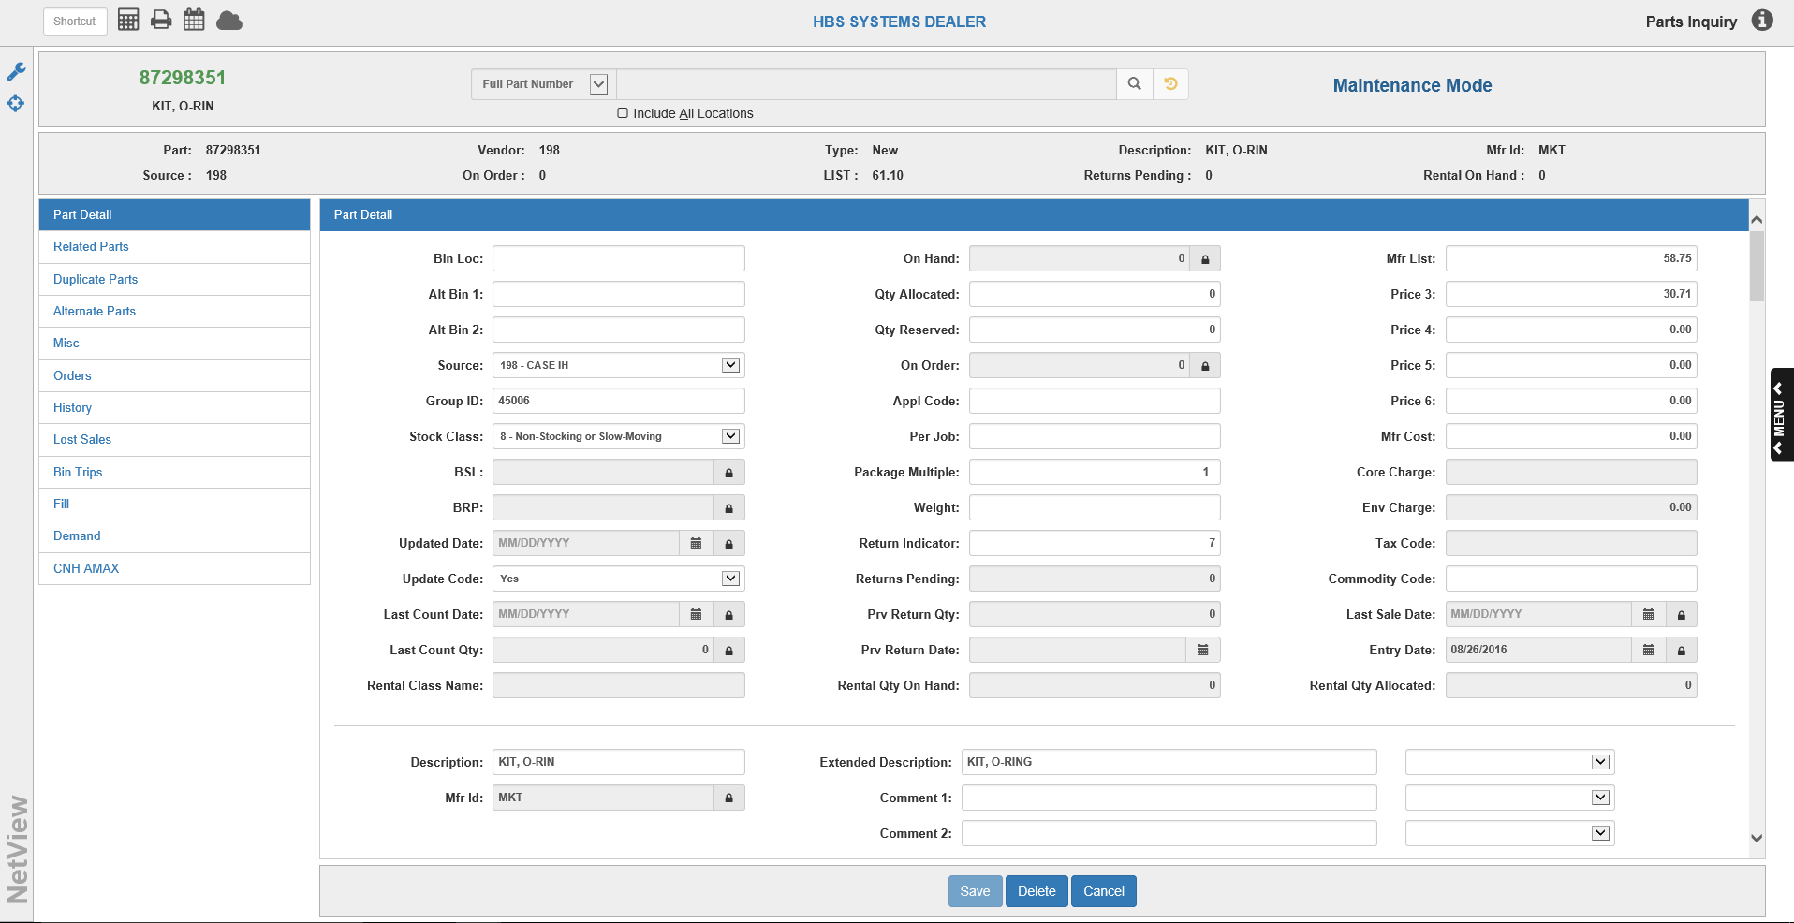

DS01 Pricing in the Part Master: When you have updated your inventory with the latest NH price file, the DS01 value will show in the part master for the price code you selected in Price Update and Variance. The example above shows a DS01 value in price code 3.

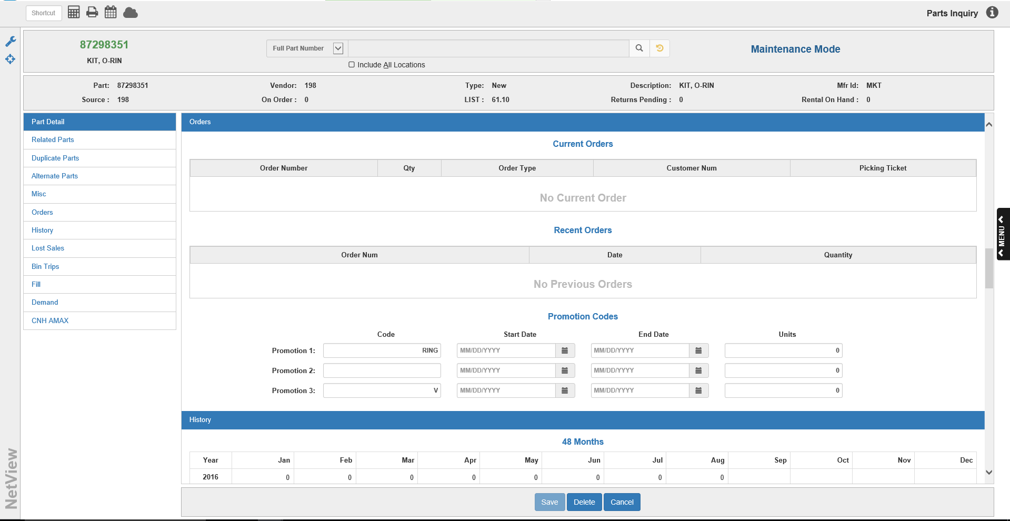

The PMC (parts marketing code) appears in the Promo 3 field (V in the example above).

Using Custom Prompts (INCP): When you add or change parts, it would be wise to have a field included your series of custom prompts that identifies if the part has DS01 pricing. Use INCP to make changes in your custom prompts for parts. Be sure to change the settings for both NEW parts and Parts added from Inquiry.

You should add Promo#3 on the second page of prompts. This field holds the PMC (Parts Marketing Code for each Case part.

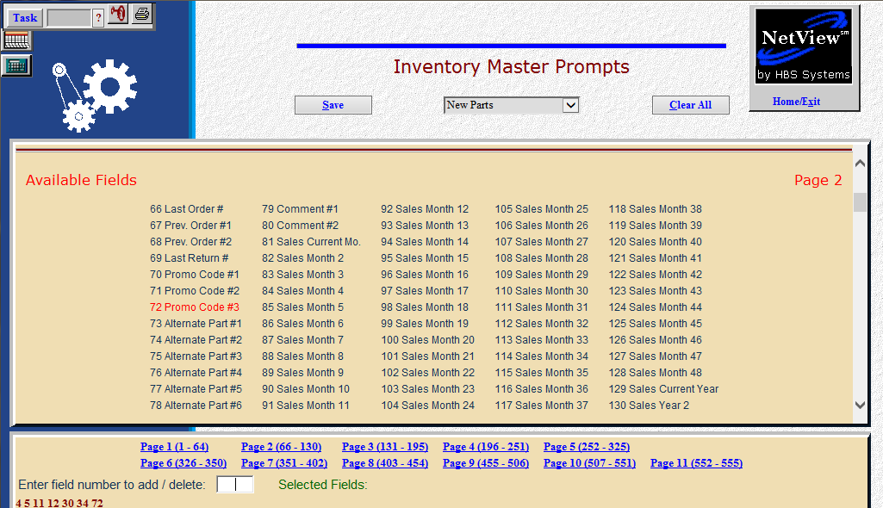

Stock Order Selections

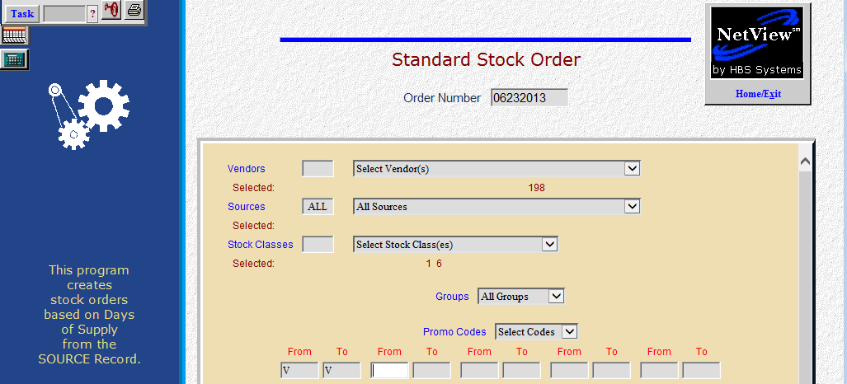

One of the fields carried in from the Case price file is the PMC (parts market code). This code (S, V, or B) has been placed in the Promo 3 field on the orders & returns tab of the parts master. The PMC can be used in the parts ordering process as one of the selection criteria. With a Standard Stock Order (SSO), it can be selected as a promo code (V in the above screen) and used to look at only those parts with that code.

It can also be used in the same way for a Custom Stock Order (CSO) as shown below:

