Price File Inquiry (PFI)

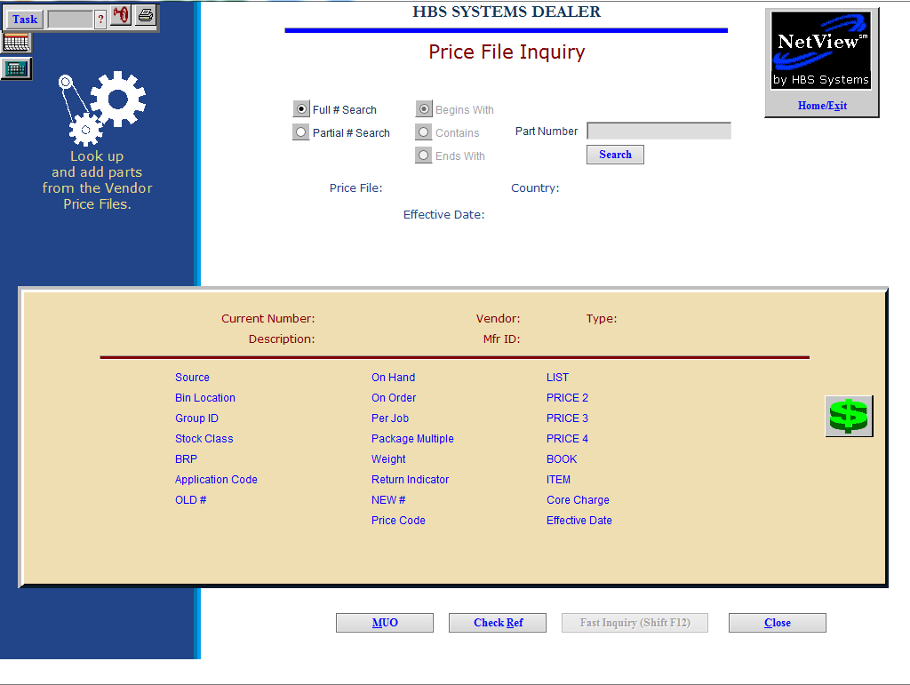

Price File Inquiry (PFI) allows you to look up and add parts from the Vendor Price Files to your inventory.

To access this feature, you can either:

- Select “Inventory” from the menu and choose the “Price Files” submenu. Click on “Price File Inquiry.”
- Type “PFI” in the Shortcuts Bar.

Search Options:

Full # Search: If you know the full part number you are looking for, select this option.

Partial # Search: If you only know part of number, select this option.

Begins With: If you know the beginning characters of the number, select this option.

Contains: If you only know that the number contains certain characters, select this option.

Ends With: If you know the ending characters of the number, select this option.

Part Number: Type the full or partial part number in this field.

Search: Click “Search” to look up which price files contain that full or partial part number. The relevant files will display in a new window.

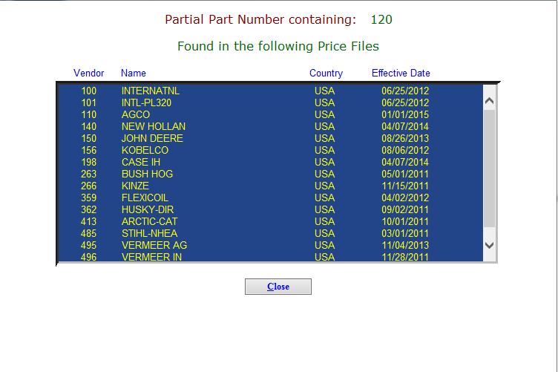

Click on a price file to view the list of relevant parts. Find your desired part number and click it to open the part’s entry in the price file.

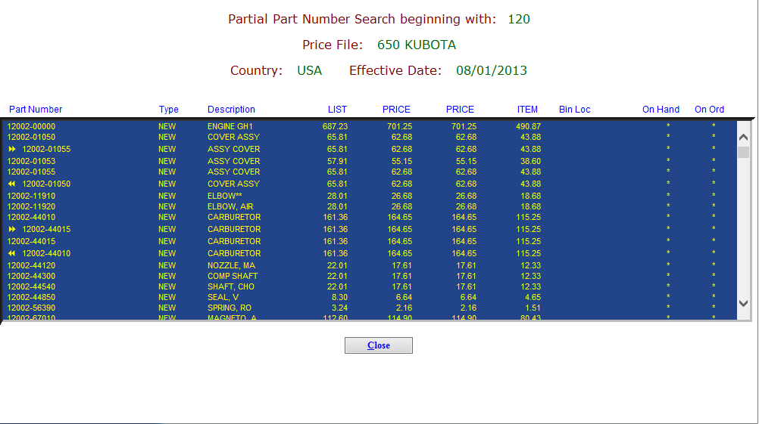

Related Parts: If a part number has a related part, that number will display below it on the list, along with either a double left arrow or a double right arrow .

- If the arrows are pointing left, than the other part number is superseded by the number it is listed below.
- If the arrows are pointing right, then the other part number replaces the number it is listed below.

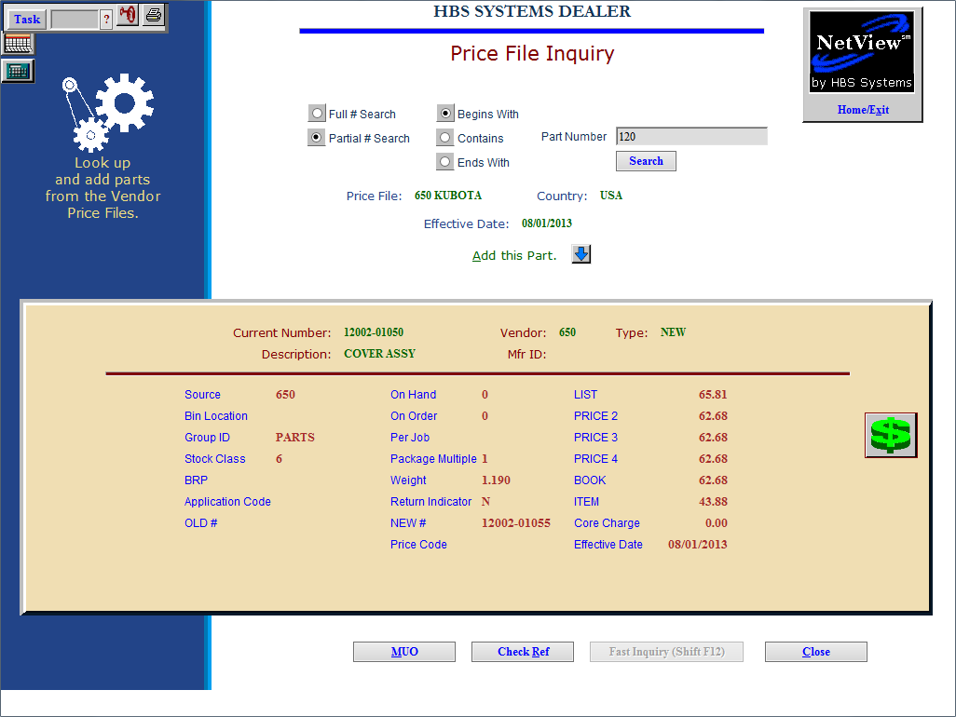

Field Definitions:

Price File: This field shows the name of the vendor price file where the part is located.

Country: This field shows the country where the vendor is located.

Effective Date: This field holds the date that the price file was last updated.

Current Number: This field shows the part number.

Description: This field shows a description of the part.

Vendor: This field shows the vendor number.

Mfr ID: This field shows the manufacturer ID.

Type: This field shows the part’s type, which could be one of the following:

- New
- Used
- Remanufactured
- Core
- Memo

Source: This field shows the part’s source number.

Bin Location: This field shows the part’s bin location, if applicable.

Group ID: This field shows the part’s Group ID from the price file, if one exists.

Stock Class: This field shows the part’s stock class.

BRP: This field shows the part’s Best Restocking Point, if known.

Application Code: This field shows the part’s Application Code, if applicable. This is used primarily for New Holland and Ford Motor dealers to specify sorting preferences, as it contains the Base Number of all the old Ford part numbers.

OLD #: If this part number replaces another, the old part number shows in this field.

On Hand: This field shows the part’s on-hand quantity.

On Order: This field shows the part’s on-order quantity.

Per Job: This field shows the part’s per job quantity.

Package Multiple: This field shows the part’s package multiple, if one exists.

Weight: This field shows the part’s weight.

Return Indicator: This field shows the return indicator code(s), which indicates whether or not this part is accepted as a return, as well as possibly more detailed information like how long it may be returnable, obsolescence, etc.

NEW #: If this part number is superseded by another part number, the new part number shows here.

Price Code: This field shows the part’s price code, if applicable.

LIST/PRICE 2-4/BOOK/ITEM: These fields show the pricing for the part, as defined in POS.

Core Charge: This field shows any core charges associated with this part.

Effective Date: This field holds the date that the part’s entry in the price file was last updated.

Buttons:

Add this Part: Click this button to add the part to your inventory via Custom Part Maintenance (CPM).

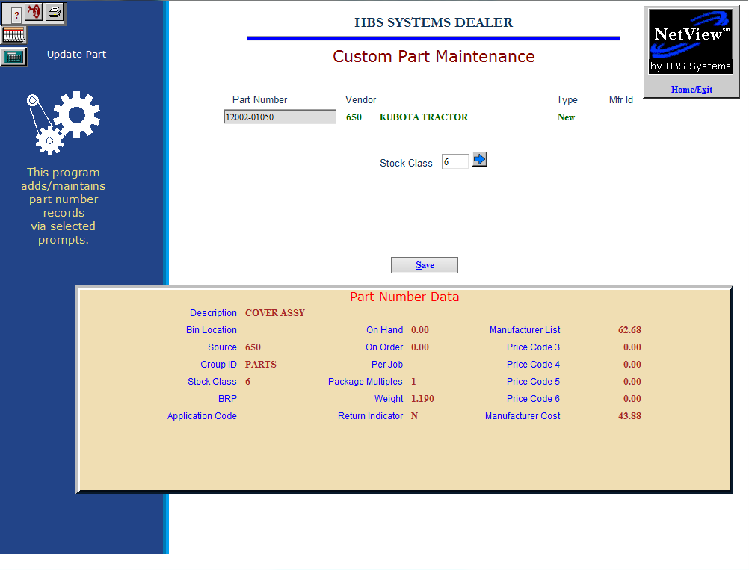

After you add the part, its entry in PFI will now display the message “Part in Inventory” in place of this button.

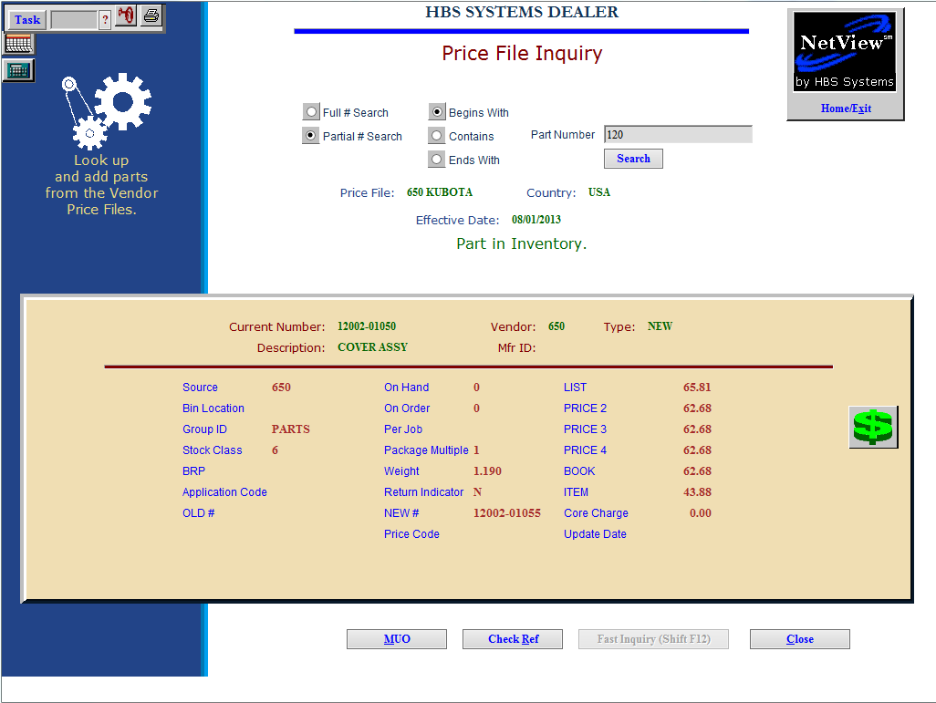

% Profit: Click the green dollar sign to the right of the screen to view the percent profit made when the part is sold at each of the prices listed in the file entry.

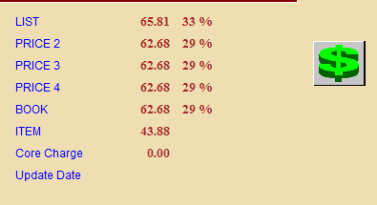

MUO: Click this button to view a list of machines this part is used on. You can print this list by selecting a printer from the drop-down menu at the bottom of the screen and clicking Print List.

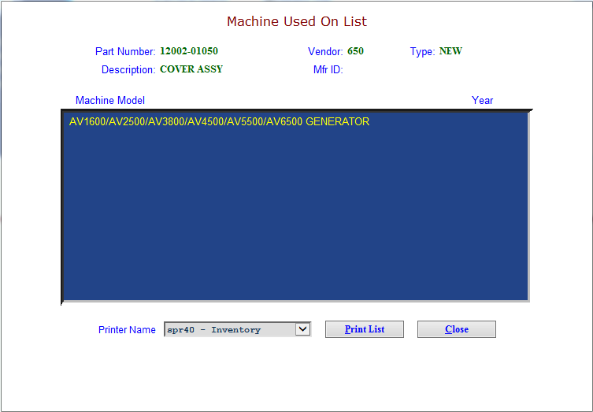

Check Ref: This button is no longer used.

Fast Inquiry: This feature is available only to Kubota and CNH dealers (the button will be greyed out for all other dealers). The button provides quick access to further information on Kubota and CNH parts straight from the manufacturers, depending on the part entry you’re viewing.

Clicking this button when viewing a Kubota part opens the Kubota Fast Inquiry feature, which allows you to quickly search the part’s informaiton and availability by warehouse and dealer (depending on whether you select Parts Inquiry or Dealer Inventory).
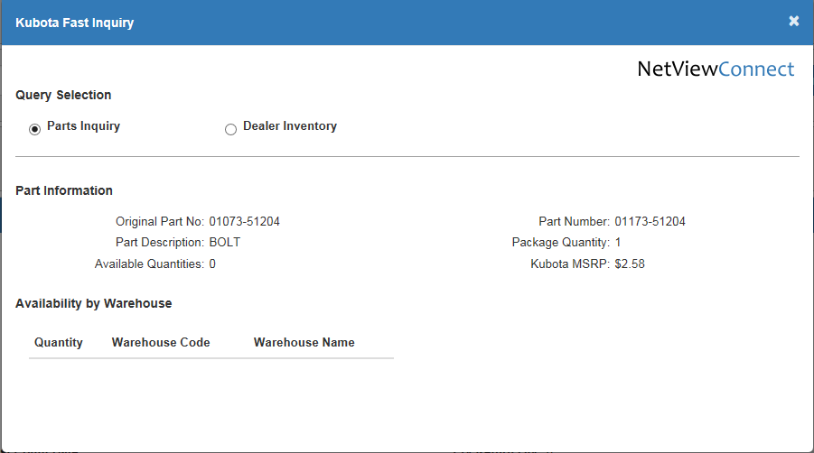

Clicking this button when viewing a CNH part opens the CNH Fast Inquiry, which gives you access to further information on the part from CNH Connect (CSPS). You can see this information by clicking the hyperlinked items in the display grid.

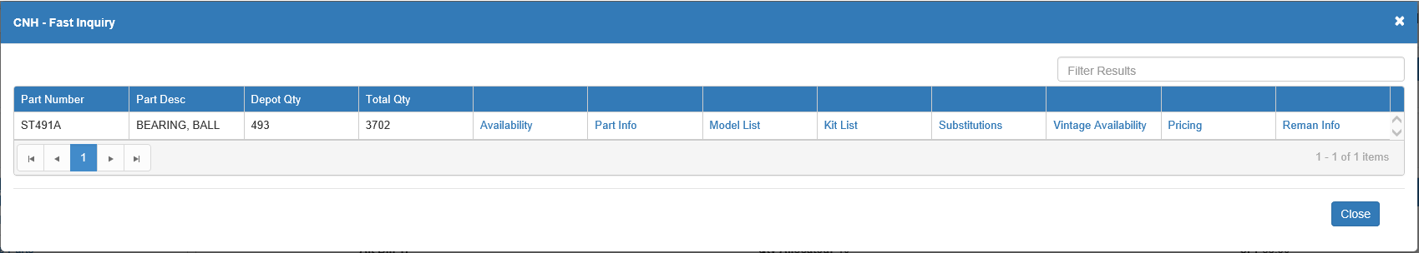

Close: Click this button to close the application.

