POS History Customer Reprint (PHCR)

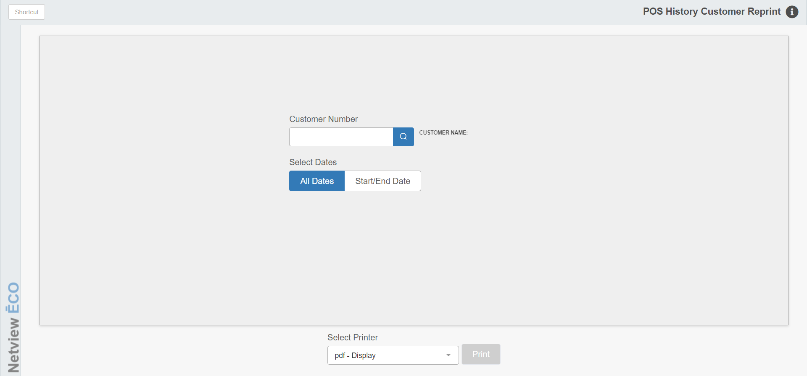

This report is useful in tracking sales activity of a specific customer. It reprints all of the POS invoices from history for the customer and date range selected.

To access the POS History Customer Reprint Report, you can either:

- Select “Inventory” from the menu. Choose the “POS History” submenu and click “POS History Customer Reprint.”
- Type “PHCR” into the Shortcuts Bar.

Field Definitions

Customer Number: Type in the customer number or look it up.

Select Dates:

- Choose All Dates to reprint ALL invoices in POS history for the customer.
- Choose Enter Start/End Dates to specify a date range of invoices to reprint.

Select Printer: Select the printer to receive the printout. A default printer name is pre-filled but can be changed as necessary. Use the pdf printer to view the report on the screen without printing a copy of it.

Print Report: Press this button to print the customer’s invoices.

