Parts Inquiry (PI)

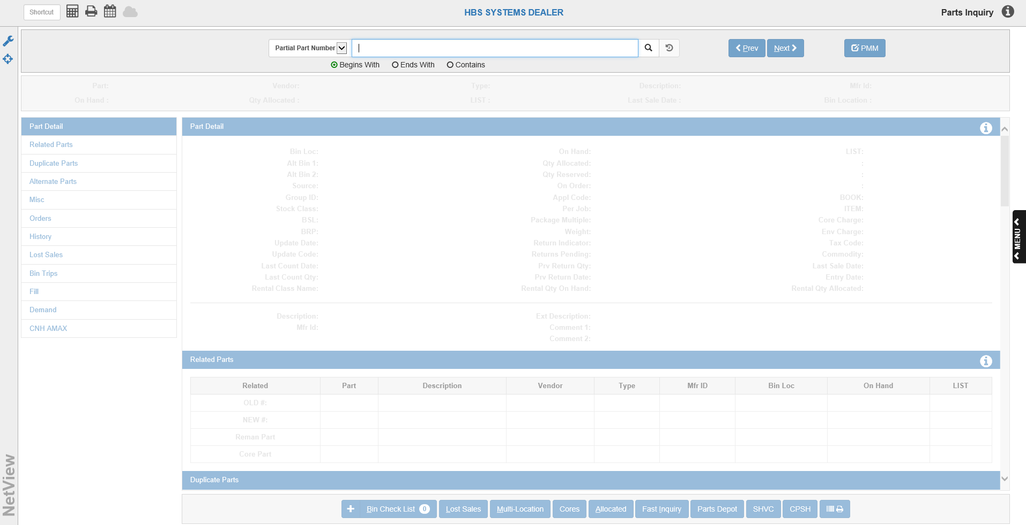

Parts Inquiry (PI) allows you to look up part numbers to view information about the part in question.

To access this feature, you can either:

- Select “Inventory” from the menu and click “Parts Inquiry.”
- Type “PI” in the Shortcuts Bar.

Search Options

Partial Part Number
If you don’t know the full part number, choose this search option from the drop-down menu to search for the part using only a part of the number.

- Begins With: Click this circle to search for a part by the first characters of its part number.
- Ends With: Click this circle to search for the part by the ending characters of its part number.
- Contains: Click this circle to search for the part by any characters contained in the part number.

Full Part Number: Choose this search option from the drop-down menu to search for the part by entering the full part number.

- Include All Locations: Check this box to search for the full part number in all dealer locations.

Description: Choose this search option from the drop-down menu to search for the part by its description.

- Begins With: Click this circle to search for a part by the first characters of its part number.
- Ends With: Click this circle to search for the part by the ending characters of its part number.
- Contains: Click this circle to search for the part by any characters contained in the part number.
- Include Extended Description: Check this box to search using the extended description.

Alias: Choose this search option from the drop-down menu to search for the part by its alias.

Search Field: Type your chosen search criteria in this field.

Search: Click this button 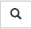 to begin the search. The results will appear in a separate window.

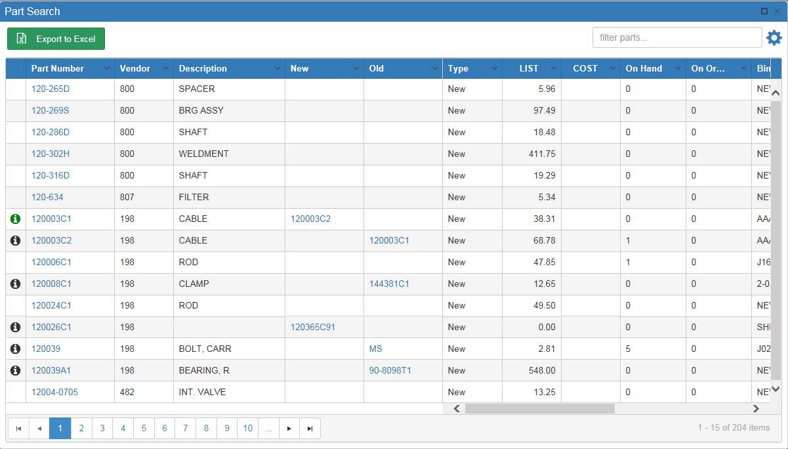

Locate the part you want and click on it to open the record.

Sort Features: Use the sort features to locate your desired part.

- Page Numbers: Use the page numbers at the bottom of the window to jump between pages.
- Sortable Headers: Click on the arrow on the right side of the column headers to view further sort options.

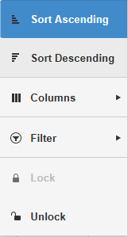

- Sort Ascending: Click this option to sort the results in ascending order by the column’s content. For example, if you click “Sort Ascending” under the Part Numbers header, then the results will sort in ascending order by Part Number. You can also perform this sort by clicking the column header once.
- Sort Descending: Click this option to sort the results in descending order by the column’s content. For example, if you click “Sort Descending” under the Part Numbers header, then the results will sort in descending order by Part Number. You can also perform this sort by clicking the column header—twice from when the search window first opens or if the results have been sorted by a different column, once if the results are already sorted in ascending order by that column’s content.
- Columns: Use this checklist to determine which columns you want to view. Unchecking a box will automatically remove the column from the results grid, while checking one will automatically add the column.
- Filter: This option allows you to filter your search results in greater detail using the data in that specific column. Use the drop-down menus to set how you want the results to filter.
- Unlock/Lock:
  - Clicking Unlock allows you to switch the column’s position in the grid order.
  - Clicking Lock fixes the column in its location.
- Filter Bar: Use the Filter Bar in the upper right-hand corner to further narrow down the results. Type in further search criteria and the results will update to reflect it.

Related Parts: The far-left column of the results grid will sometimes contain the following icon 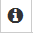. Hovering the mouse over the icon will reveal the Related Parts grid, which displays all part numbers related to this one. Clicking the part number in this display will automatically open the related part’s record.

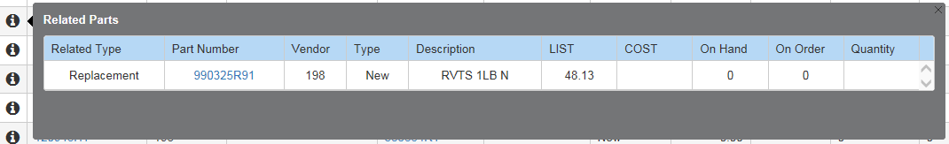

The Related Type column shows the relation between the two part numbers. In the example above, this part number is a replacement for a previous number. If the icon is green 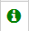, then the other part number has an available on-hand quantity.

Export to Excel: Click this button to export the search results into Microsoft Excel.

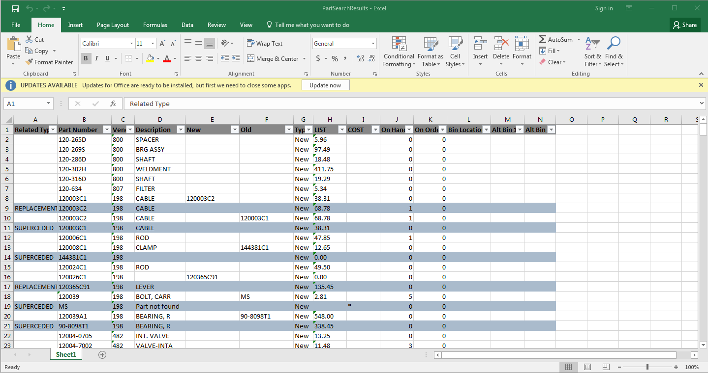

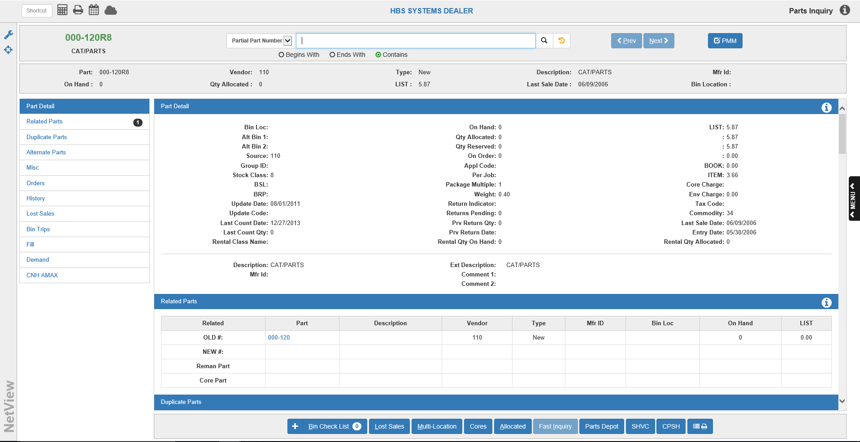

Search Recall: This button  appears next to the Search button. After you have made a search and selected a part, the button will turn gold . Clicking it will re-open the search window and display the results of your last search, allowing you to pick up exactly where you left off before selecting a record.

Base Part Info-Field Definitions: Be aware that most fields displayed in this section can be removed or added as desired. This section will cover the fields displayed in the above example. See “Focus Base Part Info” below for the other fields that can display here.

Part: This shows the part number of the record currently displayed. This field will always show for each part record.

Vendor: This shows the vendor number associated with the part. This field will always show for each part record.

Type: This shows the part’s type (New, Old, Used, etc.). This field will always show for each part record.

Description: This shows the part’s description. This field will always show for each part record.

Mfr ID: This field shows the manufacturer ID, if any. This field will always show for each part record.

On Hand: This field shows the part’s on-hand quantity.

Qty Allocated: This field shows the quantity of this Part Master that has been placed on open picking tickets (in POS and ROM). Parts that have been assigned to a picking ticket or repair order reduce the ON HAND field. When the picking ticket becomes an invoice, the quantity shown in the Qty Allocated field is relieved. The Parts Inquiry screen also displays this information.

LIST: This field shows the part’s List price, as defined in POS.

Last Sale Date: The Last Sales Date is the date of the last sale of this part. This system-maintained field is updated each time a part is sold on a POS or ROM invoice.

Bin Location: This field shows the part’s bin location.

Other Buttons:

Next: Click this button to move to the next part number record.

Previous: Click this button to return to the previous record you were looking at.

PMM: Click this button to edit the part data. See “Parts Master Maintenance (PMM)” for more information.

Save Configuration/Restore Search: Click this icon  to access the option to either save the current search configuration or reset the search to its default settings.

Focus Base Part Info: Click this icon to select what information is displayed in the Base Part Info section.

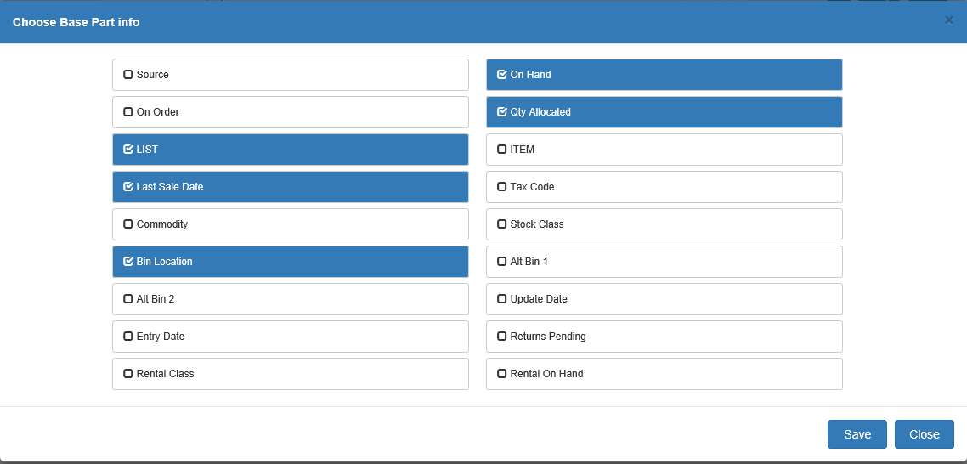

Aside from the default fields higlighted here, you can also have the following information display in the Base Part Info section:

Source: This field shows the part’s source number.

On Order: This field shows the quantity of outstanding orders (regular and back order) for this part. It is a total of ALL orders on the system, and is updated each time a new order is created, changed, or receipted. All updates to this field are processed through the ordering programs, as well as the POS and ROM Invoicing back order function.

COST: This field shows the part’s Cost, as defined in POS.

Tax Code: This field shows the part’s tax code, which locks in the part’s taxable status.

Commodty: The Manufacturer Price File updates this field when PUV is run. It contains the special pricing codes or commodity codes that the vendor has set up for ordering purposes (i.e., codes that determine grouping, pricing, discounts, and bulk ordering). The Standard Stock Order (SSO) and Custom Stock Order (CSO) both offer the ability to create orders based on these codes.

Stock Class: This field shows the part’s Stock Class.

Alt Bin 1 & 2: These fields indicate the overflow areas where parts can be stored. These fields can be up to 12 characters.

Update Date: This field is updated by Price Update and Variance (PUV) and records the effective date of the last price file installed on your system.

Entry Date: The Entry Date is the date this part was added to system. It is used for comparison purposes for inventory obsolescence.

Returns Pending: This field shows any returns pending for this part.

Rental Class: If Rental is installed and this part is a rental part, this field shows the name of the part’s Rental class.

Rental On Hand: If Rental is installed, this field shows the amount of the part available on hand for rental.

Save: Click this button to save the new Base Part Info section.

Close: Click this button to close the window.

Bin Check List: Click this button to view the Bin Check List, which is a record of parts that you wish to check that you have in inventory. The number counter display in white on the button shows how many counts of that particular part have been added to the list.

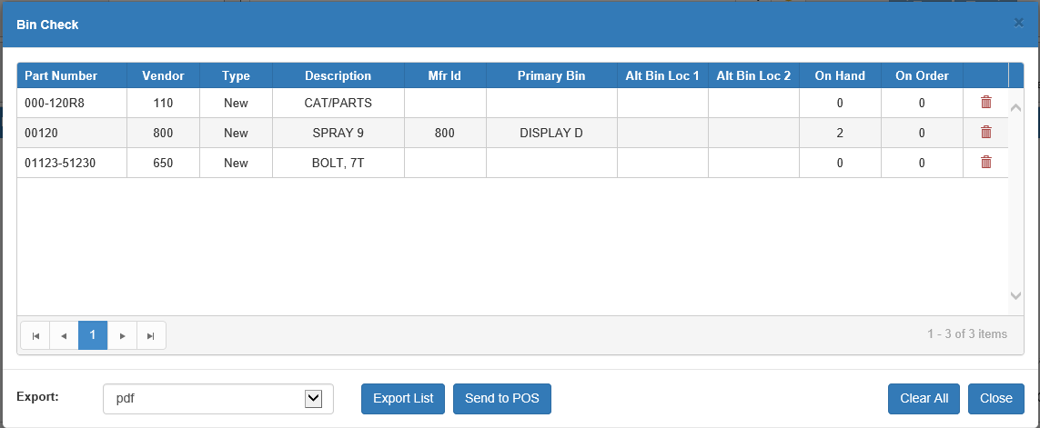

Export List: This button allows you to export the list from NetView as a separate file. Choose the file type (pdf, Excel, etc.) from the Export drop-down menu, then click the button to create the file.

Send to POS: Click this button to send the Bin Check List to Point of Sale (POS). You can then use Line Entry Task EPC in POS to add the full list to a picking ticket, with the parts not on hand automatically backordered. For more information, see the “Sales Entry Tab” section of the POS documentation.

Clear All: Click this button to clear all parts from the list.

Close: Click this button to close the list window.

Add to Bin Check: Click the plus sign (+) icon to the left of the Bin Check List button to add one count of this part to the Bin Check List. Click the button as many times as necessary to add the number of parts you are looking for.

Lost Sales: To add to the Lost Sales Quantity, click this button.

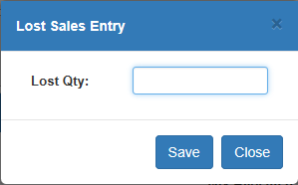

Enter the quantity and click “Save.” The amount will add to the current month and year quantities in the Lost Sales tab (see that section for more information).

Multi-Location: Click this button to look-up all the locations in the system to see which ones carry the part.

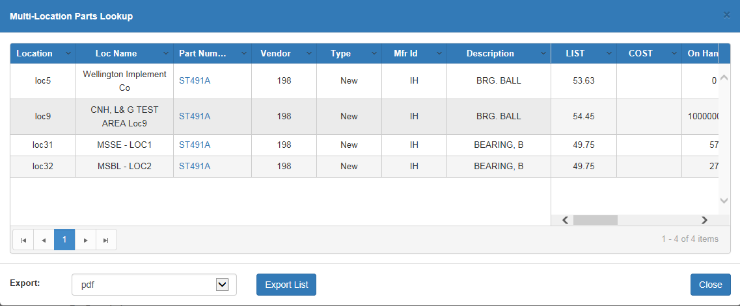

Cores: If the part is a core or related to a core, click this button to view information about it and its charges.

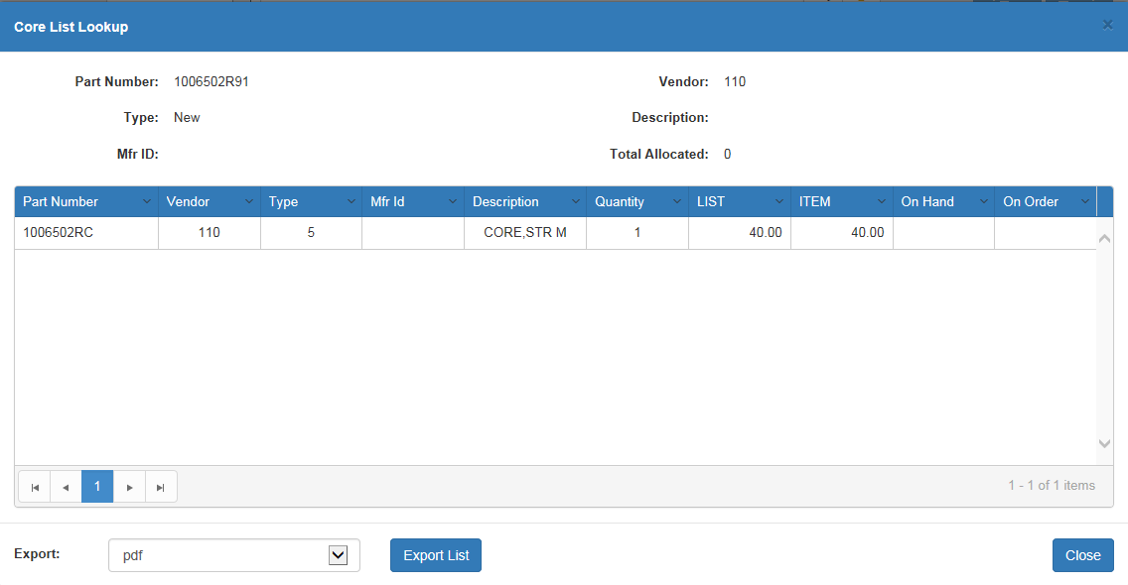

Allocated: If the part has a quanity allocated on an open picking ticket or repair order, click this button to view a list of the related tickets/ROs.

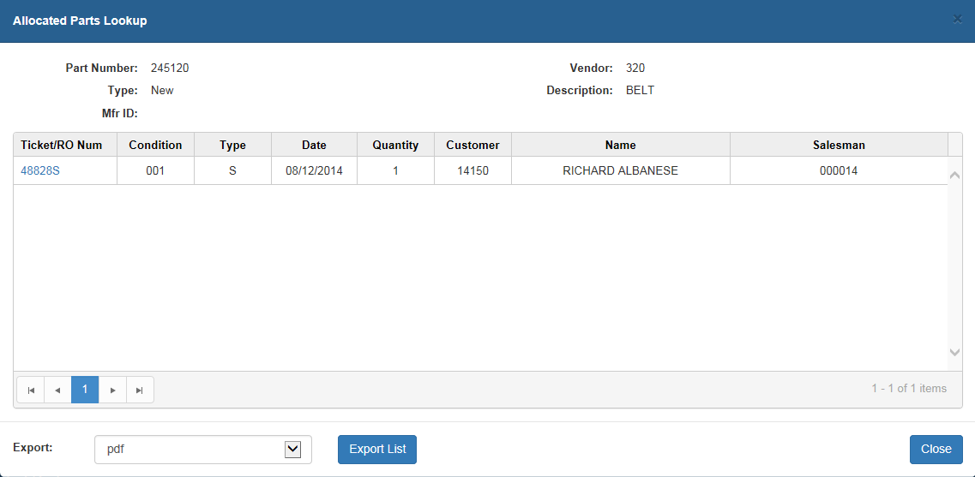

Fast Inquiry: This feature is available only to Kubota and CNH dealers (the button will be greyed out for all other dealers). The button provides quick access to further information on Kubota and CNH parts straight from the manufacturers, depending on the part entry you’re viewing.

Clicking this button when viewing a Kubota part opens the Kubota Fast Inquiry feature, which allows you to quickly search the part’s informaiton and availability by warehouse and dealer (depending on whether you select Parts Inquiry or Dealer Inventory).
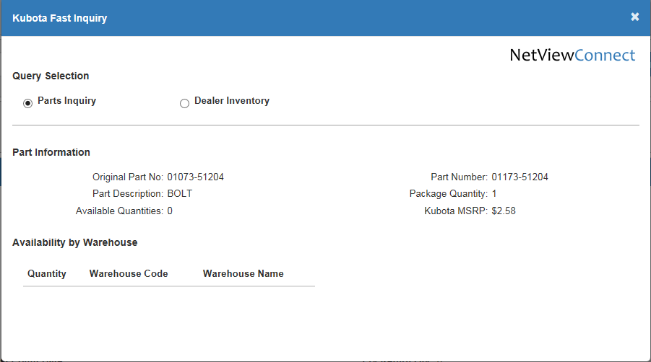

Clicking this button when viewing a CNH part opens the CNH Fast Inquiry, which gives you access to further information on the part from CNH Connect (CSPS). You can see this information by clicking the hyperlinked items in the display grid.

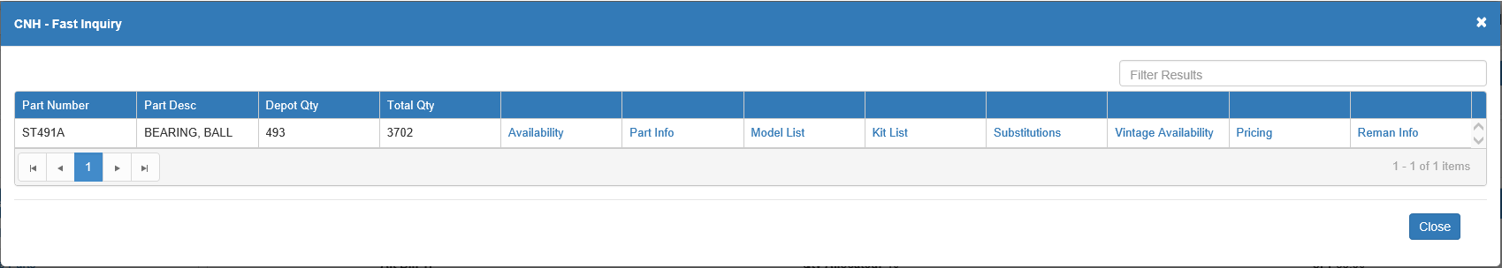

Parts Depot: Click this button to open Parts Depot. This feature lets you search for any available versions of the part stored in the depot.

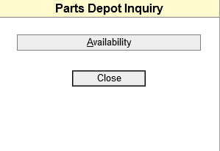

Click the Availability button to receive a report listing all the relevant parts, their locations, and the quantity at that location.

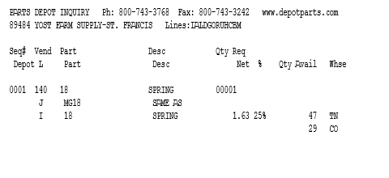

SHVC: Click this button to open the part number’s entry in Sales History Via Customers (SHVC).

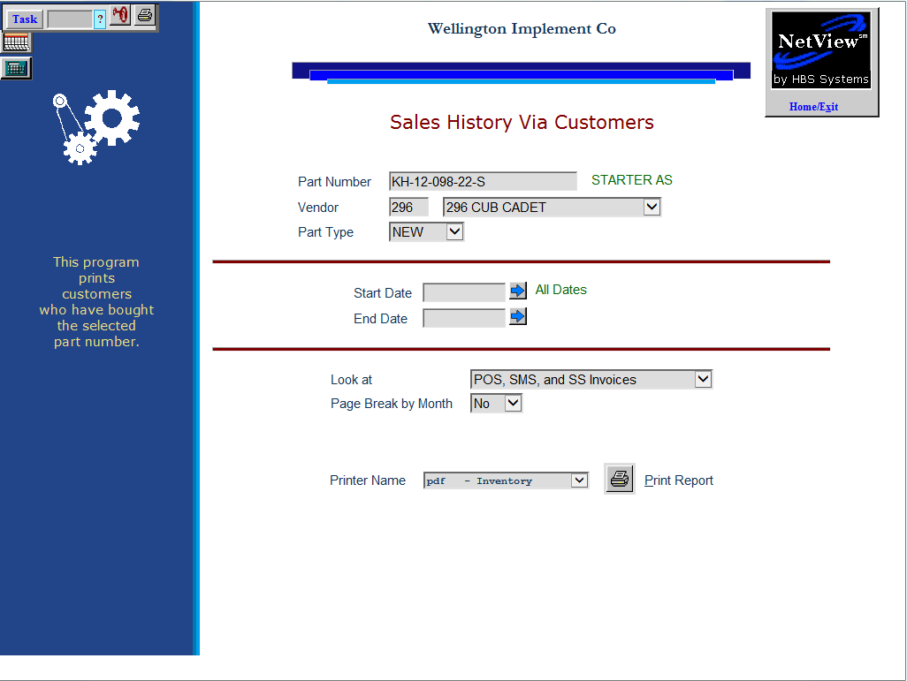

CPSH: Click this button to open the part number’s entry in Customer Parts Sales History (CPSH).

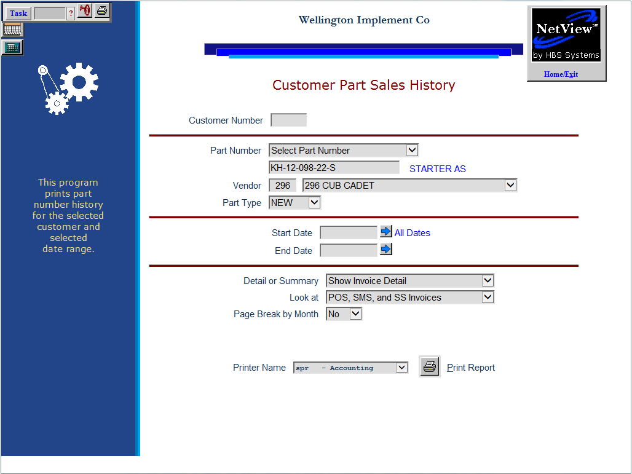

Print Bar Code Label: Click this button  to print a bar code label for the part.

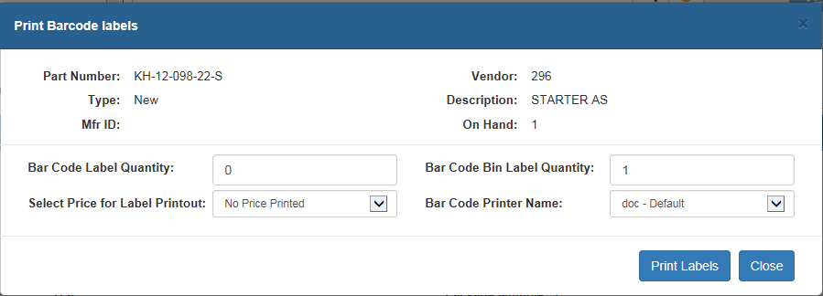

Enter the quantity, price for the label, and the printer name. Click Print Labels when finished.

Sidebar Shortcuts: On the left side of the screen is a list of the different sections that comprise a Part Inquiry entry. Click on any section name to jump to that portion of the entry.

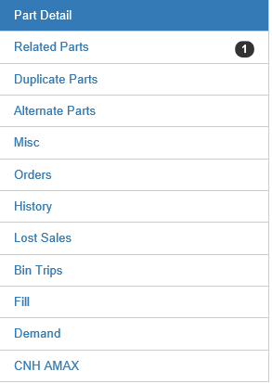

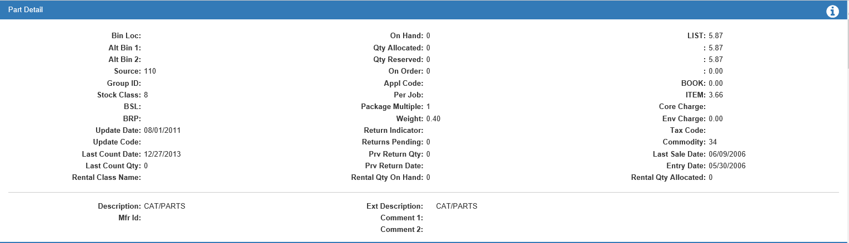

Part Detail—Field Definitions

Bin Location: The Bin Location field shows the primary physical location of the part. The bin location may print on the customer's invoice.

Alt Bin 1 & 2: The Alternate Bin Location 1 and 2 fields show where parts are kept in overflow areas, if applicable.

Source: This field shows the part’s source number. Every Part Master must be tied to a Source Number. The source contains the necessary information to:

- Price the part
- Maintain its stock class
- Determine BSL and BRP for ordering
- Handle the accounting from POS and SMS

Group ID: This field holds the 10-character Group ID Code, if applicable.

Stock Class: This field shows the part’s Stock Class. A Stock Class is the code used to identify the part's stocking status (i.e. fast-moving or non-stocking).

BSL: The Standard Stock Order (SSO) maintains the calculated Best Stocking Level (BSL) for the part. The Parts Source holds the number of days supply to keep adequate stock quantities on hand (i.e., 30, 45, 60 or 90 days). When the Standard Stock Order is run, the part’s sales history is reviewed and calculated against the Source’s criteria. The result is the part’s BSL quantity needed for the time period selected in the Source. The Multi-Store Standard Stock Order program also uses this field.

BRP: The Standard Stock Order (SSO) also calculates and maintains the Best Reorder Point (BRP) for the part. In the Parts Source, the BRP field holds the number of days’ supply the stock on hand should decrease to before an order is triggered. When running the Standard Stock Order, the system reviews and calculates the on hand quantity. When this quantity drops to the BRP, the Standard Stock Order reorders enough stock to replenish to the calculated BSL. The Multi-Store Standard Stock Order Program (MSSO) also uses this field.

Update Date: This field is updated by Price Update and Variance (PUV) and records the effective date of the last price file installed on your system.

TIP – Keeping Track of “Frozen” or Un-updated Pricing: If you block a part from being updated from the price file, it’s a good idea to use Report Writer to periodically review the manually priced parts.

Update Code: This field indicates if this part number should be affected by a price file update.

- It shows Y if Price Update and Variance (PUV) is set to update the price file information for this Part Master.
- If this part number is not to be updated by the price file when it is loaded, the field will show N. This blocks all updating from a price file.

Last Count Date: This field stores the date of the last physical inventory taken on the system. For instance, if physical inventory was taken in October of last year, this field would show the date the update was run. This can be a very useful field because it gives information about the last time this part was inventoried.

Last Count Qty: This field shows the final physical count (quantity) for this part when it was last updated from the Physical Inventory process.

Rental Class Name: If Rental is installed and this part is a rental part, this field shows the name of the part’s Rental class.

On Hand: This field shows the part’s on-hand quantity.

Qty Allocated: This field shows the quantity of this Part Master that has been placed on open picking tickets (in POS and ROM). Parts that have been assigned to a picking ticket or repair order reduce the ON HAND field. When the picking ticket becomes an invoice, the quantity shown in the Qty Allocated field is relieved. The Parts Inquiry screen also displays this information.

Qty Reserved: This field shows the quantity of the part reserved for your location in a multi-location dealership. Your dealership may want to reserve a certain quantity at all times at their location. When the Inter-Store Parts Transfer (ISPT) program is run, it considers the quantity value in this field before letting on hand quantities move to another location.

On Order: This field shows the quantity of outstanding orders (regular and back order) for this part. It is a total of ALL orders on the system, and is updated each time a new order is created, changed, or receipted. All updates to this field are processed through the ordering programs, as well as the POS and ROM Invoicing back order function.

Appl Code: This field shows the part’s Application Code, if applicable. The Application Code is used primarily for New Holland and Ford Motor dealers to specify sorting preferences. It is often provided from a price file and contains the Base Number of all the old Ford part number. In IPOS, you can specify to Sort Vendors 140 & 237 by APPL CODE. This setting is used to sort the Inventory Master Pad and other inventory/ordering reports. If you are not a New Holland/Ford Motor dealer or do not want to sort by the base number, it can be used as another classification field for parts.

Per Job: This field shows the Per Job Quantity, which represents the quantity of the part needed to complete a shop job. For example, if it takes four bearings each time this part is used, then the PER JOB amount is four. This tells the system to keep the quantity on hand in multiples of four (4). The system’s ordering formulas will consider this and the on hand quantity will be maintained in correct multiples.

Package Multiple: This field shows the Package Multiple quantity. If a vendor always ships two or more of this part number as a package, this field displays the appropriate amount. The quantity on hand and pricing for this part would be kept by piece, but the orders will be by the package quantity. For example, if a Package Multiple is 25, the stock ordering programs will generate an order quantity based on multiples of 25 (i.e., Order Quantity = 25, which is 1 package).

Weight: This field shows the actual weight of a single part. If available, this information is supplied by the Manufacturer’s Price File and is updated when PUV is run.

Return Indicator: This field shows the part’s Return Indicator, which is updated by the Manufacturer Price Files. The codes in this field indicate if the part can be returned to the vendor. For example, some vendors use a system to identify parts simply as returnable or non-returnable. Others use different codes to indicate more specific return information, such as how long it may be returnable, obsolescence, etc. This information can be used for printing a list of returnable parts or creating a parts return.

Returns Pending: This field shows any returns pending for this part.

Prv Return Qty: This field shows the previous quantity of the part returned to the dealership.

Prv Return Date: This field shows the date of the previous part return.

Rental Qty On Hand: If Rental is installed and this part is a rental part, this field shows the quantity available for rent.

LIST (Mfr List): This field stores the Manufacturer's Suggested Retail Price (MSRP), or List price, for this part. When a price file is present for this source, the displayed value is often pulled directly from there. The dollar amount here should represent the MSRP of ONE part. This dollar value must equal the quantity on hand so that, as units are sold, proper accounting entries will be made for the sale and relief of inventory.

- If the value shown here is not representative of the MSRP of ONE part, then the Cost per C field may be helpful.
- This field can be updated by the system whenever a new price file is loaded. It can also reflect a change from one of the update programs or manual changes made in the Part Master itself.
- This field is often used as the base for determining the list price, as it is often marked up to calculate the list price.

Price 3-5/BOOK (Price 3-6): These four fields hold additional prices. Some dealerships use them for special groups of customers: Export Price, Employee Price, DS01, and so on.

ITEM (Mfr Cost): This field holds the replacement cost of this part. The value shown here is what it costs the dealership to buy this part today. The dollar amount here represents the cost of ONE part. This amount must equal the quantity on hand so that, as units are sold, the correct accounting entries can be made to recognize the sale and relief of inventory.

- If the value shown here is does not represent the cost of ONE part, then the Cost/C field may be helpful for this part number.
- When a price file is present for this source, the value in this field is updated from the price file through the Price Update and Variance Report (PUV) program. If no price file is available for this source, manually maintain this field through this program or through others such as Manual Price Updates (MPU).

Average Cost: This field only appears if your dealership has Average Costing turned on. It holds the part’s calculated average cost.
Core Charge: If the part has a core charge attached to it, this field shows the charge amount.

Env Charge: If the part has an environmental charge attached to it, this field shows the charge amount.

Tax Code: This field shows the part’s tax code, if applicable. The code locks in the part’s taxable or non-taxable status.

Commodity: The Manufacturer Price File updates this field when PUV is run. It contains the special pricing codes or commodity codes that the vendor has set up for ordering purposes (i.e., codes that determine grouping, pricing, discounts, and bulk ordering). The Standard Stock Order (SSO) and Custom Stock Order (CSO) both offer the ability to create orders based on these codes.

Last Sale Date: The Last Sales Date is the date of the last sale of this part. This system-maintained field is updated each time a part is sold on a POS or ROM invoice.

Entry Date: The Entry Date is the date this part was added to system. It is used for comparison purposes for inventory obsolescence.

Rental Qty Allocated: If Rental is installed, this field shows the quantity of this part listed on open rental contracts.

Description: This field shows the part’s description.

Mfr ID: This field shows the manufacturer ID, if any.

Ext Description: This field shows the part’s extended description.

Comment 1 & 2: These two fields can hold comments made about the part.

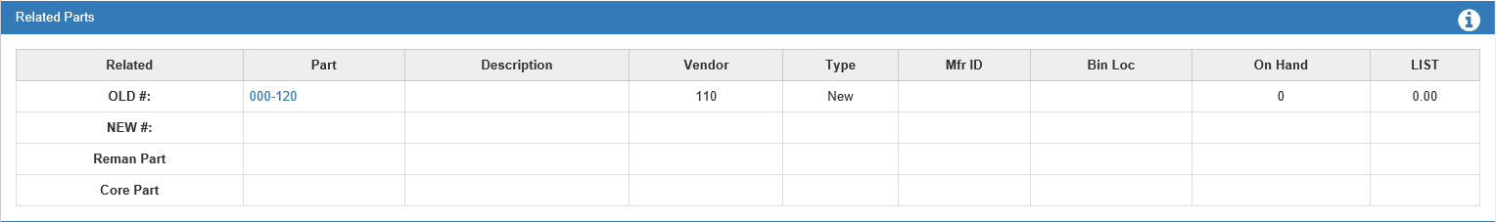

Related Parts—Field Definitions: This section shows information about any related parts that exist in the system, such as:

- Part number
- Description
- Vendor number
- Type
- Manufacturer ID
- Bin location
- On hand quantity
- List price

OLD #: The Old # row is named in IPOS. The old part number (sometimes known as the "Sub/See" number) is updated by a price file or through manual changes made in Part Number Changes (PNC). When looking up this Part Master through PI, the historical record is shown in this field. Old numbers are usually stock class A.

NEW #: The New # row is named in IPOS. It shows if the current part number has been superseded or replaced by a newer number. This information is available from some manufacturers and is often updated when a new price file is loaded. When the information is added from the price file, it updates this field with the new number, enters the old number in the OLD # row of the new part record, and changes the stock class to A on the old number. The Enter Part Number Changes (PNC) program also updates both the Old # and New # rows in both the old and new Part Master.

Reman Part: If the Part Master is linked to a rebuilt or remanufactured part, then the rebuilt part number shows here.

Core Part: If the part is linked to a core part, then the core number is shown here.

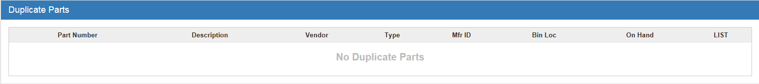

Duplicate Part Numbers—Field Definitions: If a part number is entered in any inventory program or POS/ROM Invoicing with two or more matching records, the duplicate part numbers will appear in this section, along with the following:

- Description
- Vendor number
- Type
- Manufacturer ID
- Bin location
- On hand quantity
- List price

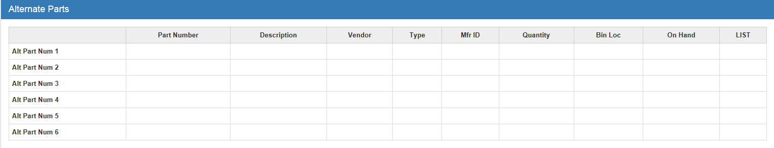

Alternate Parts—Field Definitions

Alt Part #1-6: Alt Part #1-6 is a collection of six rows that hold information about alternate part numbers. The numbers shown here do NOT have to be numbers in inventory. It could also be used to reference the components of a kit. These fields are user-maintained and will not be updated by any system process. Each part number will be noted along with the following:

- Description
- Vendor number
- Type
- Manufacturer ID
- Quantity
- Bin location
- On hand quantity
- List price

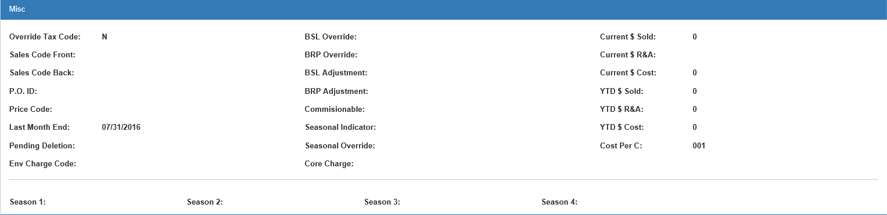

Misc-Field Definitions

Override Tax Code: This field shows if the system can override the customer's taxable status when this part is used in POS or ROM, or if it should follow the customer’s taxable status.

If it shows Y, then the tax code can be changed.

If it shows N, then the system will always follow the customer’s taxable system when charging for this part.

Sales Code Front: This field will be blank UNLESS “Y” shows in the Override Tax Code field. If so, it will show the appropriate sales code for parts counter sales in this field. This code identifies where the accounting entry will be posted when this part is added to a picking ticket or repair order.

Sales Code Back: This field will be blank UNLESS “Y” is selected for the Override Tax Code field. If so, it will show the appropriate sales code for shop parts sales in this field. This code identifies where the accounting entry will be posted when this part is added to the picking ticket or repair order.

P.O. ID: This field is a reference-only field which can contain miscellaneous information. It does not affect any inventory or ordering function, or any standard inventory reports. Often when HBS converts parts info from other systems, miscellaneous data is placed in this field. Sometimes the parts source from the previous system is kept here for future reference.

Price Code: This field shows the two-digit Price Code. The Manufacturer Price File updates the Price Code when PUV is run. This price code is vendor-specified, like for discounts, etc. It has nothing to do with the price code used in POS or ROM. You can maintain this information if it’s not on the price file and the vendor has supplied it to you.

Last Month End: The Month End date in this field is maintained by INME. It is automatically updated and shows the last time the Month End Process was run.

Pending Deletion: The Pending Deletion field is maintained by INME and identifies the parts flagged for deletion. The program flags the part with a D in this field if the part meets all of the criteria for deletion. The flagged part is then deleted during the following month’s process as long as the criteria are still met. The criteria are:

- No on hand quantities
- No on order quantities
- No sales history in the specified time range for the Month End Program (12/24/36/48/60 months)
- Stock Class is NOT A (History or Replaced By number)

It is not possible to remove the D from this field in order to save the record. In order to keep this part, one of the following actions may be taken:

- Take a physical count to determine if there is stock on hand. If so, make the changes in Post Inventory Adjustments.
- When the next Month End program is run, change the time range for deletion. If a lower range of months is selected, it may spare the deletion of this part.
- Cross-reference the part to an active number with a quantity that has sales history. Make the reference in PNC.
- Manually change the stock class to A. This action would be appropriate if none of the preceding reasons apply. Stock class A parts are not deleted by the Month End program.

Environmental Charge Code: This field may hold the code for an environmental charge that applies to this part. The Environmental Codes can be used to comply with local, state/provincial, or federal taxes or charges on specific items. It can also be used to add “dealership generated” fees to items. The charge may be a flat amount or a percentage of the selling price of the part itself. You can “attach” any environmental code created in Environmental Charge Maintenance (ECM) to a part. Then, each time you sell the part in POS or ROM, it will automatically add the charge to the part on the invoice. If you sell multiple units of the part with the charge, the invoicing programs will suggest the same number of environmental charges, but can be changed as necessary. Additional environmental charges may be added in ECM.

BSL Override: The Best Stocking Level Override field holds a manual best stocking level for this part. When a quantity is present, it overrides the BSL value calculated by the Standard Stock Order (SSO).

However, if the part has a stock class 6, anything entered in the BSL Override and BRP Override fields is removed during INME after the part reaches the end of its trial period. On these special parts, a value can be entered to provide a desired stocking level. Once the trial period is over, the Month End Process upgrades/downgrades the stock class 6 to either 1, 5 (both fast-moving) or 8 (non-stocking), and the BSL override value is removed. For stock class 6 parts, the ordering system also always keeps at least one in stock during the trial period.

BRP Override: The Best Reorder Point Override field holds a manual best reorder point for this part. When a quantity is present, it overrides the BSL value calculated by the Standard Stock Order (SSO).

However, if the part has a stock class 6, anything entered in the BSL Override and BRP Override fields is removed during INME after the part reaches the end of its trial period. On these special parts, a value can be entered to provide a desired stocking level. Once the trial period is over, the Month End Process upgrades/downgrades the stock class 6 to either 1, 5 (both fast-moving), or 8 (non-stocking), and the BRP override value is removed. For stock class 6 parts, the ordering system also always keeps at least one in stock during the trial period.

BSL Adjustment: The Best Stocking Level Adjustment field holds a manual BSL adjustment amount. Instead of overriding like the BSL/BRP override fields do, this manual amount is used WITH the system-calculated best stocking level. When the system calculates the best stocking level, it checks this field for a manual adjustment. For example, you could increase the stocking level for this part a little by putting 1 or 2 in this field. This adds 1 or 2 to the suggested order quantity by boosting the calculated stocking level (i.e., if the BSL is calculated at 10 then, add in the manual BSL adjustment to get 12).

- A positive quantity here adds to the system’s calculated BSL.
- A negative quantity here subtracts from the system’s calculated BSL.

BRP Adjustment: The Best Reorder Point Adjustment field holds a manual BRP adjustment amount. Instead of overriding like the BSL/BRP over-ride fields do, this manual amount is used WITH the system-calculated best reorder point. When the system calculates the best reorder point, it checks this field for a manual adjustment. For example, you could increase the reorder point for this part a little by putting 1 or 2 in this field. This causes the part to reorder sooner (i.e., if the BRP is calculated at 5 then, add in the manual BRP adjustment to get 7).

- A positive quantity here adds to the system’s calculated BRP.
- A negative quantity here subtracts from the system’s calculated BRP.

Commissionable: The Commission field shows if the part is included on the Parts Commission Reports (SCR and SCN).

Y means it can be included on the commission reports.

N means this item is not to be included on the reports.

Seasonal Indicator: If the part is seasonal (stock class 5), this field will show a pound sign or an asterisk (# or *). Seasonal parts are ordered by the system while they are “in season” and stocked at 5% when “out of season.”

Seasonal Override: This field indicates if the part cannot be manipulated by the system’s seasonal calculations. . We recommend discussing the seasonal settings with a member of the HBS Support Team before implementing them.

- When it displays Never, the season indicator flag cannot be set by SCUD or INME.
- When it displays Always, the season indicator cannot be cleared by SCUD or INME

Core Charge: If the part has a core charge attached to it, this field shows the charge amount.

Current $ Sold: The Current Dollar Sold field shows the sales dollars for the current month. As each part sale through POS and ROM is processed, the actual selling price is added to this field. Since this number represents the actual dollars involved in each sale, it can be affected by special pricing for the customer, and special or manual pricing used on the invoice. The current month is defined from the date and time the Month End Process (INME) was last run through the current date.

Current $ R&A: The Current Dollar Returns and Adjusted field shows the activity from Post Inventory Adjustments (PIA). The dollars in this field are based on cost/average cost.

Current $ Cost: The Current Dollar Cost field shows the cost of sales dollars for the current month. As each part sale in POS and ROM is processed, the actual cost is added to this field. This amount can be affected by how cost is set up in the system. For example, cost may be factored as 100% of the amount in the Mfr Cost field. Cost can also be factored as a percent of the amount in the Mfr List field (as the case is when the price file does not provide a cost amount). The current month is defined from the date and time the Month End Process (INME) was last run through the current date.

YTD $ Sold: The Year to Date Dollars Sold field shows the Year to Date sales dollars for the current calendar year, through the last parts month end. The Month End Process (INME) updates this field from month to month. It clears out the Current $ Sold field and adds the new amount to whatever has been in this field. When the December Month End is run, this field is cleared to prepare for the new calendar year.

YTD $ R&A: The Year to Date Dollars Returns and Adjusted field shows the Year to Date adjustment dollars for the current calendar year through the last parts month end. INME updates this field from month to month. It clears out the Current $ R&A field and adds that amount to whatever has been in this field. When the December Month End is run, the field is cleared to prepare for the new calendar year. The dollars in this field are based on cost/average cost.

YTD $ Cost: The Year to Date Dollars Cost field shows the Year to Date cost of sales dollars for the current calendar year through the last parts month end. INME updates the information in this field from month to month. It clears out the Current $ Cost field and adds that amount to whatever has been in this field. When the December Month End is run, the field is cleared to prepare for the new calendar year.

Cost Per C: The Cost Per C (cost per 100) field prompts the system to divide the factored list price and cost by the number shown here (which can be from 1 to 999). This field is used when the pricing on the part number is for a quantity of the part rather than an individual part. Typically, bulk parts carry the bulk list and cost on a price file. This field lets the system automatically calculate the individual price and cost when necessary. For example, if the pricing shown for the part is for a 5-gallon unit and it is to be sold in one-gallon units, the number “5” should show in this field.

Season 1-4: The system can define up to four dealer seasons for each part. Each season contains the beginning and ending month for the part.

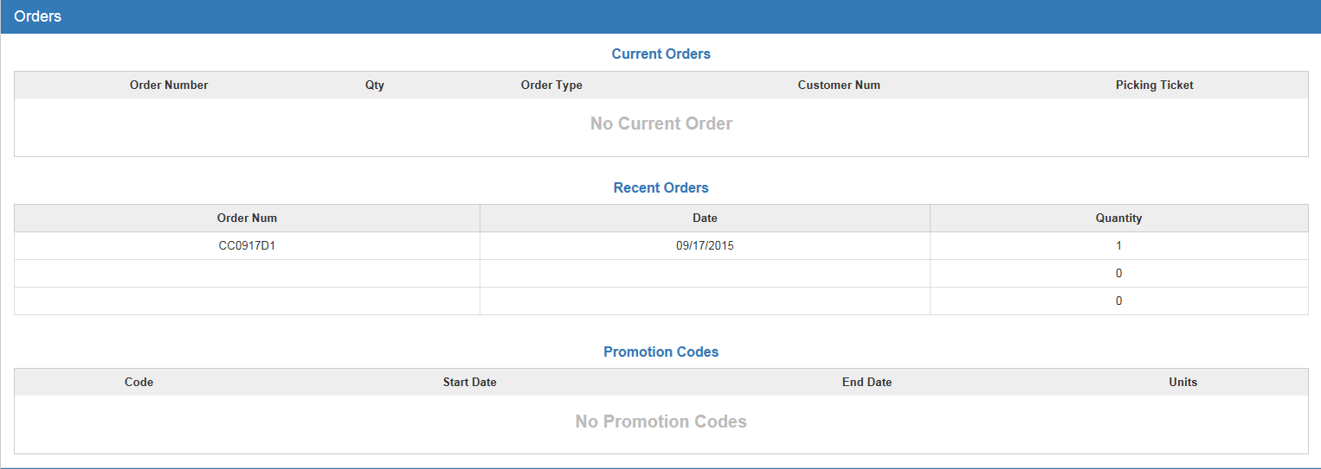

Orders—Field Definitions

Current Orders: This section lists all current orders for the part, including:

- The order number
- The quantity of the order
- The order type
- The customer number
- The picking ticket number

Previous Orders: This section lists the last three previous orders by their order number, the date of each order, and the quantity of each.

Promotion Codes: PUV updates these fields from the price file. Some vendors include promotional codes, dates, and how many units can be accumulated when this part number is ordered repeatedly for special discounts, credits, and other vendor-sponsored rewards.

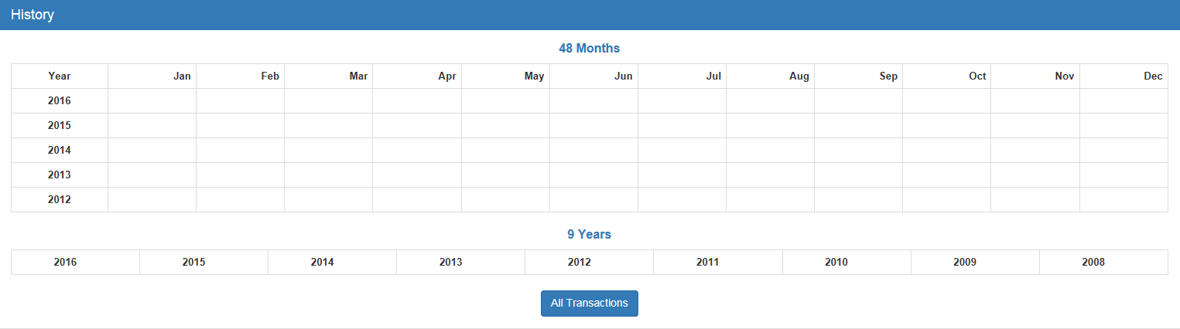

History Tab—Field Definitions

Monthly Sales: POS and ROM Invoicing update the monthly sales grid. INME also maintains this section. This grid holds 48 rolling months of sales counts. Whenever a part is sold or returned, the quantity is added or subtracted to the current month column. The monthly sales also store fractional quantities such as 12.50. At the end of the month, INME rolls the sales history value from the current month into the previous one. The rest of the fields roll back one field to keep the complete 48 months of sales information.

9 Years – Sales: This grid holds the summary of the nine years of sales counts. The counts come from POS and ROM Invoicing. When a part is sold or returned, the quantity is added or subtracted to the current month and the current year column. INME also maintains this grid. When you run INME for December, the sales quantity in each yearly row rolls to the next oldest year in order to prepare for the new calendar year’s sales activity.

All Transactions button: Click the All Transactions button at the bottom to view all the part’s ITR activity.

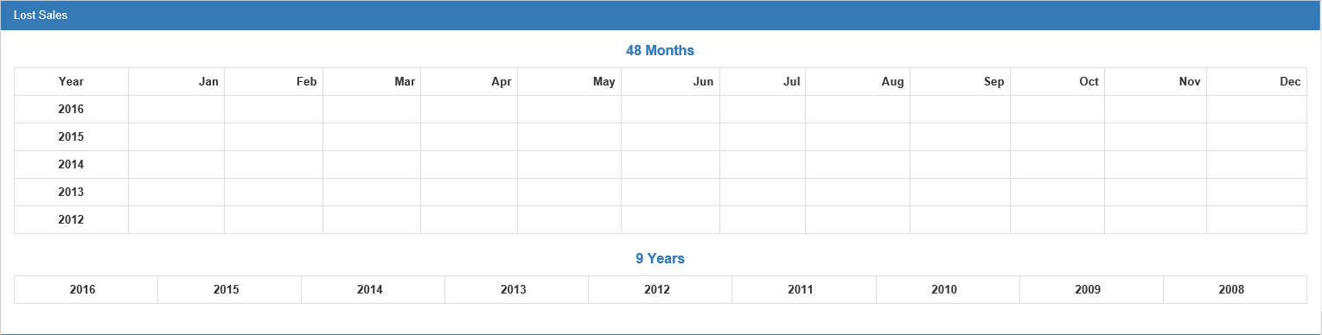

Lost Sales—Field Definitions: POS/ROM invoicing and Parts Inquiry maintain this section every time you enter a lost sale. A lost sale is when a customer comes in to make a purchase and you do not have enough stock to satisfy the customer’s needs. It means that if a customer wants to purchase an item that has either never been in stock or is currently out of stock at the time, this is considered a lost sale. NOTE: You can add Lost Sales in PI using the Lost Sales button (see “Lost Sales” under “Other Buttons” for more information).

Monthly Lost Sales: This grid holds the lost sale quantities recorded from POS/ROM invoicing and Parts Inquiry. The screen keeps up to 48 months of lost sales history. Storing lost sales quantities helps the ordering system order enough to cover lost sale entries. At the end of the month, INME rolls the lost sales value from the current month row into the previous month and the rest of the fields roll over one column to retain the complete 48 months of lost sales information.

9 Years – Lost Sales: This grid holds the summary of the nine years of lost sales counts. The counts come from POS/ROM invoicing and Parts Inquiry. When you record a lost sale, the quantity is added to the current month column and the current year column. INME maintains these columns. For example, when you run INME for December, the lost quantity in each yearly column rolls to the next column in order to prepare for the new calendar year.

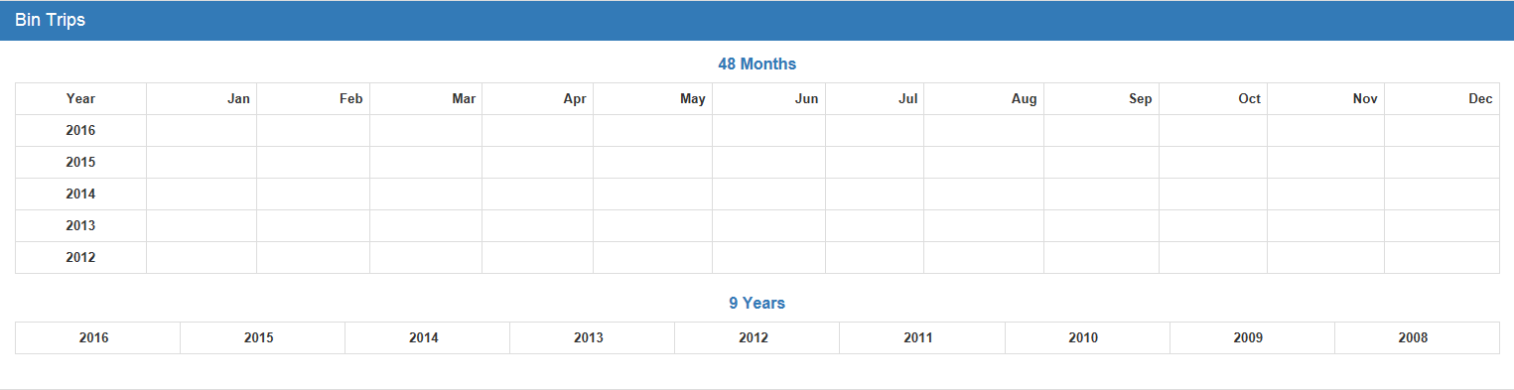

Bin Trips—Field Definitions: This information is maintained by POS and ROM invoicing. Every time a part is added to a picking ticket or repair order, a bin trip is added to the current month and year of the part sold. INME rolls the monthly bin trip history. A bin trip is the “number of trips to the bin to cover a customer’s purchase.” If a customer asks for a single quantity of one item, the parts person walks once to the bin to get it. Likewise, if a customer wants two of the same item, the parts person still only walks once to the bin. In both cases, a single bin trip is recorded, regardless of the quantity sold. Bin trip information is valuable to you since it provides additional insight of what is really taking place with a part. In a month of history with a large number of sales, it can provide you with the number of customers actually making purchases.

Monthly Bin Trips: This monthly grid holds the number of bin trips as maintained by POS and ROM invoicing. At the end of the month, the Month End Process (INME) rolls the bin trip value from the current month column into the previous one, and the rest of the fields move one column to retain the complete 48 months of bin trip information.

9 Years – Bin Trips: This grid holds the summary of the nine years of bin trips. The counts come from POS/ROM invoicing. When you record a sale, the quantity is added to the current month column and to the current year column. INME maintains these columns. For example, when you run INME for December, the bin count in each yearly column rolls to the next column in order to prepare for the new calendar year.

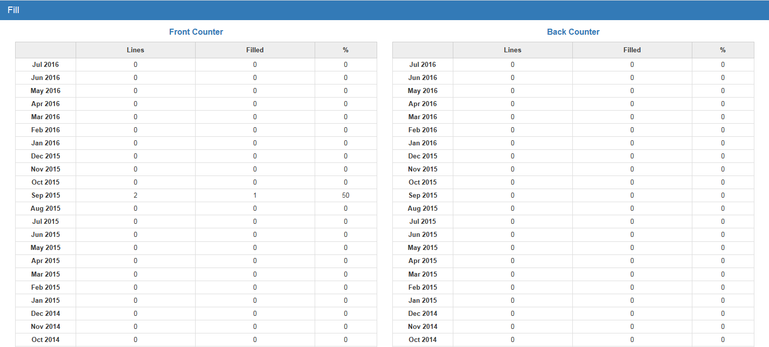

Fill—Field Definitions: The Fill section is used for the CNH Availability Max interface. It focuses on the number of invoice lines for the part number and the number filled from inventory for each of the previous 24 months. The percentage filled displays in the third column. The columns show activity for both the front counter (parts invoices) and back counter (repair orders). Totals are recorded at the bottom of the section.

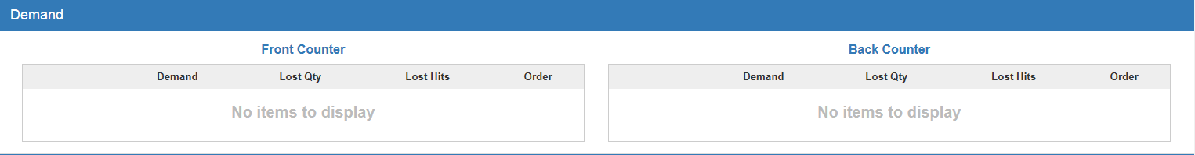

Demand—Field Definitions: The Demand section is used for the CNH Availability Max interface. It focuses on the demand for the part number, lost sales quantity, lost sales hits, and order quantities for each of the previous 24 months. These columns show activity for both the front counter (parts invoices) and back counter (repair orders).

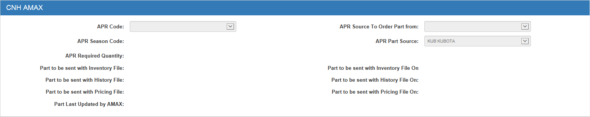

CNH AMAX—Field Definitions: The fields in this section are completely maintained by the CNH Amax interface. They provide information about how this specific part number is to be handled.

