Post Inventory Adjustments (PIA)

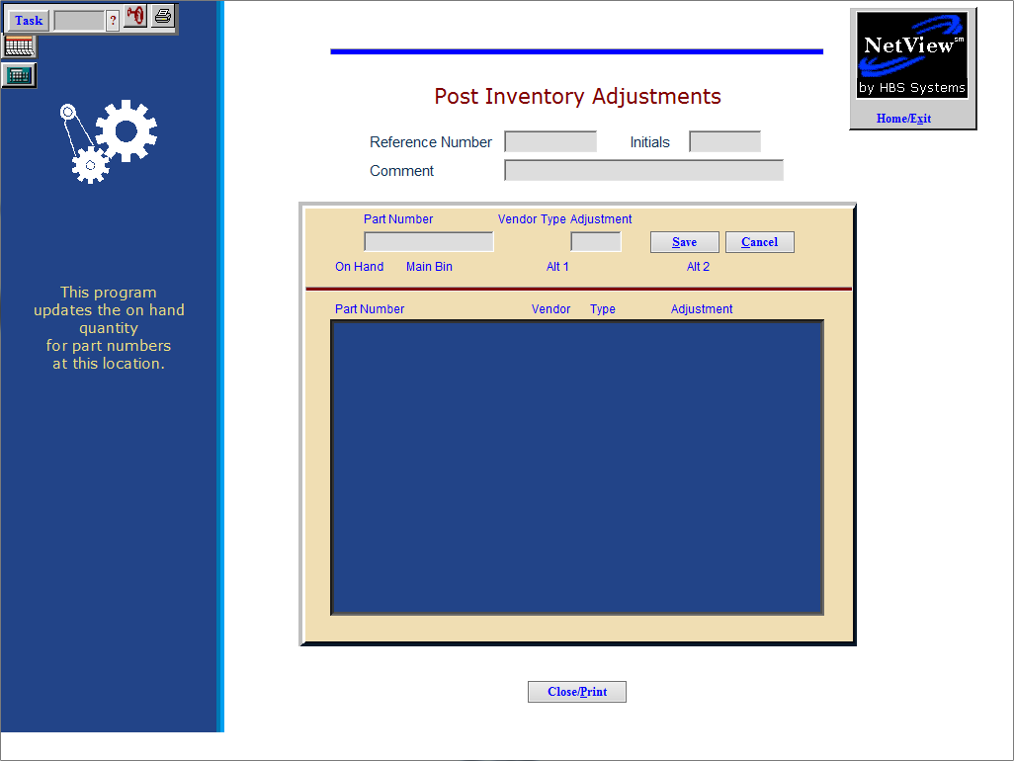

Post Inventory Adjustments lets you adjust inventory quantities. Everything that occurs in this screen is updated in the Part Master and recorded in the inventory transaction file, which can be accessed anytime through the Inventory Transaction Report (ITR). It also produces a report of all changes made.

This is THE recommended place to make changes in the Quantity on Hand.

- To access Post Inventory Adjustments, either:
  - Select “Inventory” from the menu. Choose the “Parts/Source Update” submenu and click “Post Inventory Adjustments.”
  - Type “PIA” in the Shortcuts Bar.

Field Definitions

Reference Number: This field holds the reference number of the inventory item you are adjusting. An example might be IN062016 (inventory adjustment for 06/20/2016).

Initials: Enter your initials in the space provided.

Comment: Enter any brief comment about the quantity adjustment.

Part Number: Enter the part number at this field. The following information about the part will show for reference:

Vendor

Type

Current on hand

Main bin location

Alternate bin location 1

Alternate bin location 2

Adjustment: Enter the quantity that you want to adjust.

A positive number will increase the quantity on hand.

A negative quantity will decrease the quantity on hand.

Save / Cancel:

- Press Save to record your adjustment.
- Press Cancel to clear the entry.

Close/Print: Press this button when all adjustments have been entered.

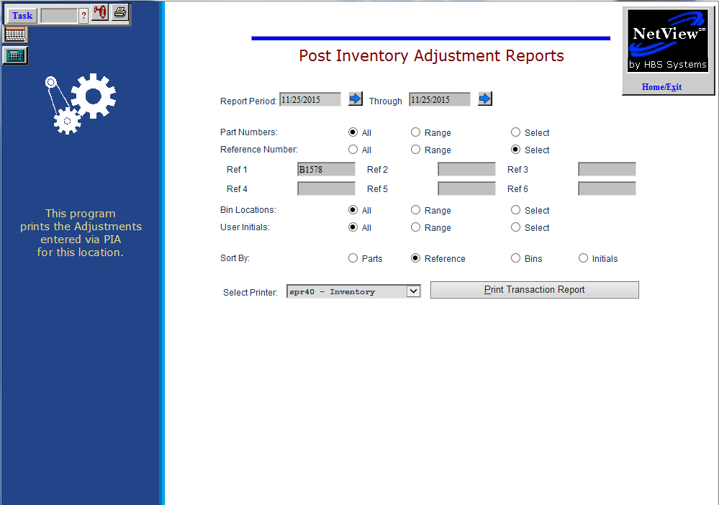

After the adjustments are entered, you are passed to the report screen. It pre-fills with the details of the adjustment made. Press the “Print Transaction Report” button to receive the printout of your changes.

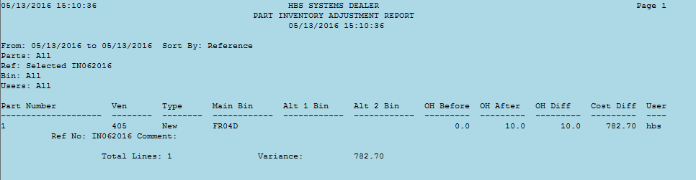

Report Columns Include:

Part Number: This shows any part numbers adjusted.

Ven: This column displays the vendor of the part.

Type: This column shows the part type.

Main Bin: This column shows the main bin location.

Alt 1 Bin: This column shows the 1st alternate bin location.

Alt 2 Bin: This column shows the 2nd alternate bin location.

OH Before: This column shows the on hand quantity before the adjustment.

OH After: This column shows the on hand quantity after the adjustment.

OH Diff: This shows the quantity difference.

A positive (+) number means there was an increase in quantity.

A negative (-) number means there was a decrease in quantity.

Cost Diff: This column shows the cost of the adjustment made.

User: This column shows the initials of the person who made the adjustment.

The reference number and comments are shown for each item adjusted. Totals are provided for the number of lines adjusted and the total cost variance.

In addition to the printout selections for the adjustments just made, you may also access the adjustment history at any time. All adjustments are now stored in a transaction file that be accessed via PIAR. Click on the “Close/Print” button at the bottom of the screen to reach the printout choices.

Report Criteria: You may generate a report based on any of the following criteria:

Report Period: Enter the beginning and ending dates.

Part Numbers: Choose one of the following options:

All adjusted

Range of adjusted

Select a specific number

Reference Number: Choose one of the following options:

All reference numbers

Range of numbers

Select a specific number

Bin Locations: Choose one of the following options:

All adjusted

Range of adjusted

Select a specific bin

User Initials: Choose one of the following options:

All

Range

Select a specific set of initials

Sort by: Choose one of the following options:

- Part Number
- Reference
- Bins
- Initials

