Payment/Interest Comparison (PIC)

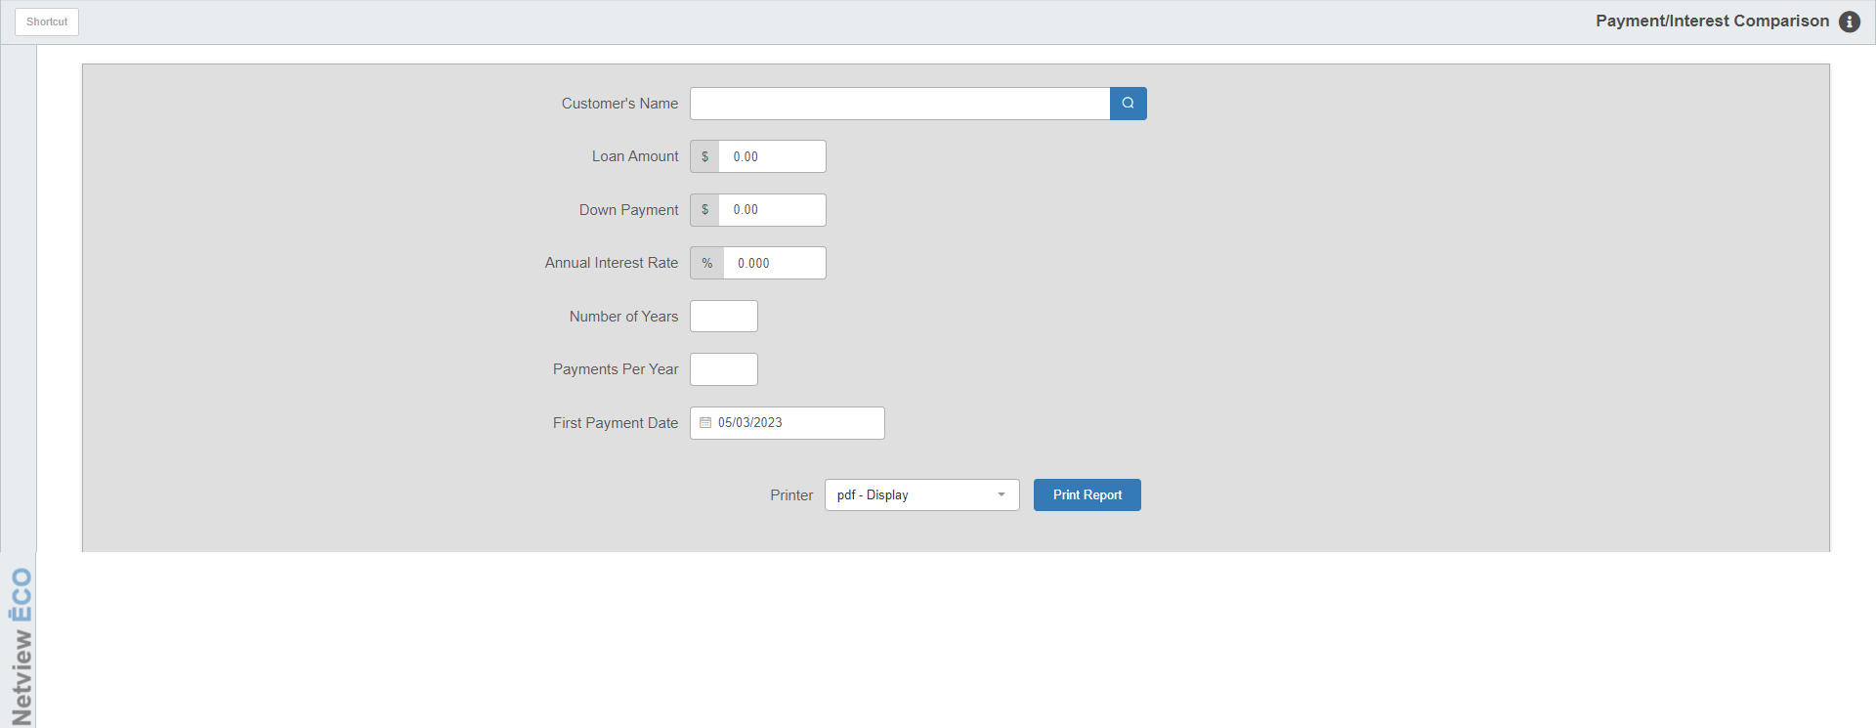

Payment / Interest Comparison (PIC) lets you generate, review, and print a comparison chart that allows you to compare payment amounts for varying loan amounts and interest rates. The chart shows the effects of varying the loan amount and the interest rates.

- To access this function, you can either:
  - Select “Units” from the menu. Choose the “Amortization” submenu and click “Payment/Interest Comparison.”
  - Type “PIC” in the Shortcuts Bar.

Field Definitions

Customer’s Name: Type a customer name. The name entered is used only for printout purposes.

Loan Amount: Type the amount of the loan, without a decimal point. For example, type “1000000” for $10,000.00.

Down Payment: Type the amount of the customer’s down payment on the unit, without a decimal point. For example, type “50000” for $500.00.

Annual Interest Rate: Type the amount of the annual interest rate on the loan, without a decimal point. For example, type “10000” for 10.000%.

Number of Years: Enter the number of years within which the customer will make loan payments.

Payments Per Year: Enter the number of payments the customer will make per year. Type 1 for annual, 4 for quarterly, 12 for monthly, and so on.

First Payment Date: Type the date the customer will make the first loan payment. For example, type “101511” for October 15, 2011. You can also use the blue arrow to select it from a calendar.

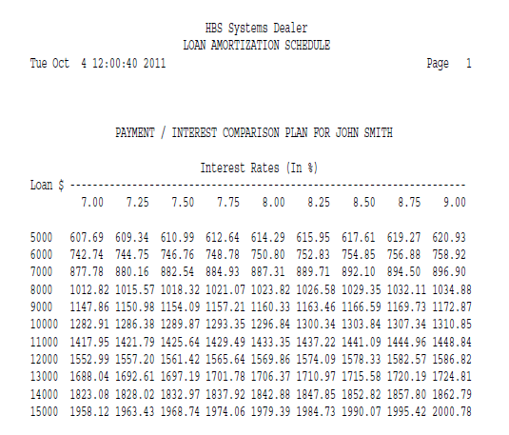

Report Details

Loan $: This column lists the five amounts below and above the original loan amount in one thousand dollar increments.

Interest Rates (In %): This column lists the interest rates.

Payments: The chart shows possible loan payment amounts at various interest rates. It provides differing loan amounts in $1000 increments (five over and five under) from the amount you enter. In addition it shows differing interest rates in quarter point (0.25%) increments (four over and four under) from the interest rate you enter.

