POS Session Defaults

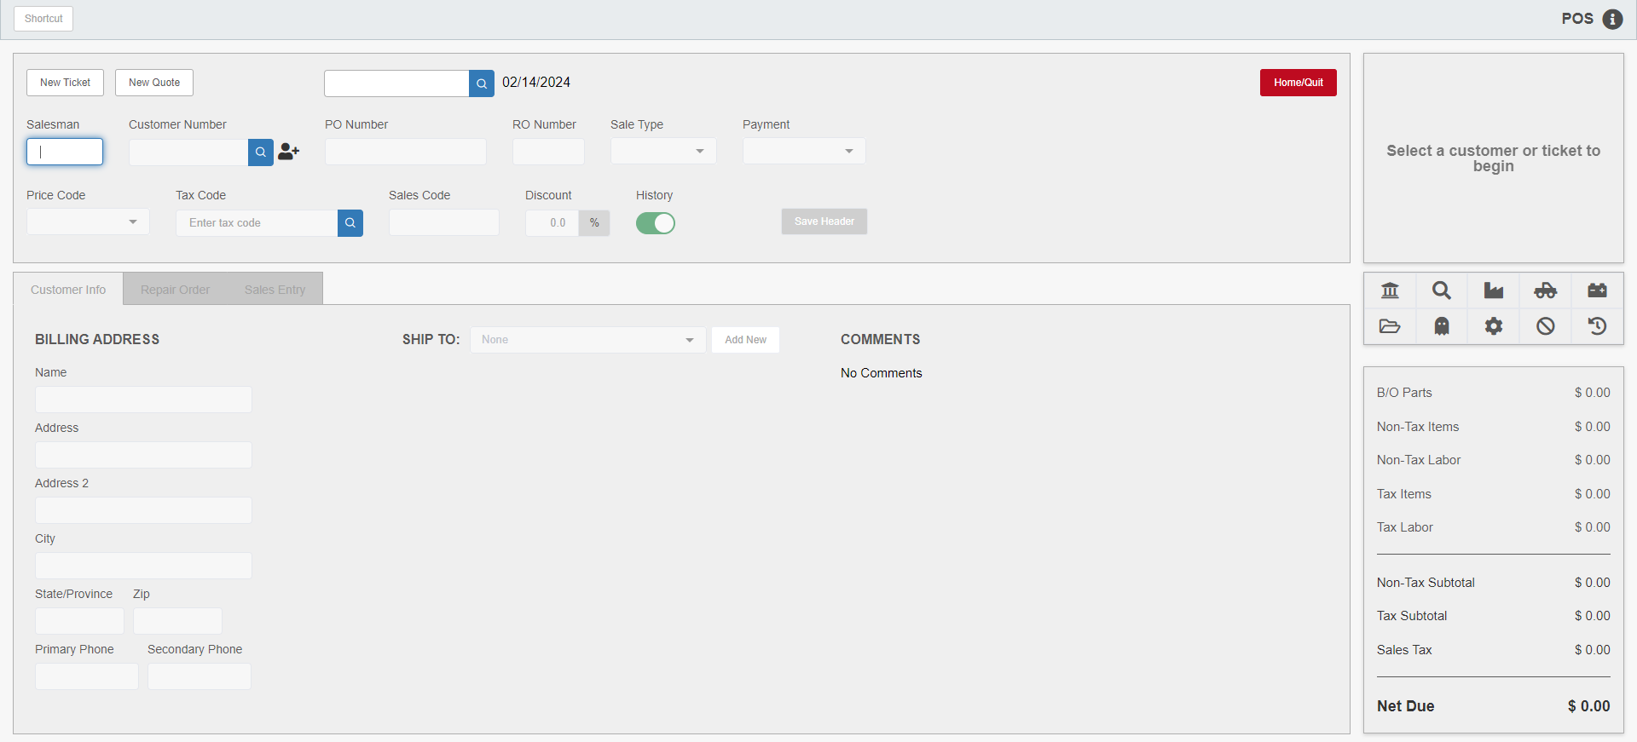

POS Defaults allows dealers to setup various default values for Point-of-Sale Invoicing (POS) to suit the way their dealership normally uses the program. The application is located within the POS program.

To access this function, you can either:

Select “Parts Point Of Sale” from the menu.

Type “POS” into the Shortcuts Bar.

To access the defaults screen, click the POS Defaults button, which has an icon shaped like a gear on it:

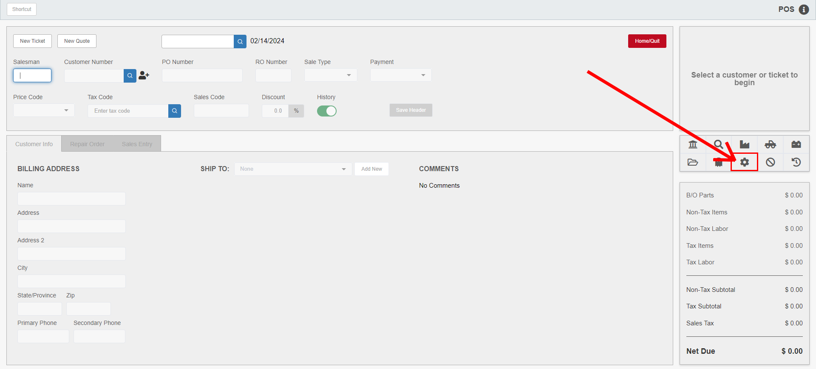

The following window will open:

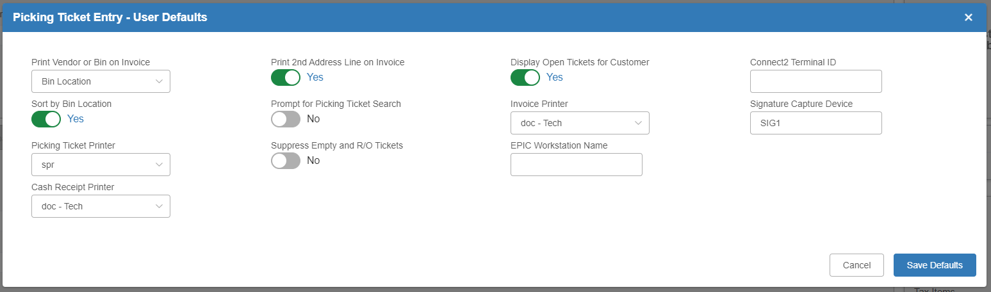

The choices on this screen allow you to customize the session settings for each login.

Field Definitions:

Print Vendor or Bin on Invoice: Use the dropdown selection to choose whether to print the vendor number or the bin location on POS invoices for each part number.

Sort by Bin Location:

- Set this option to Yes if you want to have the “Sort by Bin Location” option in the Picking Ticket Printing screen to default to “Yes.”
- Set the option to No if you want the Picking Ticket Printing screen option to default to “No.”

Picking Ticket Printer: Select the default printer for printing picking tickets.

Cash Receipt Printer: Select the default printer to print cash receipt style POS invoices (requires a cash receipt printer).

Print 2nd Address Line on Invoice: In some dealerships, the 2nd Address Line is used for additional information needed for mailing requiring a Dept#, Attn., Mail Stop, etc.

- Choose Yes to print the second address line on POS invoices.
- Choose No to omit it.

Prompt for Picking Ticket Search: This prompt is no longer in use and MUST be set to NO.

Display Open Tickets for Customer: This field determines if the Open Picking Tickets pop-up window automatically displays when you type a customer account number in the ticket Header.

- Select Yes to turn on the Picking Ticket Lookup feature.
- Choose No to turn off this function.

Suppress Empty and R/O Tickets:

- Choose Yes to exclude empty and/or repair order tickets (tickets without part numbers or any other detail lines) from the Open Picking Tickets pop-up window.
- Select No to include all open tickets for a selected customer.

Invoice Printer: Select the default printer to print POS invoices.

EPIC Workstation Name: The system uses this name to identify your computer to POS and Electronic Parts Catalog programs (i.e. EPIC, PAL, Solutions, etc.). This identification lets you import the contents of an electronic parts catalog picking ticket into a POS picking ticket.

Connect2 Terminal ID: Enter the Connect2 Terminal ID here.

Signature Capture Device: If applicable, enter the Signature Capture Device name in this field.

Cancel: Press this button to discard changes and return to POS.

Save Defaults: Press this button to save the POS defaults selected and return to POS.

