Step 8—Post Inventory Counts (PINC)

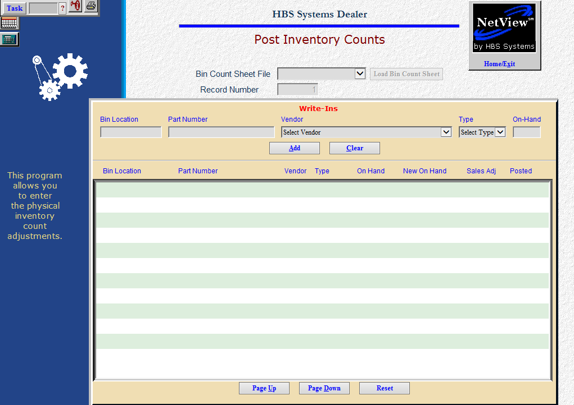

Post Inventory Counts is where you actually enter the quantity that was counted during the Physical Inventory process. You can begin entering the counts as soon as you receive completed count sheets. Ideally, someone will be available to key in the counts as the count process itself is proceeding. Several people can do this step at the same time as long as they access different part numbers/bin locations.

- To access Post Inventory Counts, you can:
  - Select “Inventory” from the menu. Choose the “Physical Inventory” submenu and click “Post Inventory Count.”
  - Type “PINC” in the Shortcuts Bar.

Field Definitions

Record Number: Here you enter the Record Number shown on the top of the count sheet. Each full page contains 25 part numbers. You should complete it before exiting the program.

Bin Count Sheet File: Choose the Bin Count Sheet File to update.

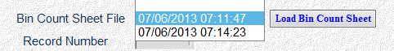

Load Bin Count Sheet: Press this button once you have selected the Bin Count Sheet File to update.

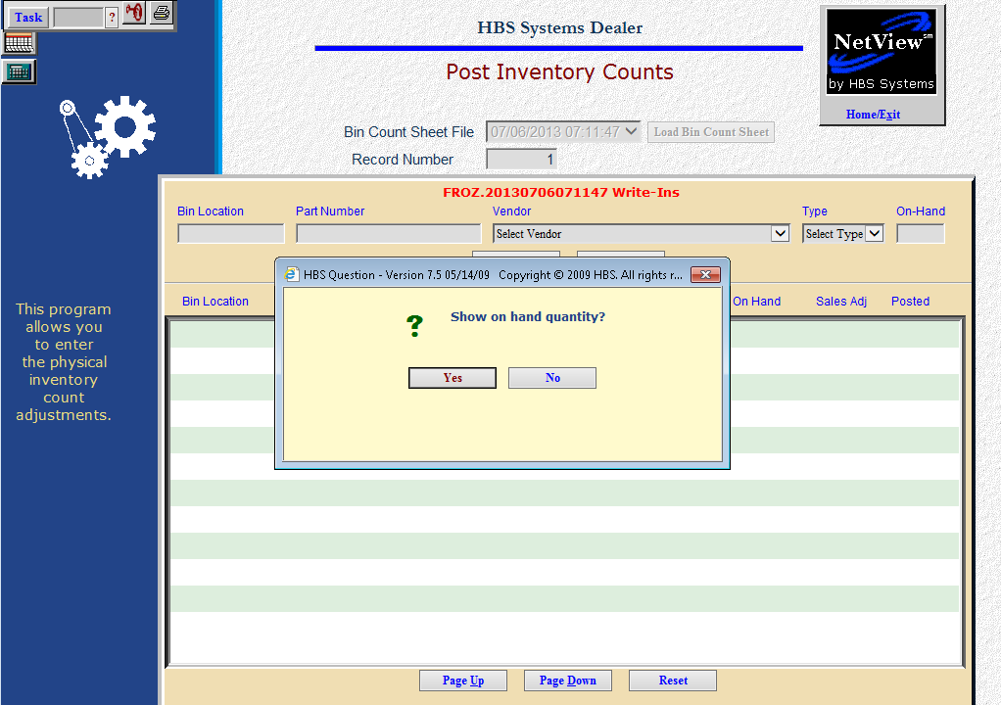

Show on hand quantity: This prompt appears once you load the bin count sheet file.

Select Yes to display the On Hand quantity on the count entry screen.

Select No if you do not want to see the On Hand displayed.

Utilize sales adjustment: This prompt asks if you want to use the Sales Adjustment column. We do NOT recommend using this feature.

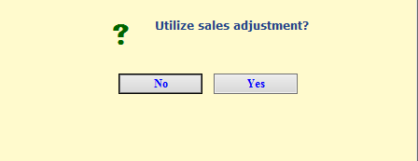

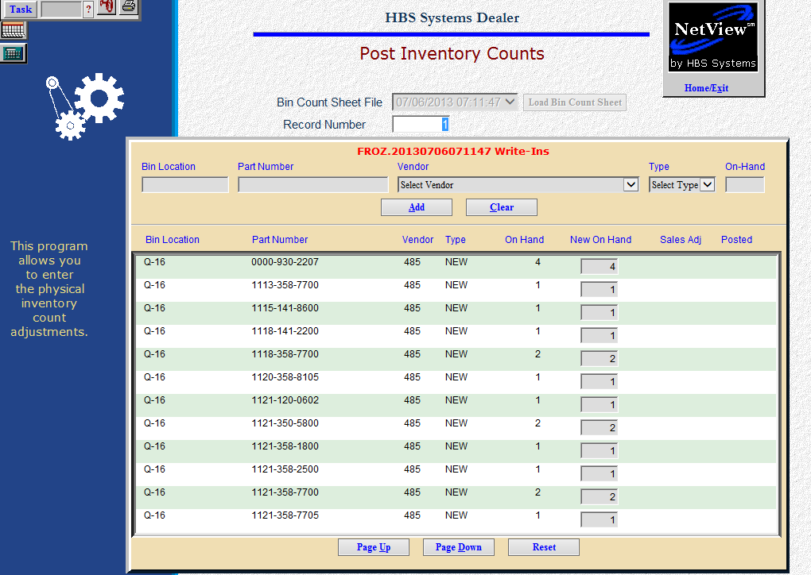

Bin Location: The screen displays the selected Bin Location.

Part Number: Here are the part numbers for the record selected.

On-Hand: If you selected to show the On-hand quantity, it will show here.

New On Hand: Here you enter the quantity from the count sheets. If you enter an incorrect count, re-enter the amount and it will replace the original amount.

Sales Adj: This field can be used to enter sales made during the inventory process. We do not recommend using this field.

Saving Counts: Each line is saved as it is entered.

Posted: If this line has been posted, you will see an indicator in this field.

Page Up / Page Down / Reset:

- Use Page Up to return to a previous screen of parts.
- Use Page Down to advance to the next screen of parts.
- Use Reset to leave this selection and choose another record number.

Write Ins: To add a part number “on the fly” that is not listed on the Bin Count Sheets, enter the information in the name fields. This feature can be used when the part number does not exist in the system.

- Bin Location: Enter the bin location of the part to be added.
- Part Number: This is the part to be added.
- Vendor: Choose the vendor from the drop-down menu.
- Type: Select one of the following:
  - New
  - Reman
  - Core
  - Used
  - Memo
- On Hand: Enter the on hand quantity for the part.
- Add: add the part number to the inventory.
- Clear: clear the fields without adding the part number to inventory.

