STEP 10 – Post the Variances using Post Inventory Variance (PIV)

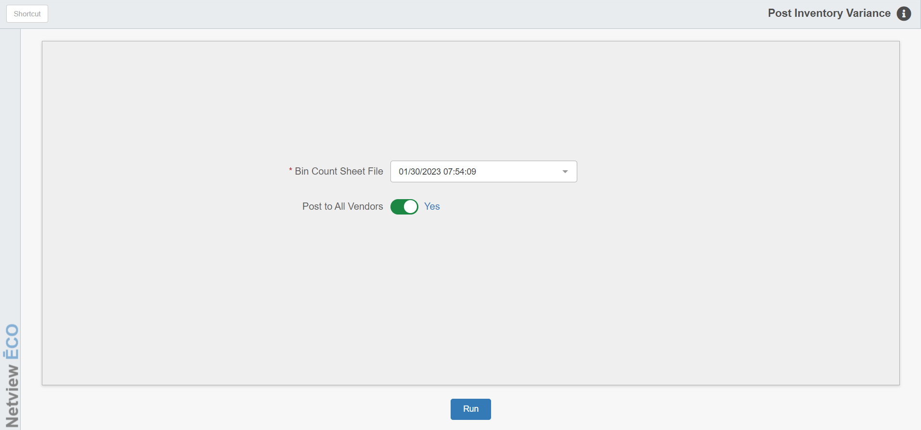

Make sure you have reviewed the variance report and that all variances are accurate before running this program. You may choose to post the changes to selected vendors. If you do, the important thing to remember here is that each vendor counted MUST be posted at some point, so it may be wise just to post to All Vendors.

To access this program, you can:

Select “Inventory” from the menu. Choose the “Physical Inventory” submenu and click “Post Inventory Variances.”

Type “PIV” in the Shortcuts Bar.

Bin Count Sheet File: Choose the Bin Count Sheet File to post.

Post to All Vendors/Selected:

- Select Yes if you want the updated counts to post to all your vendors.
- Although it is not recommend you can enter No if you only want to post updated counts on selected vendors.
  - If you enter “No” to specify vendors, simply type in or select the vendors (up to ten) from the drop-down menu that you want to update.

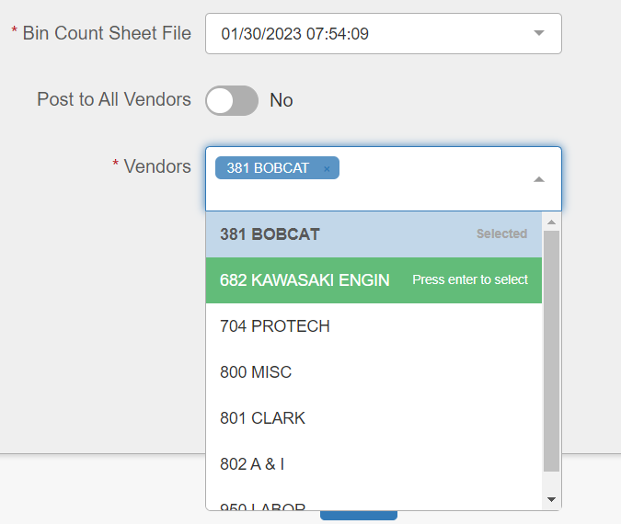

Run: Press this key to post new on-hand counts to the inventory records.

STEP 11 - Print a new Parts Value Report

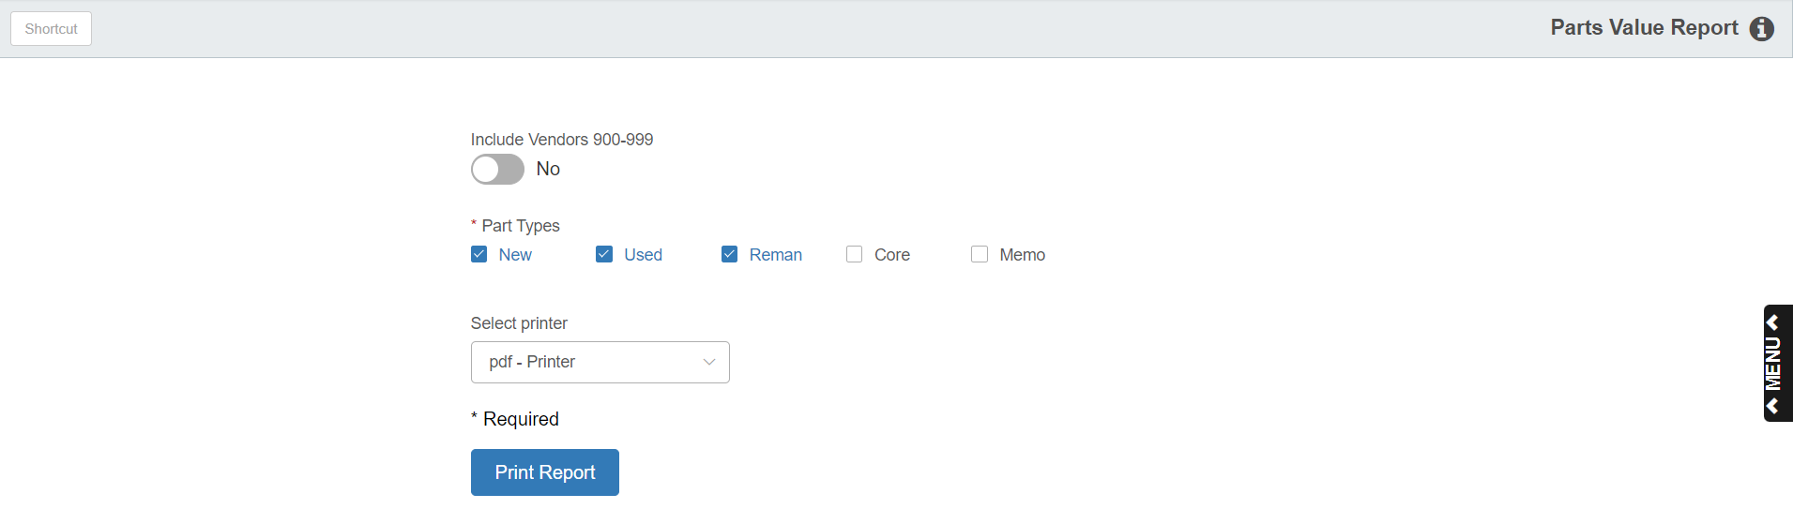

This is the final step in running a Full Physical Inventory. This report will show you the revised value of your inventory after completing the physical inventory process. For information on running a Parts Value Report (PVR), see “Parts Value Report.”

