Pre-Journal Invoice Modifications (PJIM)

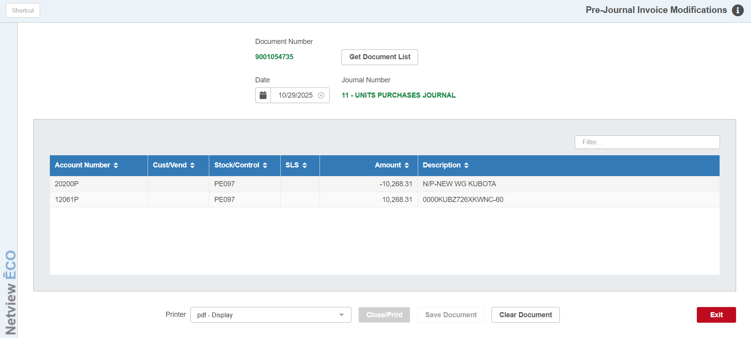

This program will ONLY allow you to open an existing pre-Journal Unit invoice and modify its DATE.

