Parts Job Maintenance (PJM)

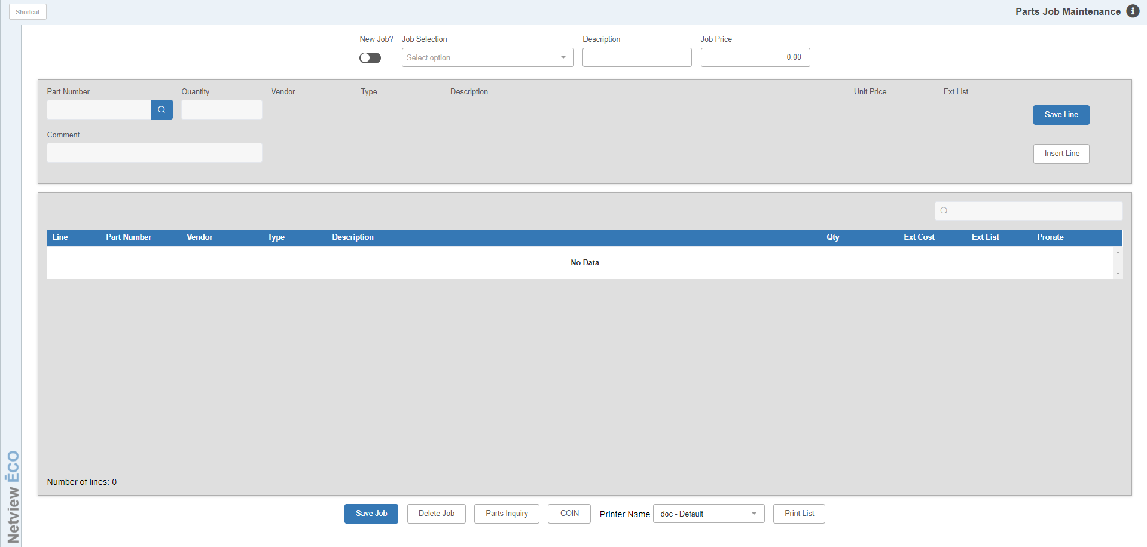

The Parts Job Maintenance (PJM) program creates jobs that can be used for setting up standard shop tasks such as tire repairs, oil changes, brake checkups, standard equipment maintenance work, and so on in Point of Sale (POS).

When setting up a shop ticket in POS, you type the Job List number on the picking ticket. POS extracts a copy of this job and automatically enters all the part numbers and labor charges associated with this repair on the picking ticket.

You can edit, delete, and add new shop jobs as needed. This means you can set up shop specials. For example, if your shop department runs a winter special to prepare equipment before the spring planting, you could create Service Specials through this program. You could even assign the advertised service special prices to these jobs.

To access Parts Job Maintenance, either:

- Select “Inventory” from the menu. Choose the “Parts/Source Maintenance” submenu and click “Parts Job Maintenance.”
- Type “PJM” in the Shortcuts Bar

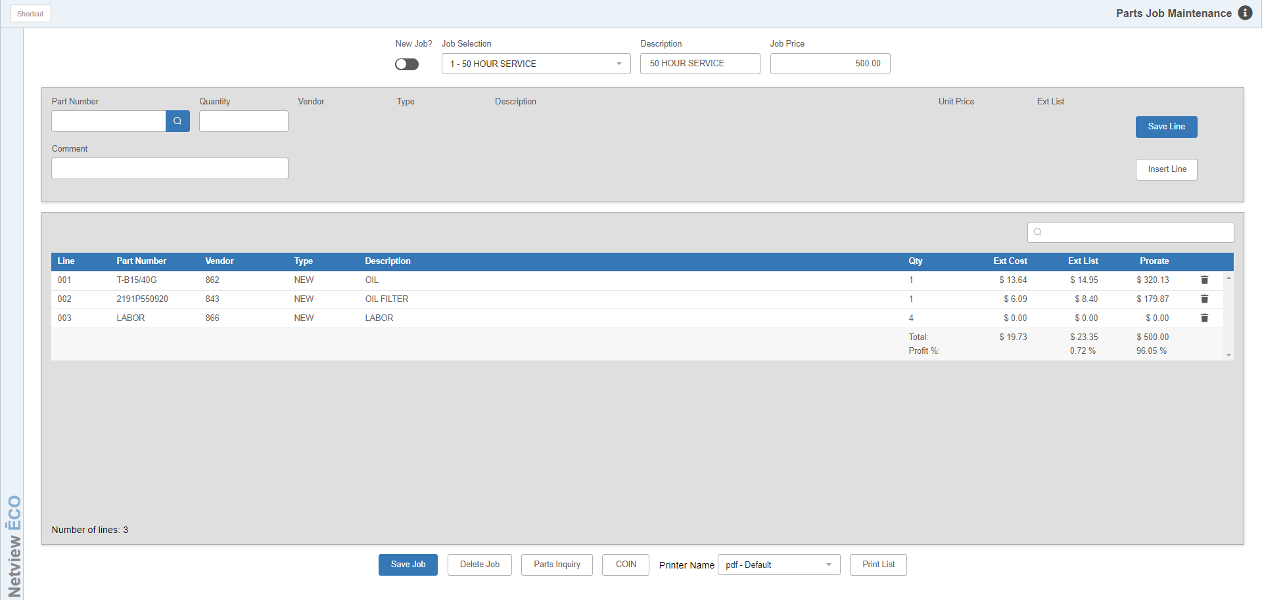

Job Maintenance Fields:

New Job?: Use this toggle to set whether or not you are creating a new job. It defaults to “No,” so you can immediately select an existing job if desired. Change it to “Yes” if you want to start adding a new job.

Job Selection:

If “New Job?” is set to Yes, this field will let you enter a new job number to begin creating the new job. You can enter up to 999 jobs.

If “New Job?” is set to No, then you can select an existing job from the drop-down menu in order to open it. You can then modify it as desired.

Description: This field sets the job’s description.

Job Price: This field holds the total dollar amount for the job, which is the total value of all parts and labor listed on the job. It will automatically recalculate based on any changes made to the dollar amounts or quantities of the job lines. NOTE: These automatic changes can be overridden, but the program will then start prompting you to update your pricing based on the actual calculation for the job.

Part Number: Type in the part number here to add it to the job. The part’s information will display in the fields to the right. Only part numbers in your inventory can be added. Do not add parts with an environmental charge or a core charge. Once you add a part line to the job, you cannot change the part number on the line.

Quantity: Enter the quantity of the part required for this job. This will determine the part line’s Extended List price, which will display in the “Ext List” field before you add the part to the job. You can change the quantity on an existing part line as many times as desired, which will recalculate the Extended List price and subsequently the Job Price.

Comment: If you want to create a comment line to add to the job, type the comment in here and then save the line. Note that you cannot create a part line with a comment, as the two are mutually exclusive: you can either create a part line or a comment line.

Save Line: Click this button to save your new line, or changes you have made to an existing line.

Insert Line: Click this button to insert a line in the job.

Job Grid: All lines on the job are displayed in the grid, which also lists the number of lines on the job in the bottom left-hand corner. You can use the Filter field above the grid to see only specific job lines by typing in information from those lines in the field.

Grid Columns: The grid shows the following information for each part line listed:

- Line number
- Part number
- Part vendor
- Part type
- Part description
- Part job quantity
- Part extended cost for the job
- Part extended list for the job
- Part prorate amount for the job

Job Stats: The last line on the part job shows information about the overall job, which will recalculate whenever the job is adjusted:

- Job Total Extended Cost
- Job Total Extended List
- Job Total Prorate
- Job Total % Profit off Total Extended Cost
- Job Total % Profit off Total Prorate

Delete Line: To delete a part or comment line from the job, click the trash can icon on the line. The line will be removed from the job and the overall job will update to show the removal.

Footer Buttons: The buttons at the bottom of the screen provide additional features.

Save Job: Click this button to save any changes made to the job. That includes after you add a new line to the job, as it may not save otherwise.

Delete Job: Click this button to delete the job. The following warning will appear, asking if you are sure you want to delete the job:

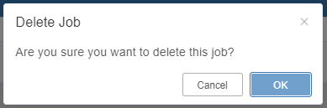

Click OK to delete the job.

Parts Inquiry: Use this button to access Parts Inquiry (PI) and look up part number information while building your job.

COIN: This button opens the COIN Inquiry screen and allows you to make searches in that program while working on your jobs.

Print List: Select this button to print the current job info. Make sure you set the Printer Name field to the printer you want to receive the printout.

Using the Job in POS Invoicing: You can include any Job on a POS picking ticket. At the Part-Number field on the POS ticket, type “Job Number <space> J” and press “Enter.”

