Price Matrix Maintenance (PM)

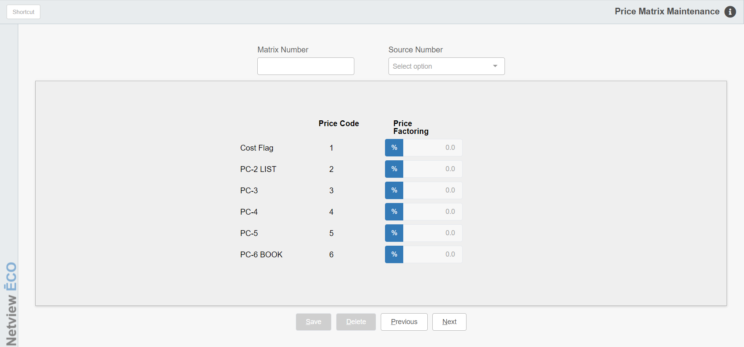

Price Matrix Maintenance offers the ability to build a discount structure based on individual Parts source numbers. The records created here may be used in the Customer Master to indicate special pricing for that customer.

This feature can be helpful when a customer gets a discount on parts in certain sources but pays regular list for the remainder of purchases. In this case, a series of price matrices can be created which define the discount the customer receives for any source.

Multiple matrices can be built within the same matrix number. Example: A customer is to receive a 15% discount off list for New Holland parts, AGCO parts, and Kubota parts. To accomplish this discount structure, build a price matrix (like number 100) for each of the three sources showing the 15% discount. They all would have the same Matrix number and then reference each of the three sources to be discounted. The Matrix number then must be added to the Price Matrix Code field in the Customer Master (ECI). When parts are sold to the customer in the future, parts from the three identified sources would be discounted 15% while all other parts would be sold at regular list.

To access this function, either:

- Select “Accounts Receivable” from the menu and choose the “Data Entry” submenu. Click on “Price Matrix Maintenance.”
- Type “PM” in the Shortcuts Bar.
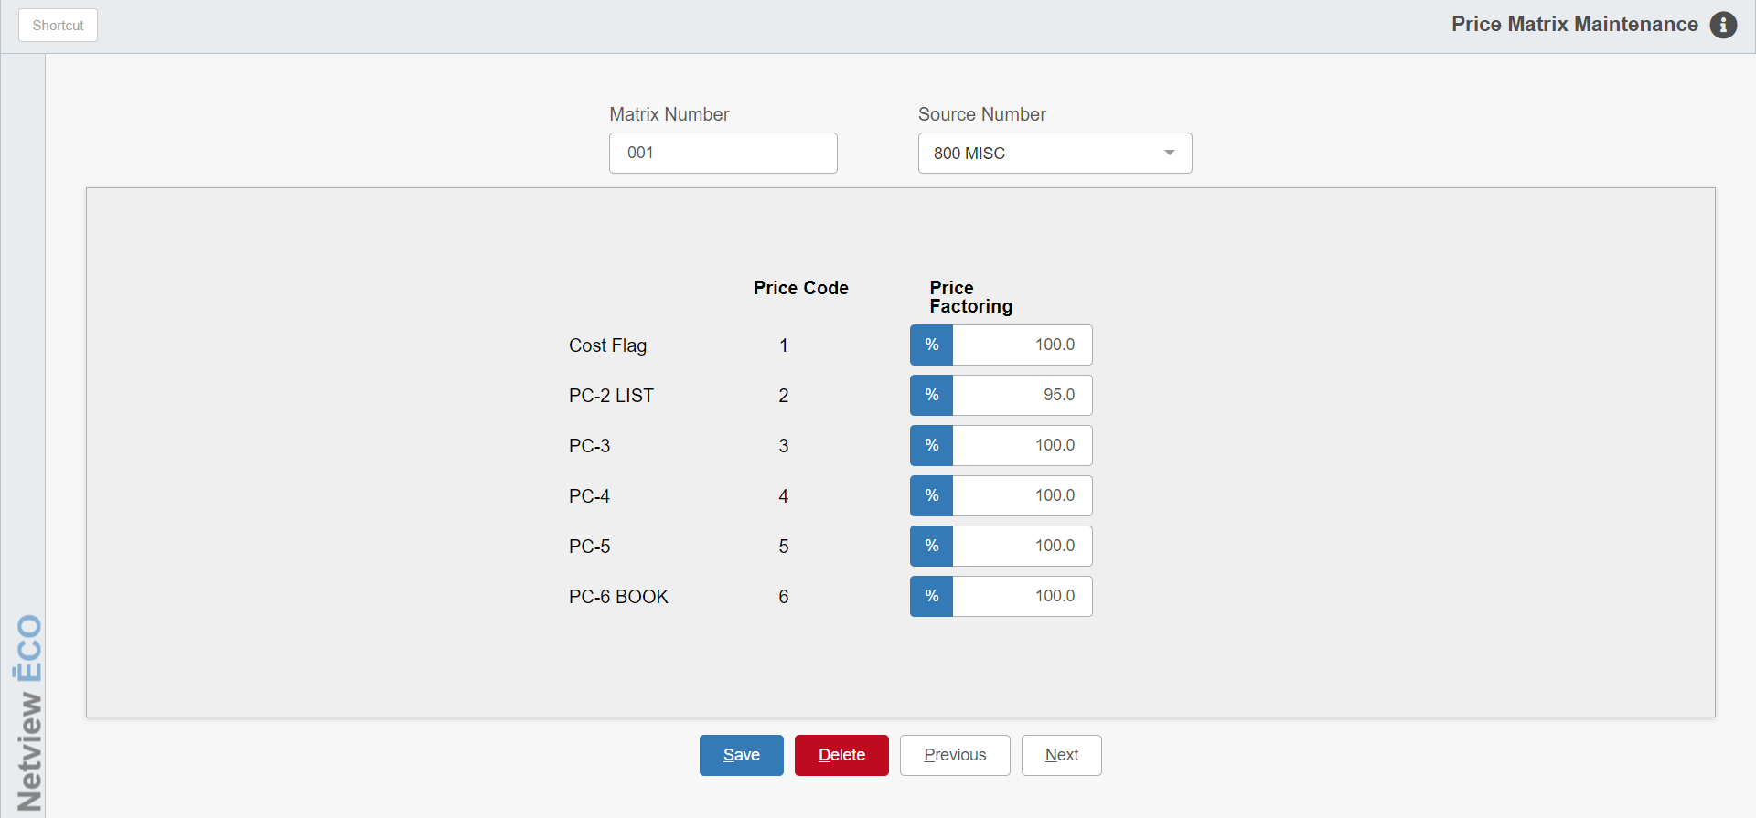

Field Definitions

Matrix Number: This field holds the matrix number of the pricing structure. It can be up to 3 digits long. The same matrix number can be used to collect the discounts for multiple sources if needed.

Source Number: Type in the parts source number or use the drop-down menu to select it.

Cost Flag (Price Code 1): This field shows the percentage to be used for the definition of Cost for the matrix. This percentage is applied to the value in the MFR COST field in the Part Master and/or the definition in the Price Level for this source.

You might use this field if the discount is based on cost.

If the discount for this matrix is not based on cost, the field should be defined with 100.0 in the Price Factoring field so its value is kept the same.

PC-2 List (Price Code 2): This field shows the percentage to be used for the definition of Price Code 2 or List for the matrix. This percentage is applied to the value in the LIST field in the Price Level for this source.

A number less than 100 percent in this field indicates a discount from the usual calculation of the List value.

A number higher than 100 percent in this field indicates a bump over the usual calculation of the List value.

If the discount for this matrix is not based on List, the field should be defined with 100.0 in the Price Factoring field so its value is kept the same.

PC-3 (Price Code 3): This field shows the percentage to be used for the definition of Price Code 3. This percentage is applied to the value in the Price Code 3 in the Price Level record for this source.

A number less than 100 percent in this field indicates a discount from the usual calculation of the Price Code 3 value.

A number higher than 100 percent in this field indicates a bump over the usual calculation of the Price Code 3 value.

If the discount for this matrix is not based on Price Code 3, the field should be defined with 100.0 in the Price Factoring field so its value is kept the same.

PC-3 (Price Code 4): This field shows the percentage to be used for the definition of Price Code 4. This percentage is applied to the value in the Price Code 4 in the Price Level record for this source.

A number less than 100 percent in this field indicates a discount from the usual calculation of the Price Code 4 value.

A number higher than 100 percent in this field indicates a bump over the usual calculation of the Price Code 4 value.

If the discount for this matrix is not based on Price Code 4, the field should be defined with 100.0 in the Price Factoring field so its value is kept the same.

List (Price Code 5): This field shows the percentage to be used for the definition of Price Code 5. This percentage is applied to the value in the Price Code 5 in the Price Level record for this source.

A number less than 100 percent in this field indicates a discount from the usual calculation of the Price Code 5 value.

A number higher than 100 percent in this field indicates a bump over the usual calculation of the Price Code 5 value.

If the discount for this matrix is not based on Price Code 5, the field should be defined with 100.0 in the Price Factoring field so its value is kept the same.

MSRP or Book (Price Code 6): This field shows the percentage to be used for the definition of Price Code 6, also known as Book or MSRP (Manufacturers Suggested Retail Price). This percentage is applied to the value in the Book or MSRP field in the Price Level record for this source.

A number less than 100 percent in this field indicates a discount from the usual calculation of the MSRP value.

A number higher than 100 percent in this field indicates a bump over the usual calculation of the MSRP value.

If the discount for this matrix is not based on MSRP, the field should be defined with 100.0 in the Price Factoring field so its value is kept the same.

NOTE: Each price code’s name is customizable by dealership, so the exact name shown for each price code may vary.

Price Code: The Price Code column lists all of the available price codes.

Price Factoring: The Price Factoring column shows an additional discount off the standard pricing structure. The calculation works like this:

Example: Parts Master Value times % Markup in Parts Source times % Found in Matrix
  - 90.00 (Part Master) times 110.00% (Parts Source) times 80.00% (Matrix)
  - 90.00 x 110.00% = $ 99.00 x 80.00% = $79.20
- Example: Parts Master Value times % Markup in Parts Source times % Found in Matrix
  - 55.00 (Part Master) times 107.00% (Parts Source) times 85.00% (Matrix)
  - 55.00 x 107.00% = $ 58.85 x 85.00% = $50.02

Up to 999 Price Matrix tables may be created. Within each Price Matrix, you may reference any combination or all sources on the system. In addition, discounts may be included for all or selected price codes for that source.

