Price Matrix List (PML)

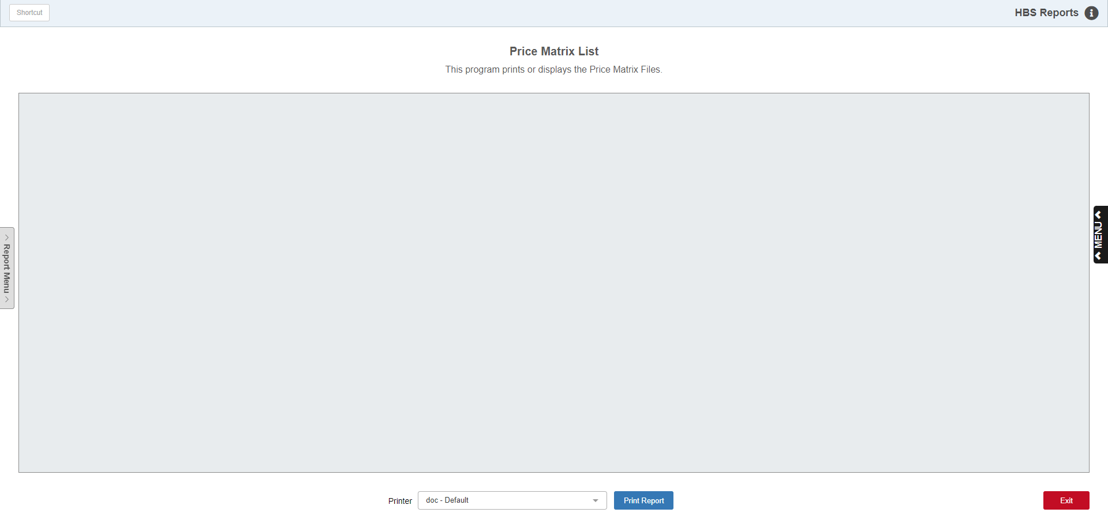

This report provides information about any price matrix structures defined on the system. The pricing structures show the discounts/pricing base for the sources shown. It is wise to review these periodically to make sure the discount structure remains appropriate.

To access this function, either:

- Select “Accounts Receivable” from the menu and select the “Memo Reports” submenu. Click on “Price Matrix List.”
- Type “PML” in the Shortcuts Bar.

Printer Name: Select the printer to receive the printout. A default printer name is pre-filled but can be changed as necessary using the menu. Use the pdf printer to view the report on the screen without printing a copy of it.

Print Report: Click this button to start the report.

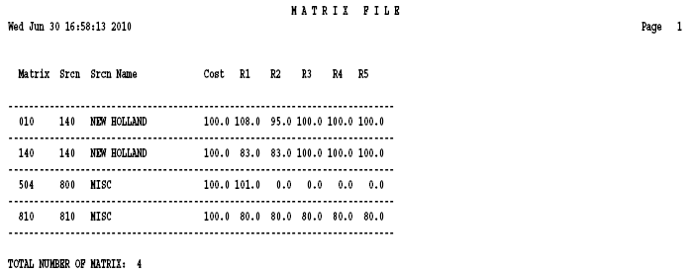

Report Field Definitions:

Matrix: This column shows the matrix number of the pricing structure.

Srcn: This column displays the source number affected by the price matrix.

Srcn Name: This column displays the name associated with the source affected by the price matrix.

Cost: This column shows the percentage to be used for the definition of Cost for the matrix. This percentage is applied to the value in the MFR COST field in the Part Master and/or the definition in the Price Level for this source.

R 1: This column shows the percentage for Retail 1 or List or Price Code 2 for the matrix. This percentage is applied to the value in the LIST field in the Price Level.

R 2: This column shows the percentage for Retail 2 or Price Code 3. This percentage is applied to the value in the Price Code 3 in the Price Level record for this source.

R 3: This column shows the percentage for Retail 3 or Price Code 4. This percentage is applied to the value in the Price Code 4 in the Price Level record for this source.

R 4: This column shows the percentage for Retail 4 or Price Code 5. This percentage is applied to the value in the Price Code 5 in the Price Level record for this source.

R 5: This field shows the percentage for Retail 5 or Book or MSRP or Price Code 6. This percentage is applied to the value in the Book or MSRP field in the Price Level.

