Parts Master Maintenance (PMM)

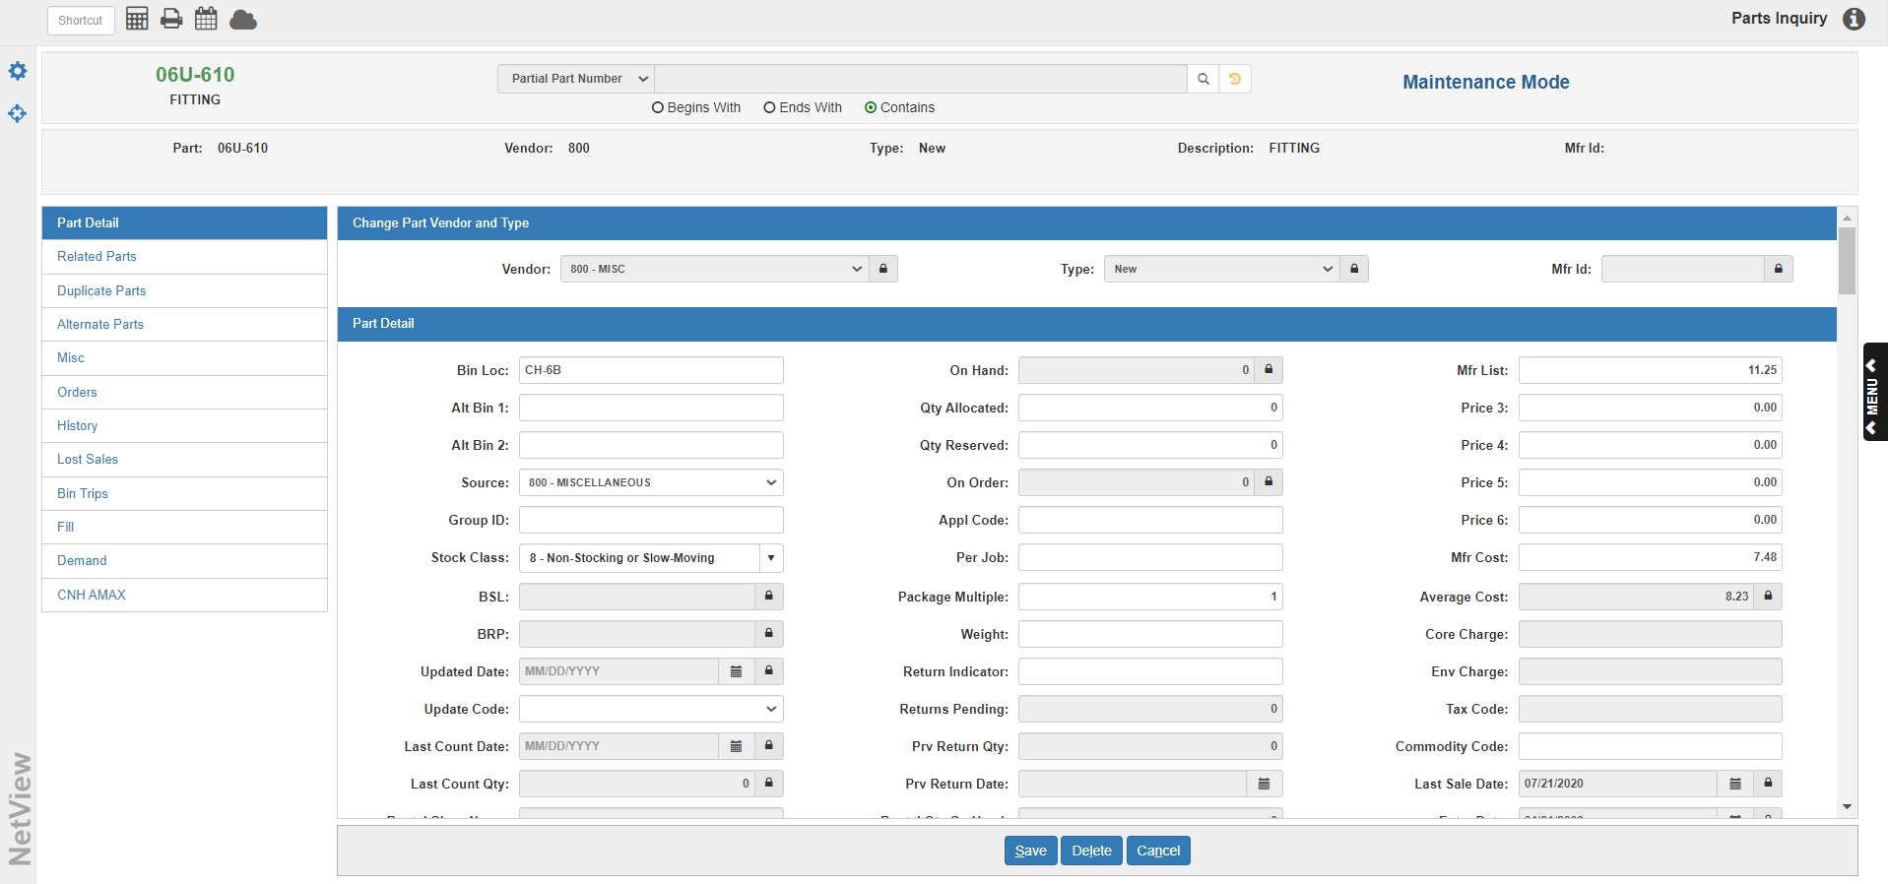

The Parts Master is the source of the finest level of detail about an individual part’s behavior in terms of pricing, stocking requirements, history, and lifecycle. This is where general information about the current cost, suggested selling price, current on hand, and on-order quantities is kept. Yearly and monthly summaries of activity for each part number are also available.

A Parts Master record is required for each individual part number on the system. When a new Part Master is created, defaults are pulled into the record from the appropriate Source Master and defaults in the company files. These auto-filled defaults can be changed to fit the individual characteristics of the part itself. There is the option to customize the settings to match the unique qualities of the part and how it is to perform. These settings can provide extensive handling instructions for the record which apply to pricing, ordering, and maintenance.

Duplicate Part Number Usage: If a part number is entered in any inventory program or POS/ROM Invoicing with two or more matching records, a duplicate part number pop-up box displays all of the applicable part number records along with their descriptions, vendor numbers, and types. Select the desired number to continue.
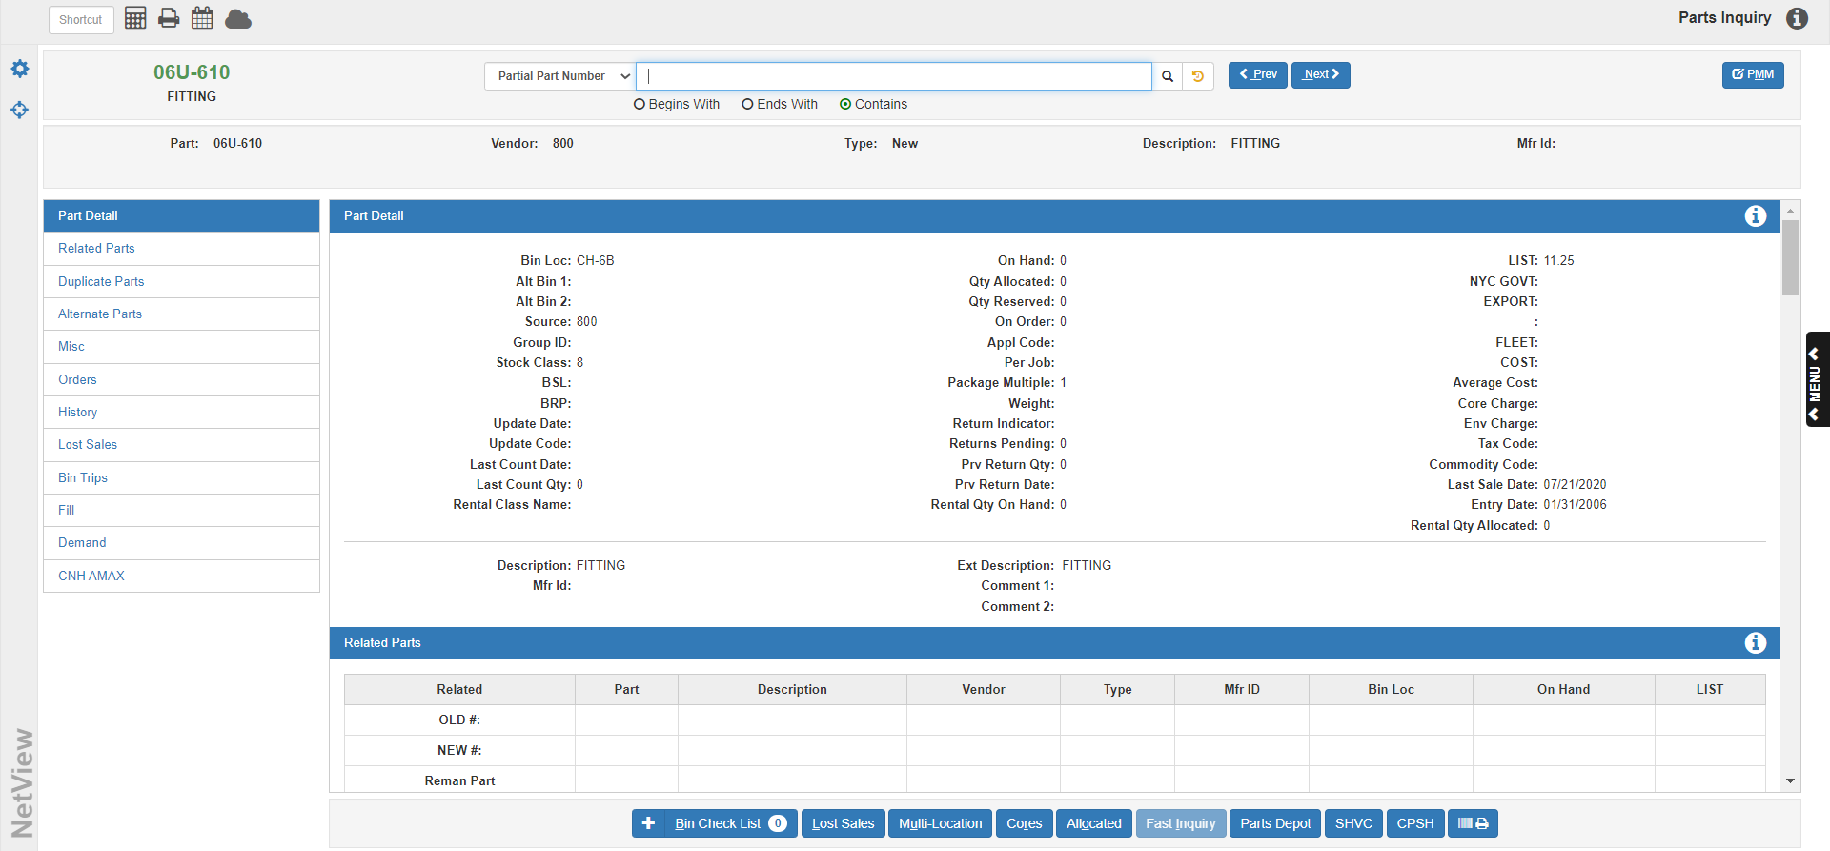

To access this program, you can either:

- Select “Inventory” from the menu. Choose the “Parts/Source Update” submenu and click “Parts Master Maintenance.”
- Type “PMM” in the Shortcuts Bar.

Additionally, as this application has now been merged with Parts Inquiry (PI), you can access the program by either:

- Selecting “Inventory” from the menu and clicking “Parts Inquiry.”
- Type “PI” in the Shortcuts Bar.

Parts Inquiry will open. Use the Search feature at the top of the page to locate the Part Master record you wish to modify.

Search Options

Partial Part Number: If you don’t know the full part number, choose this search option from the drop-down menu to search for the part using only a part of the number.

- Begins With: Click this circle to search for a part by the first characters of its part number.
- Ends With: Click this circle to search for the part by the ending characters of its part number.
- Contains: Click this circle to search for the part by any characters contained in the part number.

Full Part Number: Choose this search option from the drop-down menu to search for the part by entering the full part number.

- Include All Locations: Check this box to search for the full part number in all dealer locations.

Description: Choose this search option from the drop-down menu to search for the part by its description.

- Begins With: Click this circle to search for a part by the first characters of its part number.
- Ends With: Click this circle to search for the part by the ending characters of its part number.
- Contains: Click this circle to search for the part by any characters contained in the part number.
- Include Extended Description: Check this box to search using the extended description.

Alias: Choose this search option from the drop-down menu to search for the part by its alias.

Search Field: Type your chosen search criteria in this field.

Search: Click this button 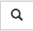 to begin the search. The results will appear in a separate window. Locate the part you want and click on it to open the record.

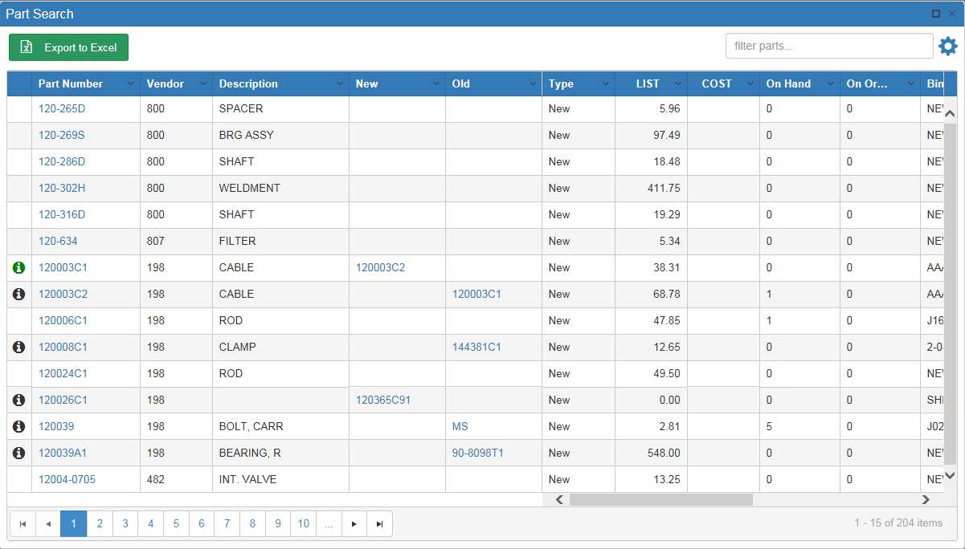

Sort Features: Use the sort features to locate your desired part.

- Page Numbers: Use the page numbers at the bottom of the window to jump between pages.
- Sortable Headers: Click on the arrow on the right side of the column headers to view further sort options.

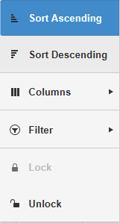

- Sort Ascending: Click this option to sort the results in ascending order by the column’s content. For example, if you click “Sort Ascending” under the Part Numbers header, then the results will sort in ascending order by Part Number. You can also perform this sort by clicking the column header once.
- Sort Descending: Click this option to sort the results in descending order by the column’s content. For example, if you click “Sort Descending” under the Part Numbers header, then the results will sort in descending order by Part Number. You can also perform this sort by clicking the column header—twice from when the search window first opens or if the results have been sorted by a different column, once if the results are already sorted in ascending order by that column’s content.
- Columns: Use this checklist to determine which columns you want to view. Unchecking a box will automatically remove the column from the results grid, while checking one will automatically add the column.
- Filter: This option allows you to filter your search results in greater detail using the data in that specific column. Use the drop-down menus to set how you want the results to filter.
- Unlock/Lock
  - Clicking Unlock allows you to switch the column’s position in the grid order.
  - Clicking Lock fixes the column in its location.
- Filter Bar: Use the Filter Bar in the upper right-hand corner to further narrow down the results. Type in further search criteria and the results will update to reflect it.

Related Parts: The far-left column of the results grid will sometimes contain the following icon 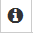. Hovering the mouse over the icon will reveal the Related Parts grid, which displays all part numbers related to this one. Clicking the part number in this display will automatically open the related part’s record.

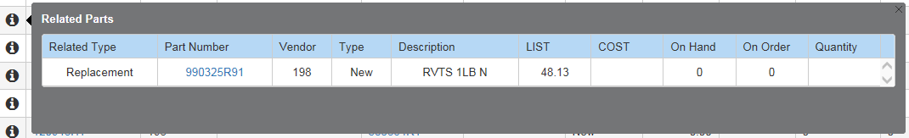

The Related Type column shows the relation between the two part numbers. In the example above, this part number is a replacement for a previous number. If the icon is green 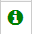, then the other part number has an available on-hand quantity.

Export to Excel: Click this button to export the search results into Microsoft Excel.

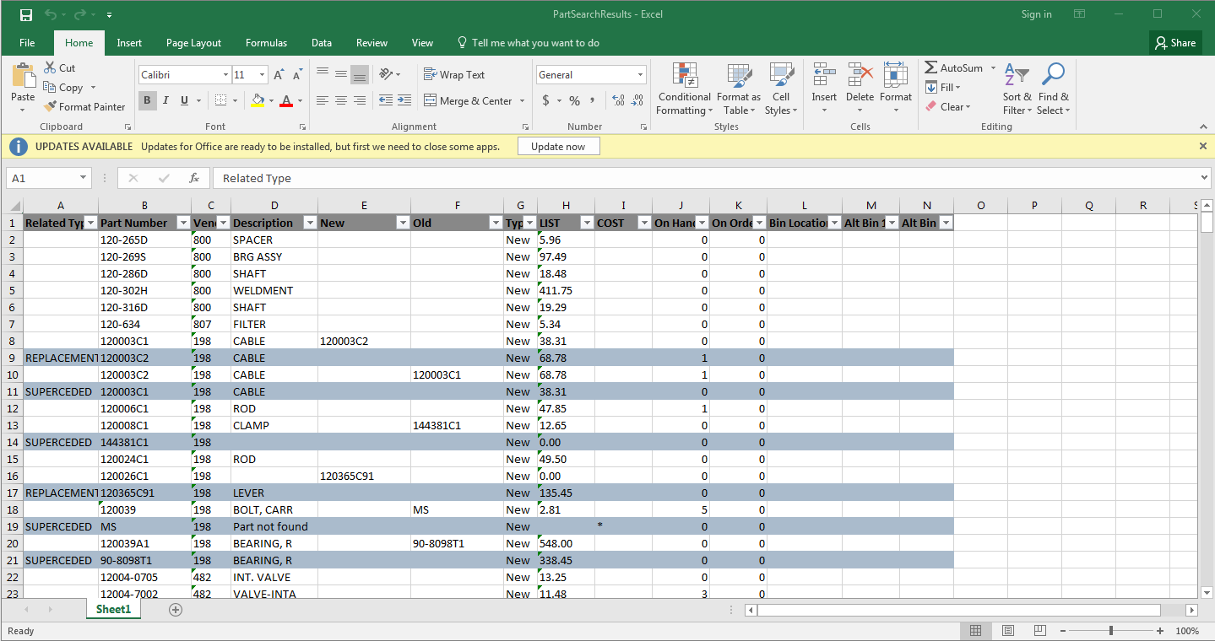

Search Recall: This button  appears next to the Search button. After you have made a search and selected a part, the button will turn gold . Clicking it will re-open the search window and display the results of your last search, allowing you to pick up exactly where you left off before selecting a record.

PMM Button: Once you have found the part record you want, click the  button in the header to open the Maintenance Screen. You can now modify the part record as desired.

Base Part Info-Field Definitions: Be aware that most fields displayed in this section can be removed or added as desired. This section will cover the default fields which will always appear for each part, as displayed in the above example. See “Focus Base Part Info” below for the other fields that can display here.

Part: This shows the part number of the record currently displayed.

Vendor: This shows the vendor number associated with the part.

Type: This shows the part’s type (New, Old, Used, etc.).

Description: This shows the part’s description.

Mfr ID: This field shows the manufacturer ID, if any.

Other Buttons

Next: This button is not active in PMM.

Previous: This button is not active in PMM.

Save: Click this button to save any changes made to the record.

TIP – Record Locking Process: The record locking mechanism only locks the record at the point of saving/updating the record. A message is displayed if the record you are editing and about to save has been edited/changed from another screen. The message screen informs you that the record was updated by someone else. If you continue, you will discard the changes made by someone else and overwrite them with your change.

Delete: Click this button to delete the record.

Cancel: Click this button to return to the Parts Inquiry display.

Save Configuration/Restore Search: Click this icon  to access the option to either save the current search configuration or reset the search to its default settings.

Focus Base Part Info: Click this icon to select what information is displayed in the Base Part Info section.

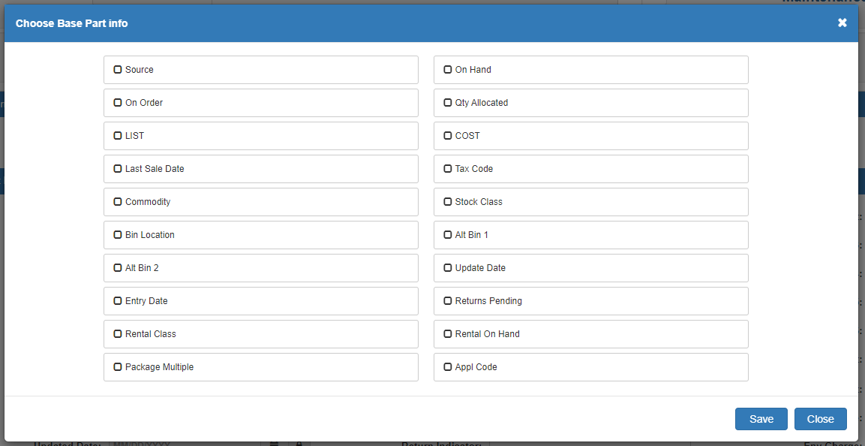

Source: This field shows the part’s source number.

On Hand: This field shows the part’s on-hand quantity.

On Order: This field shows the quantity of outstanding orders (regular and back order) for this part. It is a total of ALL orders on the system, and is updated each time a new order is created, changed, or receipted. All updates to this field are processed through the ordering programs, as well as the POS and ROM Invoicing backorder function.

Qty Allocated: This field shows the quantity of this Part Master that has been placed on open picking tickets (in POS and ROM). Parts that have been assigned to a picking ticket or repair order reduce the ON HAND field. When the picking ticket becomes an invoice, the quantity shown in the Qty Allocated field is relieved.

LIST: This field shows the part’s List/Selling price. NOTE: The field name may change depending on your dealership’s settings in Inventory/Point-of-Sale Defaults (IPOS).

COST: This field shows the part’s Cost. NOTE: The field name may change depending on your dealership’s settings in Inventory/Point-of-Sale Defaults (IPOS).

Last Sale Date: The Last Sales Date is the date of the last sale of this part. This system-maintained field is updated each time a part is sold on a POS or ROM invoice.

Tax Code: This field shows the part’s tax code, which locks in the part’s taxable status.

Commodty: The Manufacturer Price File updates this field when PUV is run. It contains the special pricing codes or commodity codes that the vendor has set up for ordering purposes (i.e., codes that determine grouping, pricing, discounts, and bulk ordering). The Standard Stock Order (SSO) and Custom Stock Order (CSO) both offer the ability to create orders based on these codes.

Stock Class: This field shows the part’s Stock Class.

Bin Location: This field shows the part’s bin location.

Alt Bin 1 & 2: These fields indicate the overflow areas where parts can be stored. These fields can be up to 12 characters.

Update Date: This field is updated by Price Update and Variance (PUV) and records the effective date of the last price file installed on your system.

Entry Date: The Entry Date is the date this part was added to system. It is used for comparison purposes for inventory obsolescence.

Returns Pending: This field shows any returns pending for this part.

Rental Class: If Rental is installed and this part is a rental part, this field shows the name of the part’s Rental class.

Rental On Hand: If Rental is installed, this field shows the amount of the part available on hand for rental.

Save: Click this button to save the new Base Part Info section.

Close: Click this button to close the window.

Lock: Next to various fields, you will see the Lock icon, with the fields themselves
greyed out. This means the fields are password-protected and can only be changed
if you know the password. Click the icon to open the password window.

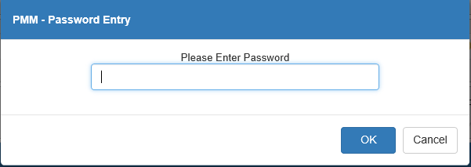

Type in the password and click "OK" to unlock ALL locked fields in the entry. The Lock icon will change to the Unlock icon and each relevant field will activate.

Change Part Vendor and Type: If you know the password to unlock all fields in a Part Master entry, you will be able to change a part’s vendor, type, manufacturer ID, and source in PMM using the fields in the top section of the record:

Vendor: This field shows the part’s current vendor. To change the vendor, select a new vendor from the dropdown menu. This will cause an additional prompt to appear, asking if you want to change the part’s source to match the new vendor:

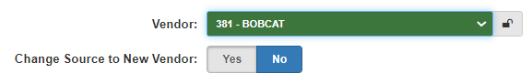

Change Source to New Vendor: If you want to change the part’s source to match its new vendor, change this option to Yes. If you want the part to retain its current source, leave it set to No.

Type: This field shows the part’s current type. To change the type, use the dropdown menu to select a new type.

Mfr Id: This field shows the part’s manufacturer ID (if any). Modify the text in the field in order to change the ID.

CHPVT Report: If you make a change in these fields when editing a Part record, you will receive the following report after clicking Save:

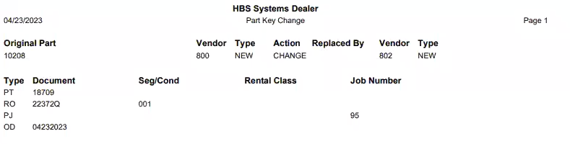

The report shows the change made as well as any additional records in the system impacted by the change. For example, the change in the example above also altered the part’s data on a picking ticket, a repair order, a parts job, and a parts order.

NOTE: If the changes you make result in the part record now duplicating another part number record, the two records will be merged together. For example, if you have two parts with the same number that belong to different vendors, and you change one part’s vendor so that both parts now have the same vendor, the records will be merged.

NOTE: You can also watch the video below for a demonstration of the process described above:

[VIDEO GOES HERE]

Sidebar Shortcuts: On the left side of the screen is a list of the different sections that comprise a Part Inquiry entry. Click on any section name to jump to that portion of the entry.

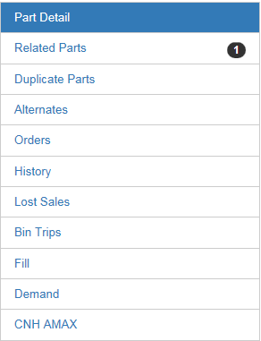

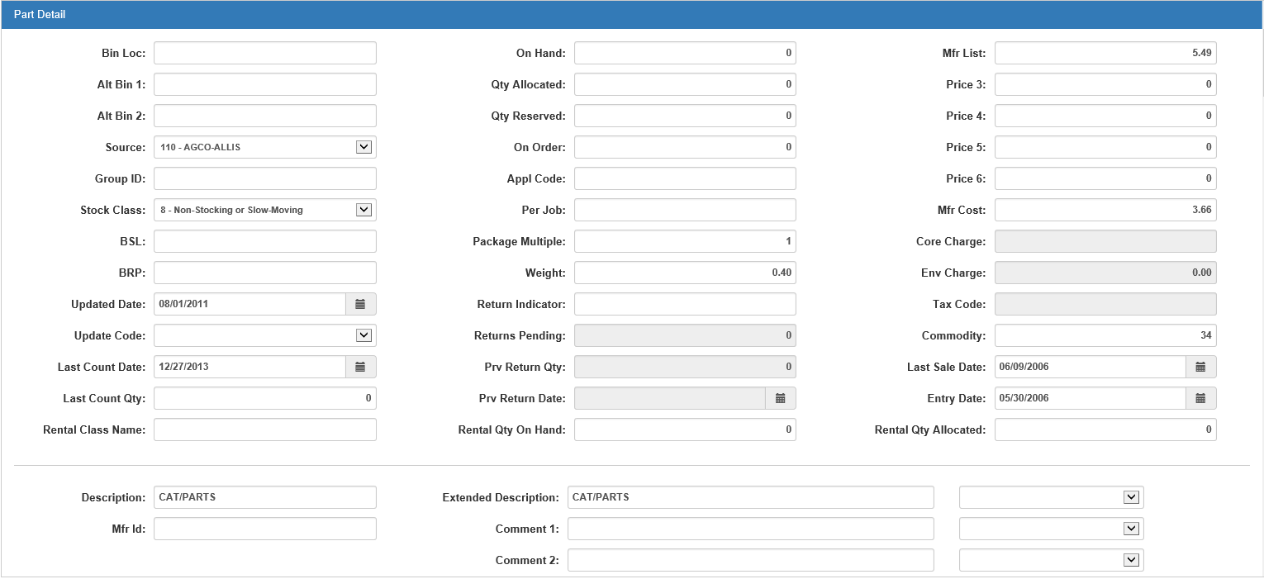

Part Detail-Field Definitions

Bin Location: The Bin Location field may contain up to 12 characters. This field shows the primary physical location of the part. The bin location displays in Parts Inquiry (PI) and may print on the customer's invoice. It is included in the ordering and return programs and printouts. All bin location assignments need to be consistent. Blank bin locations are not recommended. The Physical Inventory programs can print parts by their bin locations on Bin Count Sheets and for entering new counts.

Alt Bin Location 1 & 2: If parts are kept in overflow areas, enter these physical locations in the Alternate Bin Location 1 and 2 fields. These fields can be up to 12 characters, and appear in Parts Inquiry (PI) and on Physical Inventory Bin Count Sheets (BCS).

TIP – Designing Good Bin Locations: Most programs and reports read the Bin Location field as left justified. The Bin Location is read from the left, character by character. For example, if Bin Locations are 1, 2, 3, 10, 14, 25, they would be printed in this order: 1, 10, 14, 2, 25, 3. It is wise to design Bin Locations that are equal in length. If the longest Bin Location is three positions, then it is best to make ALL Bin Locations the same length. Bin 1 could be 001, Bin 2 could be 002, etc. This approach sorts the Bins in numerical order and helps when accessing Bin Locations sequentially.

Source: Every Part Master must be tied to a Source Number. Select the source from the drop-down menu. The source contains the necessary information to:

Price the part

Maintain its stock class

Determine BSL and BRP for ordering

Handle the accounting from POS and SMS

Group ID: The Group ID field may be manually entered and maintained OR price file provided. You can use it to set up inventory groupings by creating 10-character Group Codes. For example, if all oil products are to be grouped together, you could type “OIL” for each oil part number. These Group Codes may then be used as a basis for an oil stock order or a Report Writer report.

Some Manufacturer Price Files also categorize part numbers by Group ID. This is done so dealerships can take advantage of promotional offerings when setting up stock orders. This field is updated when running PUV. If you do not want these codes to be overwritten from a price file update, enter “No” to overwrite existing group codes when running PUV.

Stock Class: Stock Class is the code used to identify the part's stocking status (i.e. fast-moving or non-stocking). A list of the various stock classes is displayed when the arrow at the end of the field is clicked. They are also shown below.

Stock Class Definitions - Chart I:

Stock Class | Definition
1 | For fast moving parts or regular stocking parts. These parts meet the criteria defined in the Source Master. The parts show sufficient history to be considered on a suggested stock order. The system automatically includes a minimum order quantity of one (1) for all Stock Class 1 parts on a Standard Stock Order.
 | Automatic Change (when Parts Month End is run): When a Stock Class 1 part number has insufficient sales activity for the period specified in the Source Master, the system changes its Stock Class to 8.
5 | For fast moving parts sold primarily during specific times of the year or seasons. Parts with specific selling seasons are candidates for this Stock Class because they fall into predictable, defined selling times. This identification gives them special handling in the ordering routines. The selling seasons defined become part of the criteria used by the ordering routines. When the ordering period is outside the defined seasons for the part, the system will suggest a 5% demand for the parts identified with Stock Class 5 on a Standard Stock Order.
 | Automatic Change (when Parts Month End is run): When a Stock Class 5 part number has insufficient sales activity for the period specified in the Source Master, the system changes its Stock Class to 8.
6 | For new parts with sales potential. If this Stock Class is selected, usually some specific stocking levels are provided. For example, a BSL override of 1 or more is entered for these parts until they generate enough sales history for the system to calculate the BSL.
 | Automatic Change (when Parts Month End is run): When a Stock Class 6 part number has insufficient sales activity for the period specified in the Source Master, the system changes its Stock Class to 8. The system can also change the Stock Class to 1 or 5 as the sales reach the minimums set in the Source Master.
7 | For dealer-controlled or manually ordered parts. Can be used to identify parts with special purchase discounts, sporadic sales history, or other special ordering considerations.
 | Automatic Change (when Parts Month End is run): This Stock Class will not be changed by the system. Any changes to the stock class must be done manually.
8 | For parts without sufficient sales activity to meet the minimums set in the Source Master. This is commonly referred to as the Non-Stocking class.
 | Automatic Change (when Parts Month End is run): The system may change parts with Stock Class 8 to a designation of Stock Class 1 or 5 if they qualify based on sales activity.
9 | For slow moving or non-stocking parts that do not meet the minimums set in the Source Master. This code is typically used for surplus parts.
 | Automatic Change (when Parts Month End is run): The system may change parts with Stock Class 9 to a designation of Stock Class 1 or 5 if they qualify based on sales activity.
U | For non-stocking parts ordered on emergency orders for customers. These are parts that may have some sales potential.
 | Automatic Change (when Parts Month End is run): The system can change the Stock Class to 1 or 5 if sales history deserving of these Stock Classed accumulates. However, the system will not downgrade these parts to a Stock Class 8.
F | For dealer-controlled parts or parts stocked by exception. This means a part could be on a special order for a customer, or is an expensive part such as an engine. Typically, the absolute stocking levels are coordinated with this Stock Class to specify the preference or ordering habits.
 | Automatic Change (when Parts Month End is run): This Stock Class will not be changed by the system. Any changes to the stock class must be done manually.
A | This Stock Class is used for two purposes. It could be a designation by the manufacturer that this part has been replaced by another part number. This is typically added when a price file update is automatically done or manually entered. It is also used for “non-part” numbers like labor or freight when they have been added for POS. This Stock Class prevents a part number from being considered for deletion by the Month End process.
 | Automatic Change (when Parts Month End is run): This Stock Class will not be changed by the system. Any changes to the Stock Class must be done manually.

Additional Stock Class Designations: Each dealership might also set up its own manually-controlled stock classes. Any of the following codes may be used for that purpose:

2 3 4 B C D E G H I J K L M N O P Q R S T V W X Y Z

TIP – Manually Defined Stock Classes: The stock classes manually defined MUST be manually maintained. The system will not perform maintenance of the Stock Class. It is a good idea to review the history of these numbers/stock classes periodically to determine if a change to a traditional stock class is warranted. Run a Parts Inventory Master Pad (History style) to make this determination.

BSL: The Standard Stock Order (SSO) maintains the calculated Best Stocking Level (BSL) for the part. The Parts Source holds the number of days supply to keep adequate stock quantities on hand (i.e., 30, 45, 60 or 90 days). When the Standard Stock Order is run, the part’s sales history is reviewed and calculated against the Source’s criteria. The result is the part’s BSL quantity needed for the time period selected in the Source. The Multi-Store Standard Stock Order program also uses this field.

BRP: The Standard Stock Order (SSO) also calculates and maintains the Best Reorder Point (BRP) for the part. In the Parts Source, the BRP field holds the number of days’ supply the stock on hand should decrease to before an order is triggered. When running the Standard Stock Order, the system reviews and calculates the on hand quantity. When this quantity drops to the BRP, the Standard Stock Order reorders enough stock to replenish to the calculated BSL. The Multi-Store Standard Stock Order Program (MSSO) also uses this field.

Update Date: This field is updated by Price Update and Variance (PUV) and records the effective date of the last price file installed on your system.

TIP – Keeping Track of “Frozen” or Un-updated Pricing: If you block a part from being updated from the price file, it’s a good idea to use Report Writer to periodically review the manually priced parts.

Update Code: The Update Code field indicates if this part number should be affected by a price file update.

- Choose Yes from the drop-down menu for Price Update and Variance (PUV) to update the price file information for this Part Master.
- If this part number is not to be updated by the price file when it is loaded, choose No. This blocks all updating from a price file.
- A blank field defaults to Yes.

Last Count Date: This field stores the date of the last physical inventory taken on the system. For instance, if physical inventory was taken in October of last year, this field would show the date the update was run. This can be a very useful field because it gives information about the last time this part was inventoried.

Last Count Qty: This field shows the final physical count (quantity) for this part when it was last updated from the Physical Inventory process.

Rental Class Name: If Rental is installed and this part is a rental part, enter the name of the part’s Rental Class here.

On Hand: This system-maintained field reports the current quantity on hand. It is the total quantity in all bin locations for this part number. For example, if the item is sold in a case lot only, then the quantity on hand will be in case units. If the item is sold on a piece-by-piece basis, then the quantity would be the total of those single units. This field is updated by the system whenever a part is sold, or a part order or return is receipted. It can also be changed from the Post Inventory Adjustment (PIA) screen where any manual entries should be done. Since the field reflects the on shelf quantity, parts on open repair orders or open picking tickets affect this field and reduce the on hand quantity.

Qty Allocated: This field shows the quantity of this Part Master that has been placed on open picking tickets (in POS and ROM). Parts that have been assigned to a picking ticket or repair order reduce the ON HAND field. When the picking ticket becomes an invoice, the quantity shown in the Qty Allocated field is relieved.

Qty Reserved: The Quantity Reserved field is manually entered and maintained. This is a multi-location feature. Your dealership may want to reserve a certain quantity at all times at their location. When the Inter-Store Parts Transfer (ISPT) program is run, it considers the quantity value in this field before letting on hand quantities move to another location.

Qty On Order: This field is system-maintained. It shows the quantity of outstanding orders (regular and back order) for this part. It is a total of ALL orders on the system, and is updated each time a new order is created, changed, or receipted. All updates to this field are processed through the ordering programs, as well as the POS and ROM Invoicing back order function.

Appl Code: The Application Code is used primarily for New Holland and Ford Motor dealers to specify sorting preferences. It is often provided from a price file and contains the Base Number of all the old Ford part number. In IPOS, you can specify to Sort Vendors 140 & 237 by APPL CODE. This setting is used to sort the Inventory Master Pad and other inventory/ordering reports. If you are not a New Holland/Ford Motor dealer or do not want to sort by the base number, it can be used as another classification field for parts. You can enter up to 8 characters in this field.

Per Job: Per Job Quantity field is manually maintained and represents the quantity needed to complete a shop job. This helps the ordering programs to maintain proper shelf quantity. Enter the desired quantity in this field.

It is important to keep the quantity on hand by job or set, as these parts are most often used when a certain quantity is required to perform a typical job. For example, if it takes four bearings each time this part is used, then indicate that the PER JOB amount is four. This tells the system to keep the quantity on hand in multiples of four (4). The system’s ordering formulas will consider this and the on hand quantity will be maintained in correct multiples.

Package Multiple: The price files update the Package Multiple field. If a vendor always ships two or more of this part number as a package, this field displays the appropriate amount. The quantity on hand and pricing for this part would be kept by piece but the orders will be by the package quantity. For example, if a Package Multiple is 25, the stock ordering programs will generate an order quantity based on multiples of 25 (i.e., Order Quantity = 25, which is 1 package).

Weight: This field is the actual weight of a single part. If available, this information is supplied by the Manufacturer’s Price File and is updated when PUV is run. Otherwise, enter it in this field manually.

Return Indicator: This field is updated by the Manufacturer Price Files. The codes in this field indicate if the part can be returned to the vendor. For example, some vendors use a system to identify parts simply as returnable or non-returnable. Others use different codes to indicate more specific return information, such as how long it may be returnable, obsolescence, etc. This information can be used for printing a list of returnable parts or creating a parts return.

Returns Pending: This system-maintained field shows how many returns this part has pending. It cannot be changed

Prv Return Qty: This system-maintained field shows the previous quantity of the part returned to the dealership. It cannot be changed.

Prv Return Date: This system-maintained field shows the date of the previous part return. It cannot be changed.

Rental Qty On Hand: If Rental is installed and this part is a rental part, enter the quantity of the part available for rent.

Mfr List: Enter the Manufacturer's Suggested Retail Price (MSRP) for this part here. When a price file is present for this source, the displayed value is often pulled directly from there. The dollar amount here should represent the MSRP of ONE part. This dollar value must equal the quantity on hand so that, as units are sold, proper accounting entries will be made for the sale and relief of inventory.

If the value shown here is not representative of the MSRP of ONE part, then the Cost per C field may be helpful.

This field can be updated by the system whenever a new price file is loaded. It can also reflect a change from one of the update programs or manual changes made in the Part Master itself.

This field is often used as the base for determining the list price, as it is often marked up to calculate the list price.

Price 3-6: These four fields can hold additional prices. Some dealerships use them for special groups of customers: Export Price, Employee Price, DS01, and so on.

Mfr Cost: Enter the replacement cost of this part here. The value shown here is what it costs the dealership to buy this part today. The dollar amount here represents the cost of ONE part. This amount must equal the quantity on hand so that, as units are sold, the correct accounting entries can be made to recognize the sale and relief of inventory.

If the value shown here is does not represent the cost of ONE part, then the Cost/C field may be helpful for this part number.

When a price file is present for this source, the value in this field is updated from the price file through the Price Update and Variance Report (PUV) program.

If no price file is available for this source, manually maintain this field through this program or through others such as Manual Price Updates (MPU).

Average Cost: This field only appears if your dealership has Average Costing turned on. It holds the part’s calculated average cost.

Core Charge: If the part has a core charge attached to it, this system-maintained field shows the charge amount. It cannot be changed.

Env Charge: If the part has an environmental charge attached to it, this system-maintained field shows the charge amount. It cannot be changed.

Tax Code: This field shows the part’s tax code, if applicable. The code locks in the part’s taxable or non-taxable status. This field can only be changed if you chose to override the tax code. If this part can be taxable or non-taxable based on the customer, then the field should be left blank.

Commodity: The Manufacturer Price File updates this field when PUV is run. It contains the special pricing codes or commodity codes that the vendor has set up for ordering purposes (i.e., codes that determine grouping, pricing, discounts, and bulk ordering). The Standard Stock Order (SSO) and Custom Stock Order (CSO) both offer the ability to create orders based on these codes.

Last Sale Date: The Last Sales Date is the date of the last sale of this part. This system-maintained field is updated each time a part is sold on a POS or ROM invoice.

Entry Date: The Entry Date is the date this part was added to system. It is used for comparison purposes for inventory obsolescence. When adding a part, the current date is placed in this field.

Rental Qty Allocated: If Rental is installed, this field shows the quantity of this part listed on open rental contracts.

Description: Enter the part’s description here (Bolt, Core, Wheel, etc.).

Mfr Id: Enter the manufacturer ID, if any, in this field.

Ext Description: The Extended Description field holds up to 58 characters and can be provided from a price file or manually entered. Use the drop-down menu to the right of the field to choose whether to:

- Print the Extended Description on the invoice
- Leave the Extended Description off the invoice
- Follow the option set in IPOS

Comment 1 & 2: These two fields can hold comments made about the part. Use the drop-down menu to the right of the field to choose whether to

- Print the Extended Description on the invoice
- Leave the Extended Description off the invoice
- Follow the option set in IPOS

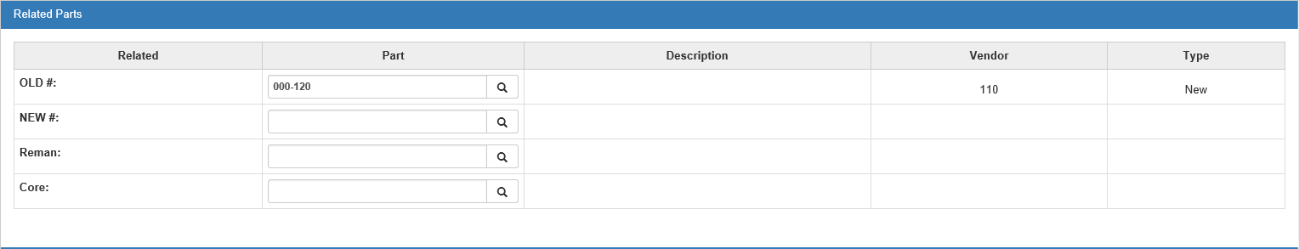

Related Parts-Field Definitions

OLD #: The Old # row is named in IPOS. The old part number (sometimes known as the "Sub/See" number) is updated by a price file or through manual changes made in Part Number Changes (PNC), though you can also manually update it in this program. When looking up this Part Master through Parts Inquiry (PI), the historical record is shown in this field. Old numbers are usually stock class A. Click the Search button to the right of the field to see a comparison of the old part number(s) and the current part number.

NEW #: The New # row is named in IPOS. It shows if the current part number has been superseded or replaced by a newer number. This information is available from some manufacturers and is often updated when a new price file is loaded, though you can also manually update it in this program. When the information is added from the price file, it updates this field with the new number, enters the old number in the OLD # row of the new part record, and changes the stock class to A on the old number. The Enter Part Number Changes (PNC) program also updates both the Old # and New # rows in both the old and new Part Master. Click the Search button to the right of the field to see a comparison of the current part number and the new part number(s).

Reman Part: If the Part Master is linked to a rebuilt or remanufactured part, then the rebuilt part number can be entered here. Click the Search button to the right of the field to see a list of remanufactured parts linked to this part number.

Core Part: If the part is linked to a core part, then the core number can be entered here. Click the Search button to the right of the field to see a list of cores linked to this part number.

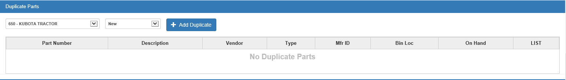

Duplicate Parts-Field Definitions: To add duplicate part numbers to the record, select the vendor number and part type (New, Used, Reman, Core, or Memo) from the drop-down menus, then click Add Duplicate. A new record will open in Custom Part Maintenance (CPM).

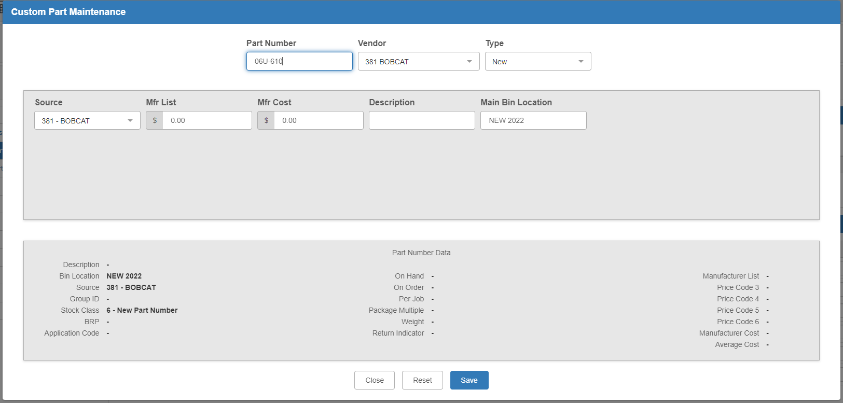

Fill in the remaining required information, then click Save. The duplicate part entry will fill in the section.

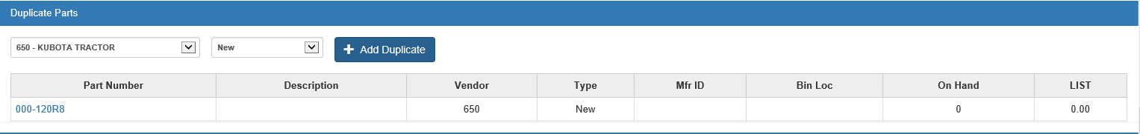

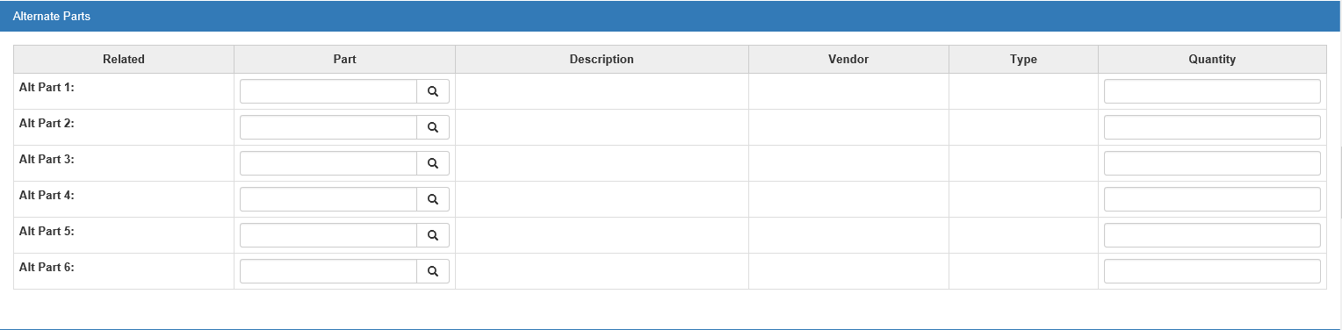

Alternate Parts—Field Definitions

Alt Part #1-6: Alt Part #1-6 is a collection of six rows that can hold information about alternate part numbers. The numbers entered here do NOT have to be numbers in inventory. It could also be used to reference the components of a kit. These fields are user-maintained and will not be updated by any system process. Type the alternate number in the Part column or use the Search button to the right of the entry field to look up a part already in the system. If you choose a part from the system, the description, vendor number, and part type will fill from the part’s record, if applicable. Enter the quantity of the alternate part in the Quantity column.

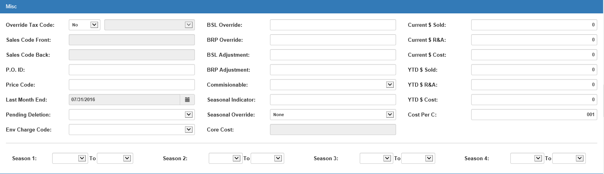

Misc-Field Definitions

Override Tax Code: This field offers the ability to lock-in the taxable nature of a part and override the customer's taxable status when this part is used in POS or ROM. When activated, this field works with the next two fields: Sales Code Front (sales code for parts counter sales) and Sales Code Back (sales code for shop parts sales).

- Select Yes from the drop-down menu to override the customer's taxable status on the picking ticket or repair order. Enter or select the correct tax code in the field next to the selection field, and fill in the sales codes in the following fields.
- Select No if it should follow the customer's taxable status.

Sales Code Front: This field is inactive UNLESS “Yes” is selected for the Override Tax Code field. If so, enter the appropriate sales code for parts counter sales in this field. This code identifies where the accounting entry will be posted when this part is added to a picking ticket or repair order.

Sales Code Back: This field is inactive UNLESS “Yes” is selected for the Override Tax Code field. If so, enter the appropriate sales code for shop parts sales in this field. This code identifies where the accounting entry will be posted when this part is added to the picking ticket or repair order.

P.O. ID: This field is a reference-only field which can contain miscellaneous information. It does not affect any inventory or ordering function, or any standard inventory reports. Often when HBS converts parts info from other systems, miscellaneous data is placed in this field. Sometimes the parts source from the previous system is kept here for future reference.

Price Code: The Manufacturer Price File updates the two-digit price code when PUV is run. This price code is vendor-specified, like for discounts, etc. It has nothing to do with the price code used in POS or ROM. You can maintain this information if it’s not on the price file and the vendor has supplied it to you.

Last Month End: The Month End date in this field is maintained by INME. It is automatically updated and shows the last time the Month End Process was run.

Pending Deletion: The Pending Deletion field is maintained by INME and identifies the parts flagged for deletion, though you can manually flag the part using the drop-down menu. The program flags the part with a D in this field if the part meets all of the criteria for deletion. The flagged part is then deleted during the following month’s process as long as the criteria are still met. The criteria are:

- No on hand quantities
- No on order quantities
- No sales history in the specified time range for the Month End Program (12/24/36/48/60 months)
- Stock Class is NOT A (History or Replaced By number)

It is not possible to remove the D from this field in order to save the record. In order to keep this part, one of the following actions may be taken:

- Take a physical count to determine if there is stock on hand. If so, make the changes in Post Inventory Adjustments.
- When the next Month End program is run, change the time range for deletion. If a lower range of months is selected, it may spare the deletion of this part.
- Cross-reference the part to an active number with a quantity that has sales history. Make the reference in PNC.
- Manually change the stock class to A. This action would be appropriate if none of the preceding reasons apply. Stock class A parts are not deleted by the Month End program.

Environmental Charge Code: This field may hold the code for an environmental charge that applies to this part. The Environmental Codes can be used to comply with local, state/provincial, or federal taxes or charges on specific items. It can also be used to add “dealership generated” fees to items. The charge may be a flat amount or a percentage of the selling price of the part itself. You can “attach” any environmental code created in the Environmental Charge Maintenance program to a part using the drop-down menu in the field. Then, each time you sell the part in POS or ROM, it will automatically add the charge to the part on the invoice. If you sell multiple units of the part with the charge, the invoicing programs will suggest the same number of environmental charges, but can be changed as necessary. Additional environmental charges may be added to the system in Environmental Charge Maintenance (ECM).

BSL Override: The Best Stocking Level Override field holds a manual best stocking level for this part. When a quantity is present, it overrides the BSL value calculated by the Standard Stock Order (SSO). Type the quantity desired in this field.

However, if the part has a stock class 6, anything entered in the BSL Override and BRP Override fields is removed during INME after the part reaches the end of its trial period. On these special parts, a value can be entered to provide a desired stocking level. Once the trial period is over, the Month End Process upgrades/downgrades the stock class 6 to either 1, 5 (both fast-moving) or 8 (non-stocking), and the BSL override value is removed. For stock class 6 parts, the ordering system also always keeps at least one in stock during the trial period.

BRP Override: The Best Reorder Point Override field holds a manual best reorder point for this part. When a quantity is present, it overrides the BSL value calculated by the Standard Stock Order (SSO). Type the quantity desired in this field.

However, if the part has a stock class 6, anything entered in the BSL Override and BRP Override fields is removed during INME after the part reaches the end of its trial period. On these special parts, a value can be entered to provide a desired stocking level. Once the trial period is over, the Month End Process upgrades/downgrades the stock class 6 to either 1, 5 (both fast-moving), or 8 (non-stocking), and the BRP override value is removed. For stock class 6 parts, the ordering system also always keeps at least one in stock during the trial period.

BSL Adjustment: The Best Stocking Level Adjustment field holds a manual BSL adjustment amount, which you enter by typing it in. Instead of overriding like the BSL/BRP override fields do, this manual amount is used WITH the system-calculated best stocking level. When the system calculates the best stocking level, it checks this field for a manual adjustment. For example, you could increase the stocking level for this part a little by putting 1 or 2 in this field. This adds 1 or 2 to the suggested order quantity by boosting the calculated stocking level (i.e., if the BSL is calculated at 10 then, add in the manual BSL adjustment to get 12).

- A positive quantity here adds to the system’s calculated BSL.
- A negative quantity here subtracts from the system’s calculated BSL.

BRP Adjustment: The Best Reorder Point Adjustment field holds a manual BRP adjustment amount, which you enter by typing it in. Instead of overriding like the BSL/BRP over-ride fields do, this manual amount is used WITH the system-calculated best reorder point. When the system calculates the best reorder point, it checks this field for a manual adjustment. For example, you could increase the reorder point for this part a little by putting 1 or 2 in this field. This causes the part to reorder sooner (i.e., if the BRP is calculated at 5 then, add in the manual BRP adjustment to get 7).

- A positive quantity here adds to the system’s calculated BRP.
- A negative quantity here subtracts from the system’s calculated BRP.

Commissionable: The Commission field determines if the part is to be included on the Parts Commission Reports (SCR and SCN).

- Select Yes to include the part on the commission reports.
- Select No to exclude the part.

Seasonal Indicator: The Seasonal Indicator is dealer maintained. Type a pound sign or an asterisk (# or *) to set the part as seasonal. This tells the system this part is sold during specific times during the year. Its selling season must be entered in the Dealer Seasons (Season 1-4) fields. Seasonal parts are additionally defined as stock class 5. INME considers the sales history of all parts with a seasonal indicator. If the sales history meets the criteria set up within the Source Master, it keeps its stock class 5 or updates the stock class from 8 to 5. Seasonal parts are ordered by the system while they are “in season” and stocked at 5% when “out of season.”

Seasonal Override: This field allows you to set the part so it cannot be manipulated by the system’s seasonal calculations. We recommend discussing the seasonal settings with a member of the HBS Support Team before implementing them.

- When a part is set to Never, the season indicator flag cannot be set by SCUD or INME.
- When a part is set to Always, the season indicator cannot be cleared by SCUD or INME.

Core Charge: If the part has a core charge attached to it, the system will fill the charge amount in this field. It cannot be manually changed.

Current $ Sold: The Current Dollar Sold field shows the sales dollars for the current month. As each part sale through POS and ROM is processed, the actual selling price is added to this field. Since this number represents the actual dollars involved in each sale, it can be affected by special pricing for the customer, and special or manual pricing used on the invoice. The current month is defined from the date and time the Month End Process (INME) was last run through the current date.

Current $ R&A: The Current Dollar Returns and Adjusted field shows the activity from Post Inventory Adjustments (PIA). The dollars in this field are based on cost/average cost.

Current $ Cost: The Current Dollar Cost field shows the cost of sales dollars for the current month. As each part sale in POS and ROM is processed, the actual cost is added to this field. This amount can be affected by how cost is set up in the system. For example, cost may be factored as 100% of the amount in the Mfr Cost field. Cost can also be factored as a percent of the amount in the Mfr List field (as the case is when the price file does not provide a cost amount). The current month is defined from the date and time the Month End Process (INME) was last run through the current date.

YTD $ Sold: The Year to Date Dollars Sold field shows the Year to Date sales dollars for the current calendar year, through the last parts month end. The Month End Process (INME) updates this field from month to month. It clears out the Current $ Sold field and adds the new amount to whatever has been in this field. When the December Month End is run, this field is cleared to prepare for the new calendar year.

YTD $ R&A: The Year to Date Dollars Returns and Adjusted field shows the Year to Date adjustment dollars for the current calendar year through the last parts month end. INME updates this field from month to month. It clears out the Current $ R&A field and adds that amount to whatever has been in this field. When the December Month End is run, the field is cleared to prepare for the new calendar year. The dollars in this field are based on cost/average cost.

YTD $ Cost: The Year to Date Dollars Cost field shows the Year to Date cost of sales dollars for the current calendar year through the last parts month end. INME updates the information in this field from month to month. It clears out the Current $ Cost field and adds that amount to whatever has been in this field. When the December Month End is run, the field is cleared to prepare for the new calendar year.

Cost Per C: The Cost Per C (cost per 100) field prompts the system to divide the factored list price and cost by the number shown here (which can be from 1 to 999). This field is used when the pricing on the part number is for a quantity of the part rather than an individual part. Typically, bulk parts carry the bulk list and cost on a price file. This field lets the system automatically calculate the individual price and cost when necessary. For example, if the pricing shown for the part is for a 5-gallon unit and it is to be sold in one-gallon units, enter the number “5” in this field.

TIP – Changing the Cost/C Information: If the Cost/C field needs to be changed, it may be necessary to make changes to the Quantity On Hand and History Sales fields to reflect the new quantity definitions. Check the PKG MULT field to see if changes are needed here as well. Whenever making changes to the Cost/C field, documenting any changes made in one of the COMMENT fields is recommended. Since the price file updates the Cost/C and these other fields, the part masters with Cost/C changes may need to be reviewed after running the Price Update and Variance Report (PUV).

Season 1-4: You may define up to four seasons. Use the drop-down menus to select the beginning and ending month for each season.

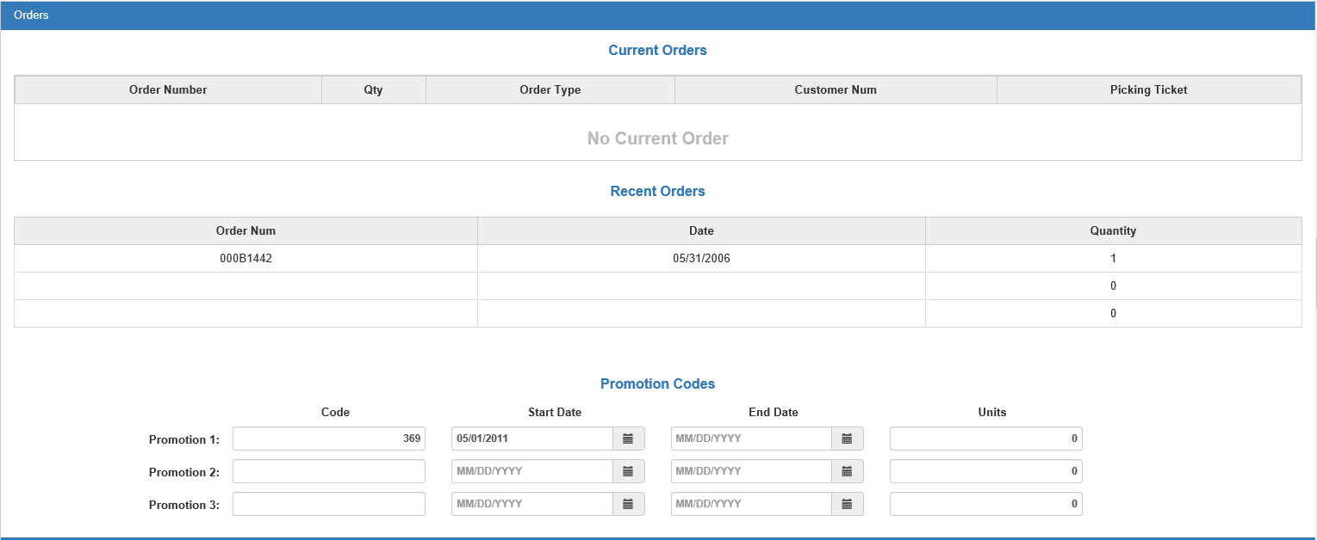

Orders-Field Definitions

Current Orders: This system-maintained section lists all current orders for the part, including:

- The order number
- The quantity of the order
- The order type
- The customer number
- The picking ticket number

Previous Orders: This system-maintained section lists the last three previous orders by their order number, the date of each order, and the quantity of each.

Promotion Codes: PUV updates these fields from the price file, though you can manually change them. Some vendors include promotional codes, dates, and how many units can be accumulated when this part number is ordered repeatedly for special discounts, credits, and other vendor-sponsored rewards. You can have up to three promotion codes on the record.

To begin, type the promotion code in the Code column. Set the start and end dates for the promotion by either typing in the dates or selecting them from a calendar. Enter the number of units connected to the promotion in the Units column.

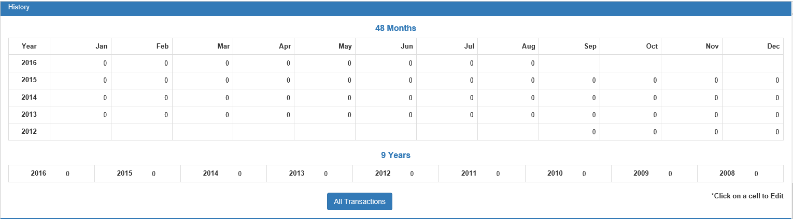

History-Field Definitions

Monthly Sales: POS and ROM Invoicing update the monthly sales grid. INME also maintains this section. This grid holds 48 rolling months of sales counts. Whenever a part is sold or returned, the quantity is added or subtracted to the current month column. The monthly sales also store fractional quantities such as 12.50. At the end of the month, INME rolls the sales history value from the current month into the previous one. The rest of the fields roll back one field to keep the complete 48 months of sales information. You can manually change the sales count by clicking on the desired cell and typing in the desired count.

9 Years – Sales: This grid holds the summary of the nine years of sales counts. The counts come from POS and ROM Invoicing. When a part is sold or returned, the quantity is added or subtracted to the current month and the current year column. INME also maintains this grid. When you run INME for December, the sales quantity in each yearly row rolls to the next oldest year in order to prepare for the new calendar year’s sales activity. You can manually change the sales count by clicking on the desired cell and typing in the desired count.

All Transactions button: Click the All Transactions button at the bottom to view all the part’s ITR activity.

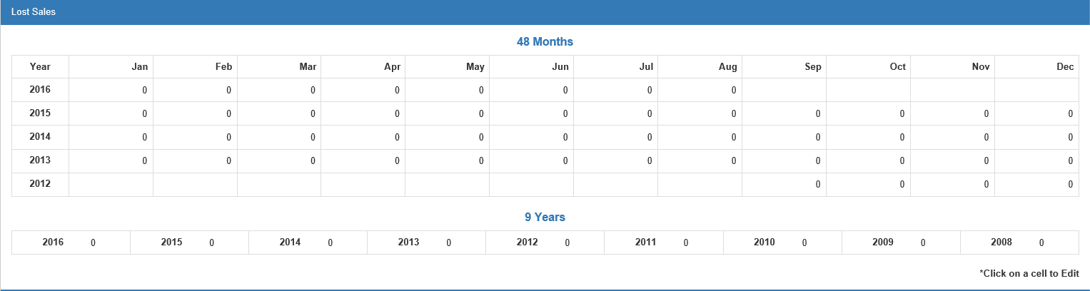

Lost Sales—Field Definitions: POS/ROM invoicing and Parts Inquiry maintain this section every time you enter a lost sale. A lost sale is when a customer comes in to make a purchase and you do not have enough stock to satisfy the customer’s needs. It means that if a customer wants to purchase an item that has either never been in stock or is currently out of stock at the time, this is considered a lost sale. You can manually change the Lost Sales counts by clicking on a cell and entering the updated number. You can also add Lost Sales in the Parts Inquiry screen using the Lost Sales button.

Monthly Lost Sales: This grid holds the lost sale quantities recorded from POS/ROM invoicing and Parts Inquiry. The screen keeps up to 48 months of lost sales history. Storing lost sales quantities helps the ordering system order enough to cover lost sale entries. At the end of the month, INME rolls the lost sales value from the current month row into the previous month and the rest of the fields roll over one column to retain the complete 48 months of lost sales information.

9 Years – Lost Sales: This grid holds the summary of the nine years of lost sales counts. The counts come from POS/ROM invoicing and Parts Inquiry. When you record a lost sale, the quantity is added to the current month column and the current year column. INME maintains these columns. For example, when you run INME for December, the lost quantity in each yearly column rolls to the next column in order to prepare for the new calendar year.

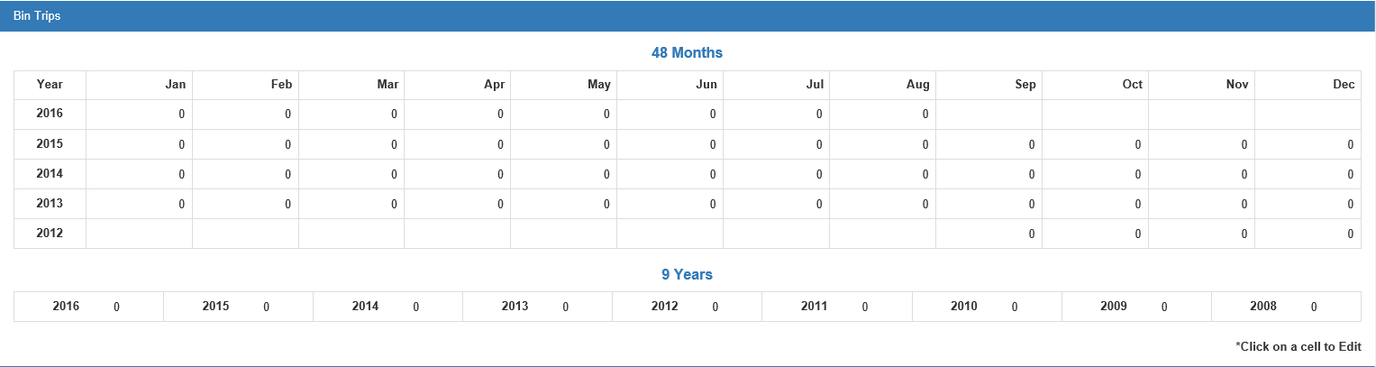

Bin Trips—Field Definitions: This information is maintained by POS and ROM invoicing. Every time a part is added to a picking ticket or repair order, a bin trip is added to the current month and year of the part sold. INME rolls the monthly bin trip history. A bin trip is the “number of trips to the bin to cover a customer’s purchase.” If a customer asks for a single quantity of one item, the parts person walks once to the bin to get it. Likewise, if a customer wants two of the same item, the parts person still only walks once to the bin. In both cases, a single bin trip is recorded, regardless of the quantity sold. Bin trip information is valuable to you since it provides additional insight of what is really taking place with a part. In a month of history with a large number of sales, it can provide you with the number of customers actually making purchases. You can manually change the Bin Trip counts by clicking on a cell and typing in the desired amount.

Monthly Bin Trips: This monthly grid holds the number of bin trips as maintained by POS and ROM invoicing. At the end of the month, the Month End Process (INME) rolls the bin trip value from the current month column into the previous one, and the rest of the fields move one column to retain the complete 48 months of bin trip information.

9 Years – Bin Trips: This grid holds the summary of the nine years of bin trips. The counts come from POS/ROM invoicing. When you record a sale, the quantity is added to the current month column and to the current year column. INME maintains these columns. For example, when you run INME for December, the bin count in each yearly column rolls to the next column in order to prepare for the new calendar year.

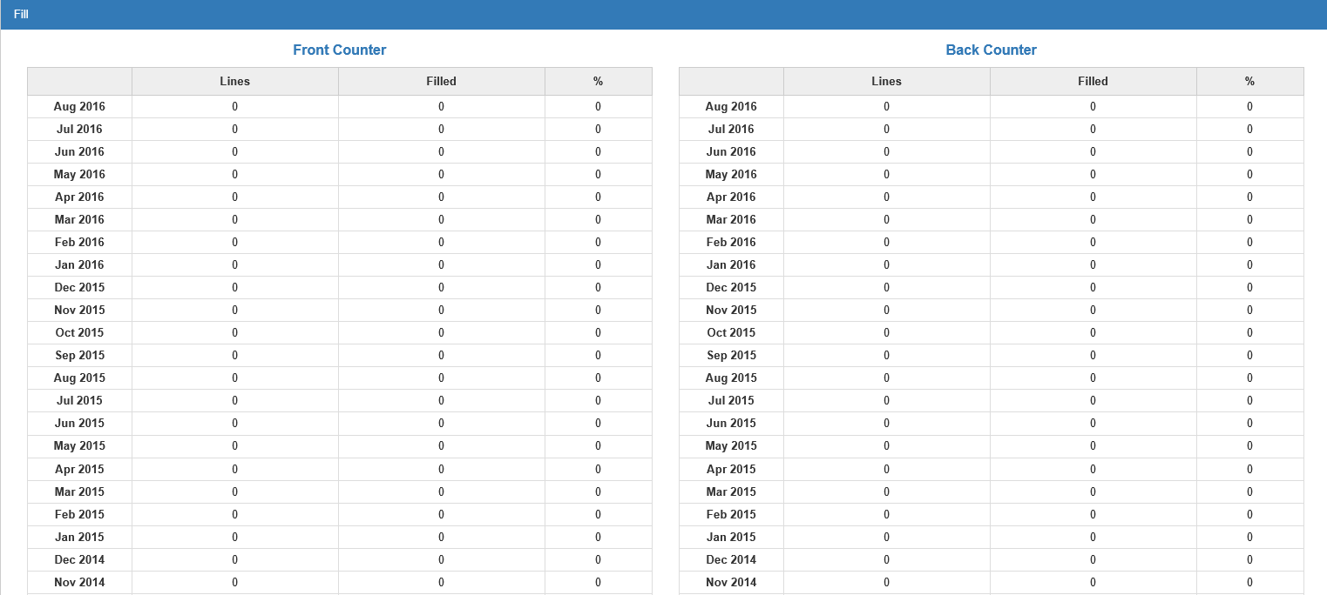

Fill—Field Definitions: The Fill section is used for the CNH Availability Max interface. It focuses on the number of invoice lines for the part number and the number filled from inventory for each of the previous 24 months. The percentage filled displays in the third column. The columns show activity for both the front counter (parts invoices) and back counter (repair orders). Totals are recorded at the bottom of the section. These fields cannot be manually changed.

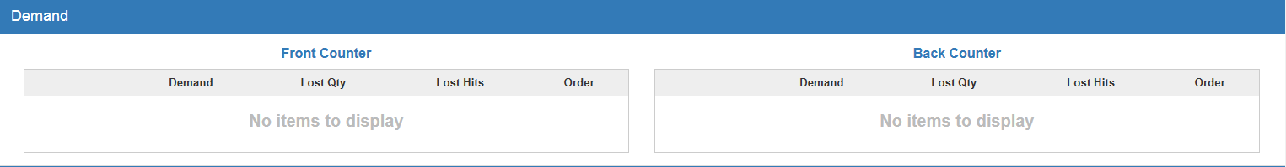

Demand—Field Definitions: The Demand section is used for the CNH Availability Max interface. It focuses on the demand for the part number, lost sales quantity, lost sales hits, and order quantities for each of the previous 24 months. These columns show activity for both the front counter (parts invoices) and back counter (repair orders).

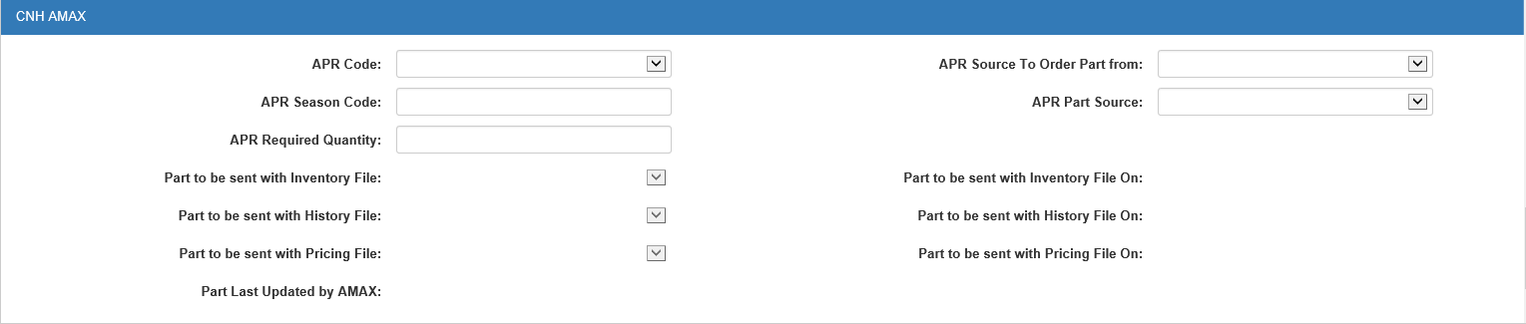

CNH AMAX-Field Definitions: The fields on this tab are completely maintained by the CNH Amax interface. They provide information about how this specific part number is to be handled. You can manually change certain fields, but this is not recommended.

