Part Number Changes (PNC)

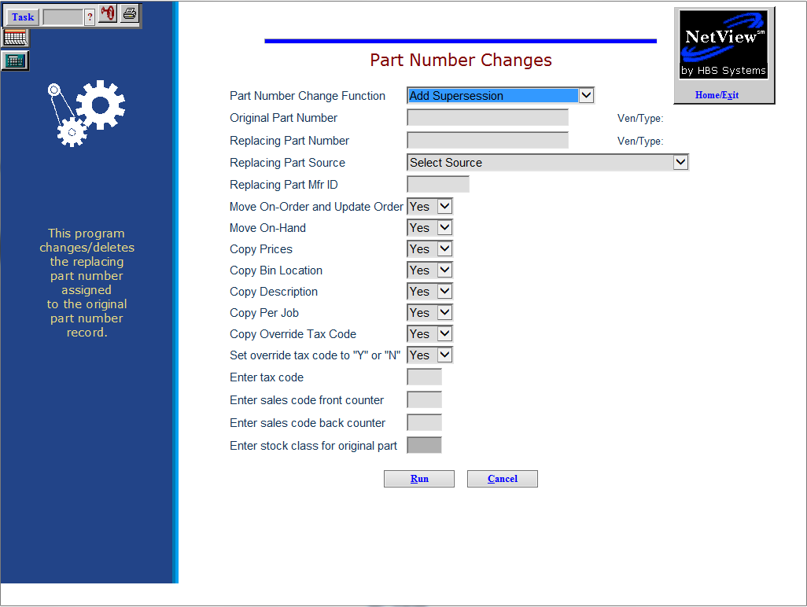

Part Number Changes (PNC) lets you link a replacing part number to an original part number or remove a replacing part number link. If the replacing number is not in your Inventory, PNC adds the record. PNC also gives you the choice to copy information from the original part number record to the replacing number.

PNC is often used to update your Inventory System before you receipt an order or when other vendor-related documentation shows a part number change. For example, you order a part under its current number, and when you receive the part, the packing slip shows a new number for it. Since the on-hand quantity should post to the newest number, you link this new number to the original part number through PNC. Then you update your order file (remove the original number and add the new part number) before receipting the on-hand quantity.

- The Stock Class for the original part number is changed to “A.”
- Sales history is NOT moved to the new/replacing number.
- All of the ordering programs look at the current part record's sales history AND the sales history of all old/superseded records to determine the order quantity.

To access this function, either:

- Select “Inventory” from the menu. Choose the “Parts/Source Update” submenu and click “Part Number Changes.”
- Type “PNC” into the Shortcuts Bar.

Field Definitions

Part Number Change Function: Select “Add Supersession” to add a “new” reference to a part number or “Remove Supersession” to delete one.

The “Remove Supersession” can only be used to REMOVE a part number change.

Original Part Number: Type the ORIGINAL part number that you want to change. The original part number must be in your inventory. This number's vendor number, type, source number, and manufacturer ID will display.

Replacing Part Number: Type the part number that you want to create or move the original information to.

If you want this part to be under the same vendor, type, and source as the old one, press “Enter” through these fields.

If you want to put this new part number in a new vendor, type, or source, make your choices here.

Replacing Part Source: This field shows the Parts Source. It is pre-filled with the source of the existing part.

If this is a new record, type its source number and press “Enter.”

Replacing Part Mfr ID: If this is a new record, type the manufacturer ID or press “Enter” if there is none.

Move On-Order and Update Order:

- Type Y or choose “Yes” to move any on order quantities from the original part number to this new number and update the order info.
- Answer N or choose “No” to leave the on hand and on order quantities with the original part number.

Move On-Hand:

- Type Y or choose “Yes” to move any on hand quantities from the original part number to this new number.
- Answer N or choose “No” to leave the on hand quantities with the original part number.

Copy Prices:

- If you want to copy the prices from the original part number file to the new/replacing part record, choose Yes.
- Choose No to leave the price field blank on the new part number.

Copy Bin Location:

- If you plan to keep the same bin/shelf location for the new/replacing part record, select Yes.
  - If the original number has an alternate bin location it is also copied to the new part number record.
- Choosing No will not copy the bin location to the new part number.

Copy Description:

- Choose Yes to copy the description of the original part number record to the new one.
- Select No to leave the description field blank on the new part number. You can enter the new description when you finish this routine.

Copy Per Job:

- Choose Yes to transfer the "per job" info (the quantity it takes to complete a repair) from the original number to the new part number.
- Enter No to prevent the copy of Per Job info.

Copy Override Tax Code:

- If the tax specifications are the same with the new part number record as it was with the old one, choose Yes.
- If you know the original record does not have override tax codes, you can skip this field.

Set override tax code to “Y” or “N”: This field offers the ability to lock-in the taxable nature of a part and override the customer's taxable status when this part is used in POS or ROM.

Select Yes from the drop-down menu to override the customer's taxable status on the picking ticket or repair order. Enter the correct tax code and sales codes in the following fields.

Select No if it should follow the customer's taxable status.

Enter Tax Code: If you chose to override the tax code, choose the appropriate Tax Code here. This code locks in the taxable nature of the part.

If this part can be taxable or non-taxable based on the customer, then the field should be left blank.

Enter Sales Code Front Counter: Leave this field blank UNLESS Yes is selected for the Override Tax Code field. If so, enter the appropriate sales code for parts counter sales in this field. This code identifies where the accounting entry will be posted when this part is added to a picking ticket or repair order.

Enter Sales Code Back Counter: Leave this field blank UNLESS Yes is selected for the Override Tax Code field. If so, enter the appropriate sales code for shop parts sales in this field. This code identifies where the accounting entry will be posted when this part is added to the picking ticket or repair order.

Enter Stock Class for Original Part: This field shows the stock class of the original part.

Press “Run” to process your selections or “Cancel” to abandon them.

