Purchase Order Defaults (PODF)

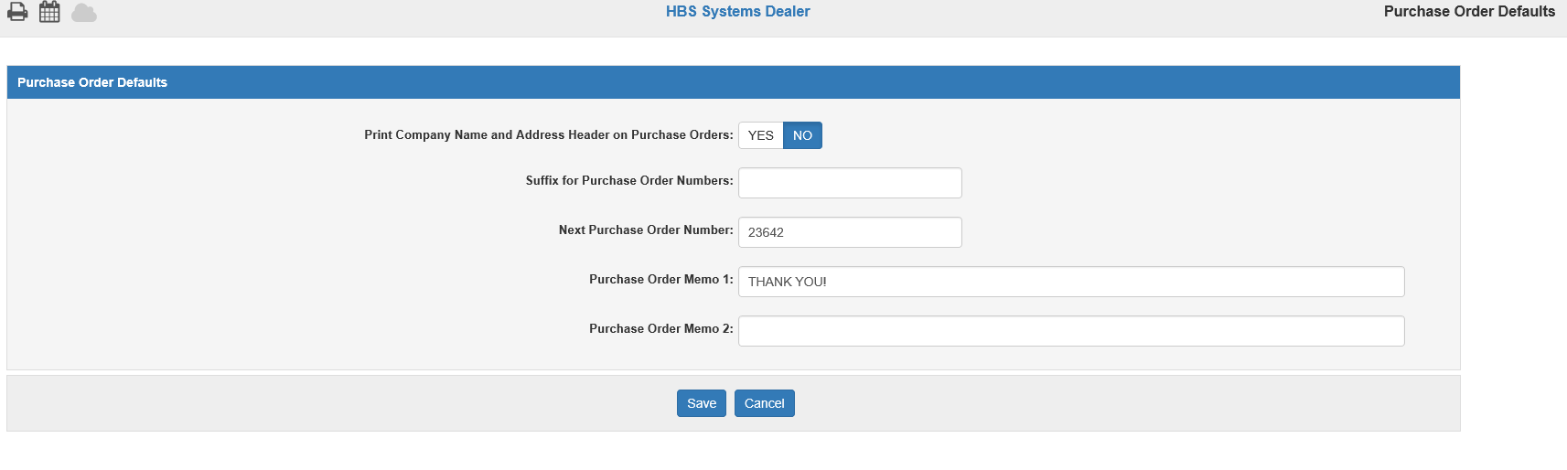

Purchase Order Defaults (PODF) allows you to maintain their Purchase Order system defaults.

To access this program, enter “PODF” in the Shortcuts Bar.

Field Definitions:

Print Company Name and Address Header on Purchase Orders:

- Select Yes to print your company’s name and address header on your purchase orders.
- Select No (default option) to leave them off the order.

Suffix for Purchase Order Numbers: This field can hold a 1-character suffix for purchase order numbers for multi-location dealerships.

Next Purchase Order Number: This field shows the next unused purchase order number in the system.

Purchase Order Memo 1: This field can hold a message that will appear on a memo line on the purchase order.

Purchase Order Memo 2: This field can hold a second memo line message for the purchase order.

Save: Click this button to save your defaults.

Cancel: Click this button to cancel any changes before saving.

