Purchase Order File Maintenance (POFM)

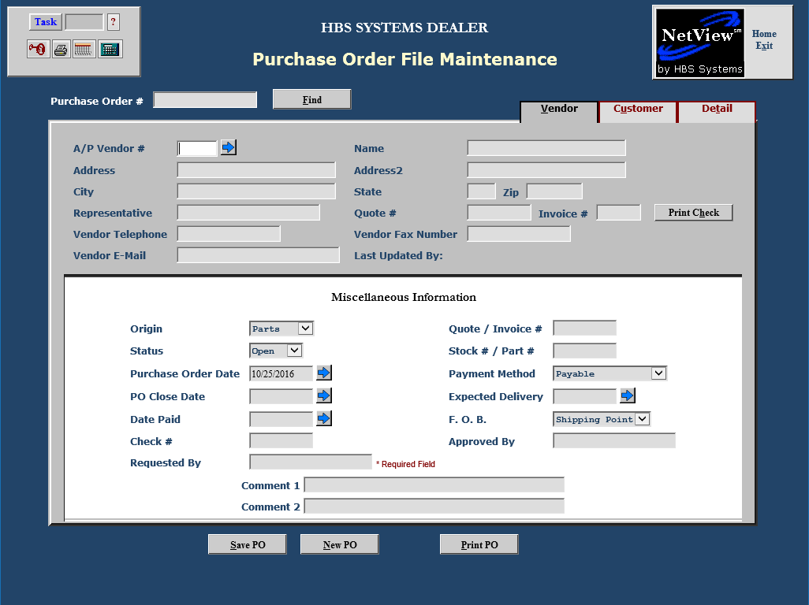

Purchase Order File Maintenance is where you create, and maintain purchase orders. To access this function, you can either:

- Select “System Maintenance” from the menu. Choose the “Purchase Order” submenu and click “PO File Maintenance.”
- Type “POFM” in the Shortcuts Bar.

PO #: When a new Purchase Order is saved, the next purchase order number (plus a suffix letter, if selected) is assigned.

Find Button: Click the Find 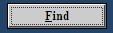 button to search for POs in the system.

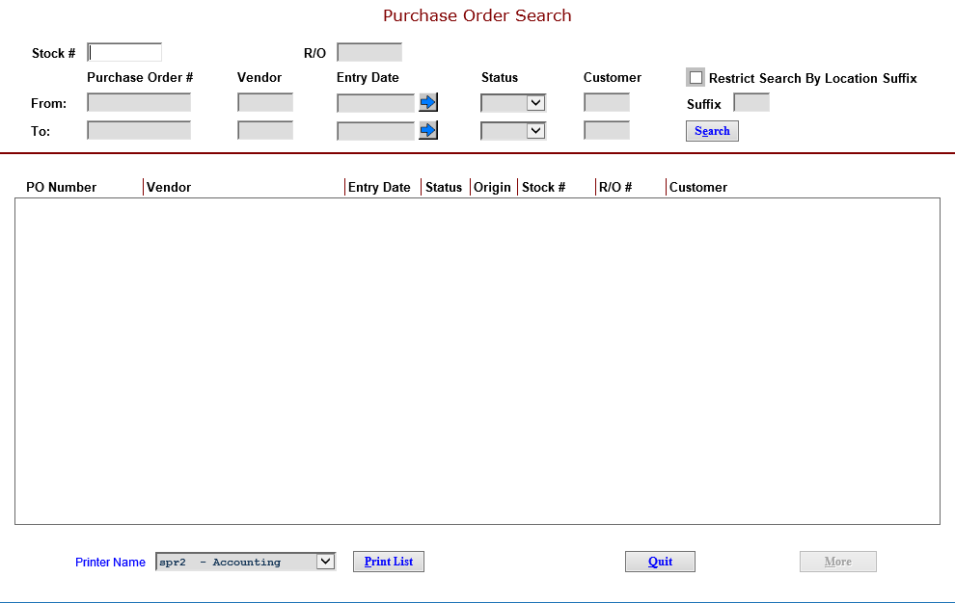

You can search by:

- Stock number
- R/O number
- A range of information (using the From and To lines):
- Purchase Order #: range of specific PO numbers
- Vendor: range of vendor numbers (look up the vendor from this field)
- Entry Date: range of dates (use the blue arrow to the right for a calendar)
- Status: range of status codes
  - Open
  - Paid
  - Closed
  - Voided
- Customer: range of customer numbers (look up the customer from this field)

Once the search results show, you can click on each column heading to “re-sort” the results. For example, if you click on Status, the results are re-sorted by status. A Printer Name selection box and Print List button are also available at the bottom of the screen.

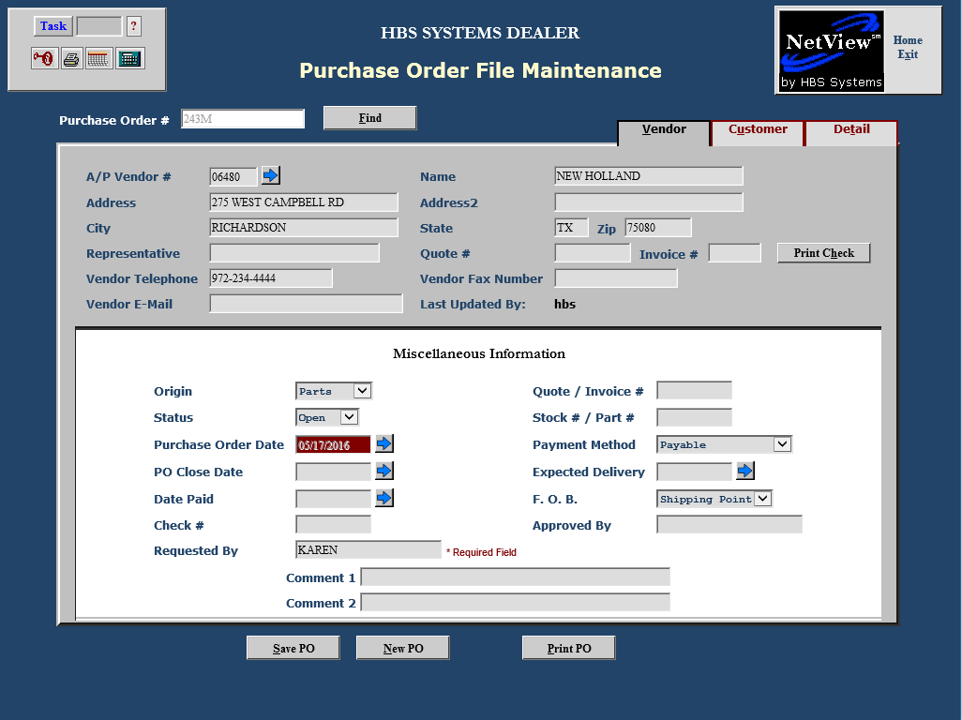

Vendor Tab

A/P Vendor #: You can enter a Vendor number in this field or type in the first few characters of the vendor name and press “Enter.” The screen displays all the vendors that contain your search entry. Use the scroll bar to view additional vendor names. Click on the vendor name to select it.

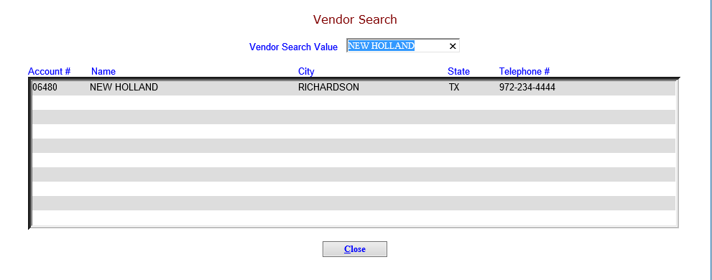

Name: This field displays vendor’s company name if you selected an existing Accounts Payable vendor. You may also type in the desired vendor name.

Address: This field displays the vendor’s mailing address if you selected an existing Accounts Payable vendor. You may also type in the desired address.

Address2: This field holds additional vendor address information if you selected an existing Accounts Payable vendor. You may also type in the desired information.

City: This field shows the vendor’s city if you selected an existing Accounts Payable vendor. You may also type in the desired city.

State: This field shows the vendor’s city if you selected an existing Accounts Payable vendor. You may also type in the desired city.

Zip: This field holds the vendor’s 5 or 9-digit zip or Canadian Postal Code if you selected an existing Accounts Payable vendor. You may also type in the code.

Representative: This field can hold the name of a vendor contact person. It can also be left blank.

Quote#: This field can hold the vendor’s quote number. It may also be left blank.

Invoice#: This field can hold a vendor’s invoice number. It may also be left blank.

Print Check: The button takes you from the PO screen directly into ODC (On Demand Checks), where the system pre-fills the vendor info and invoice amounts on the check.

Vendor Telephone: This field holds the vendor telephone if you selected an existing Accounts Payable vendor. You may type in the desired information.

Vendor Fax Number: This field holds the vendor fax number if you selected an existing Accounts Payable vendor. You may type in the desired information.

Vendor E-Mail: This field holds the vendor email address if you selected an existing Accounts Payable vendor. You may type in the desired information.

Last Updated By: This field holds the login of the person who had changed the PO info after it has been initially saved.

Miscellaneous Information

Origin: The origin is the department that requested the purchase order. The choices in the drop-down menu are:

Parts

Service

Rental

Units

Internal

Reference Fields: This information for this field varies by the Origin of this PO.

- For Parts, you can enter a Quote number or Picking Ticket number in this field along with a Stock number or Part number as a reference in the field directly below it. It may also be left blank.
- For Service, you can enter a RO number in this field along with a Condition number in the field directly below it. These entries hook directly to the Repair Order and may block the closing of the Repair Order depending on the setting in SOD for Open PO’s. It may also be left blank.
- For Rental, you can enter a Contract number in this field along with a Stock number as a reference in the field directly below it. It may also be left blank.
- For Units, you can enter a Quote or Invoice number in this field along with a Stock number in the field directly below it. These entries hook directly to the Stock number and may block the closing of the Repair Order depending on the setting in WGDF for Open POs. It may also be left blank.
- For Internal, you can enter a Reference 1 in this field along with a Reference 2 in the field directly below it. It may also be left blank.

Status: This field identifies the progression of the PO through its cycle. The choices are:

- Open: All items on the purchase order have been received but the purchase order has not been paid.
- Paid: All items on the purchase order have been received but the purchase order has been paid.
- Closed: All items on the purchase order have been received and the purchase order has been paid.
- Voided: This purchase order has been voided or canceled.

Purchase Order Date: This field holds the date of the PO. You can type a date or use the pre-filled date.

Payment Method: This field specifies how the invoice will be paid. The choices in the drop-down menu are:

Payable

Cash

Credit Cards

Check

Employee Reimbursement

PO Close Date: This field is blank if the purchase order has an Open status. Complete the field when all items have been received/paid.

Expected Delivery: This field holds the date when the items are expected to arrive at the dealership/destination.

Date Paid: Type in the date paid as soon as it is known.

F.O.B.: Choose who is responsible for paying the freight for the purchases. The choices from the drop-down menu are:

Shipping Point (the vendor)

Destination (your company)

Check #: When a payment is made, type in the check number if applicable.

Approved By: Type the name of the person who approved the purchase order.

Requested By: Type in the name of the person who requested the purchase order. This is a required field.

Comment 1 & 2: Type any additional information for this purchase order in the Comment 1 and 2 fields. This information prints on the purchase order.

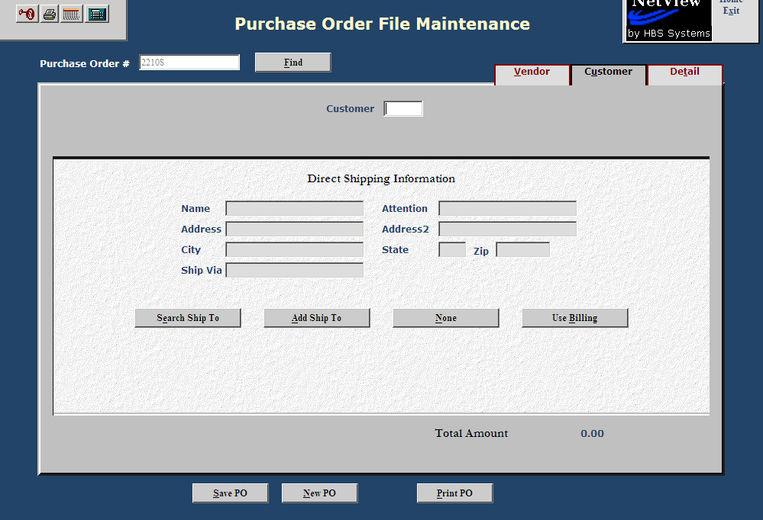

Customer Tab

Customer: If the items on this Purchase Order are to be shipped to the customer once they arrive, or if the vendor is drop-shipping them to the customer, enter the customer number. To search for this number, type in a portion of the name and use your mouse to select the desired information. There are several buttons to help select the correct shipping information, which are defined below.

The Search Ship To (Alt E) button allows you to select any ship to address info for the customer.

The Add Ship To (Alt A) button allows you to add a new ship to address at this time.

The None (Alt N) button indicates there is no ship to address for this PO.

The Use Billing (Alt B) button indicates the items will be shipped to the billing address on file.

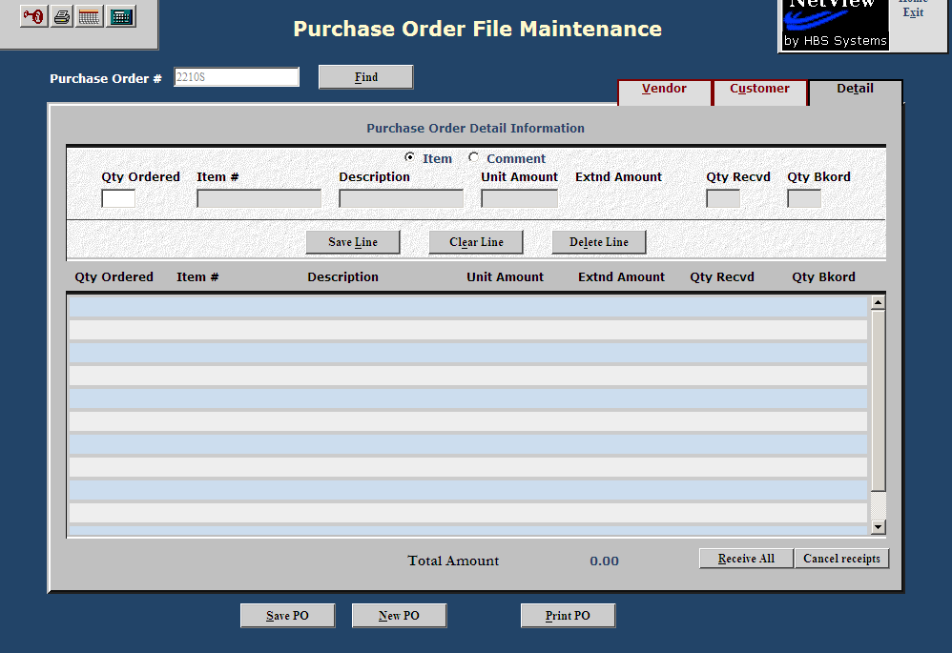

Detail Tab

Qty: Type in the number of units you want to order. The field has 2 positions past the decimal point, so it accepts partial amounts.

Item: Type in the item number. This may be a part number, unit number, serial number, etc.

Description: This field can hold the product description.

Unit Amt: This field holds the price of each item.

Once the line is complete, press the “Save Line” (Alt L) button to save it on the PO.

Updating Lines: After lines have been added to the PO, you can click on an existing line to edit or delete it. Once the line has been retrieved, it appears at the top of the screen where you can change the details, update the quantity received, update the quantity backordered, or even delete the line. Use the following buttons to update the lines:

Save Line (Alt L)

Clear Line (Alt E)

Delete Line

Finishing up the PO

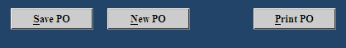

Buttons are available on the button of each screen in POFM to save, print, or create a new PO.

- Click on Save PO (Alt S) to save any new/changed information on a PO.
- Click Print PO (Alt P) to print the PO with the information entered.
- Click New PO (Alt N) to start a new PO.

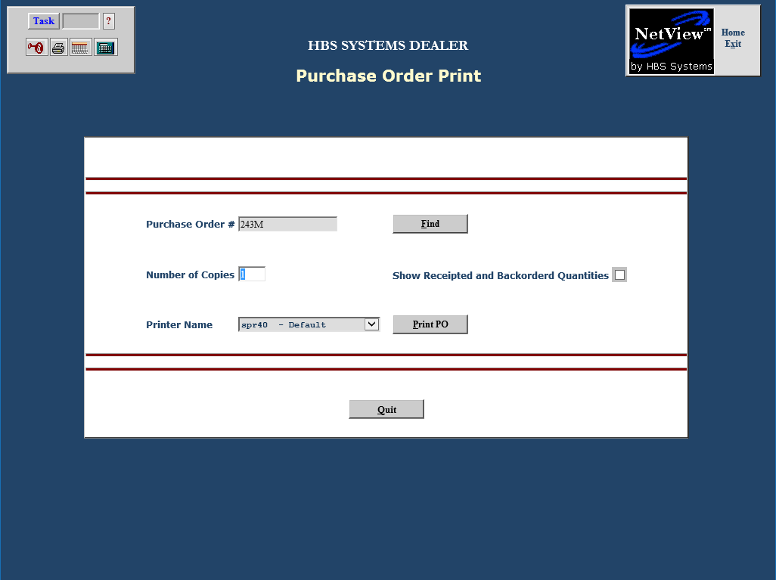

Printing the PO: The Purchase Order Print screen offers a number of printing options.

Purchase Order #: Enter the PO number you want to print.

Find: Use the “Find” button to search for the desired PO.

Number of copies: Choose the number of copies to print.

Show Receipted and Backordered Quantities: Click on this to include acknowledgement of receipted and/or backordered quantities on the printout.

Printer Name: The default printer is shown, but can be changed as needed.

Click on the “Print PO” button to generate the Purchase Order.

Sample PO printout

