Purchase Order Print (POP)

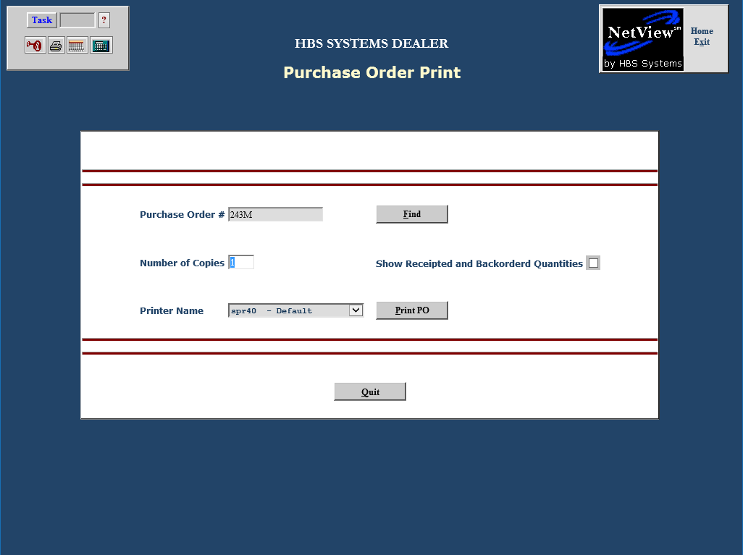

The Purchase Order Print screen offers a number of printing options. To access this function, you can either:

- Select “System Maintenance” from the menu. Choose the “Purchase Order” submenu and click “Print Purchase Order.”
- Type “POP” in the Shortcuts Bar.

Purchase Order #: Enter the PO number you want to print.

Find: Use the 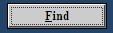 button to search for the desired PO.

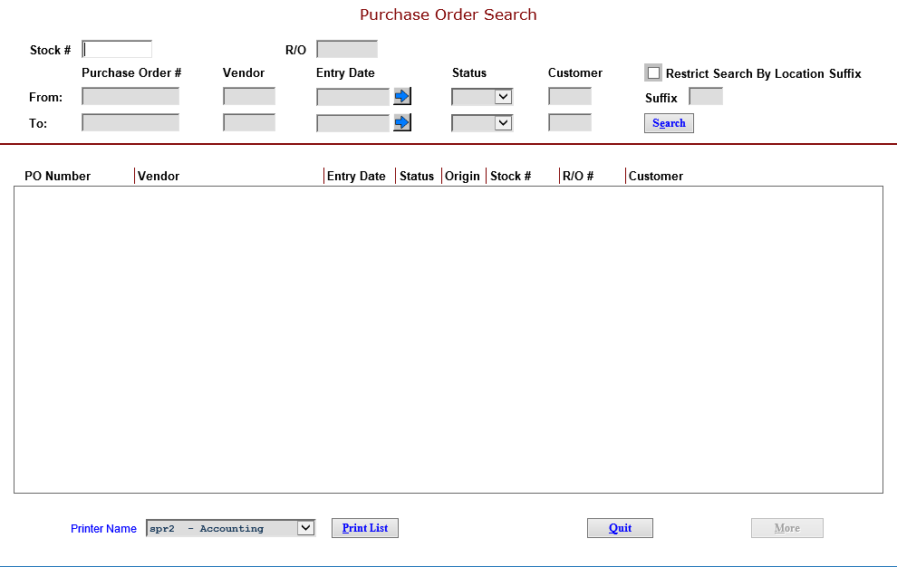

You can search by:

- Stock number
- R/O number
- A range of information (using the From and To lines):
- Purchase Order #: range of specific PO numbers
- Vendor: range of vendor numbers (look up the vendor from this field)
- Entry Date: range of dates (use the blue arrow to the right for a calendar)
- Status: range of status codes
  - Open
  - Paid
  - Closed
  - Voided
- Customer: range of customer numbers (look up the customer from this field)

Once the search results show, you can click on each column heading to “re-sort” the results. For example, if you click on Status, the results are re-sorted by status. A Printer Name selection box and Print List button are also available at the bottom of the screen.

Number of copies: Choose the number of copies to print.

Show Receipted and Backordered Quantities: Click on this to include acknowledgement of receipted and/or backordered quantities on the printout.

Printer Name: The default printer is shown but can be changed as needed.

Click on the “Print PO” button to generate the Purchase Order.

Sample PO printout

