Point of Sale History (POSH)

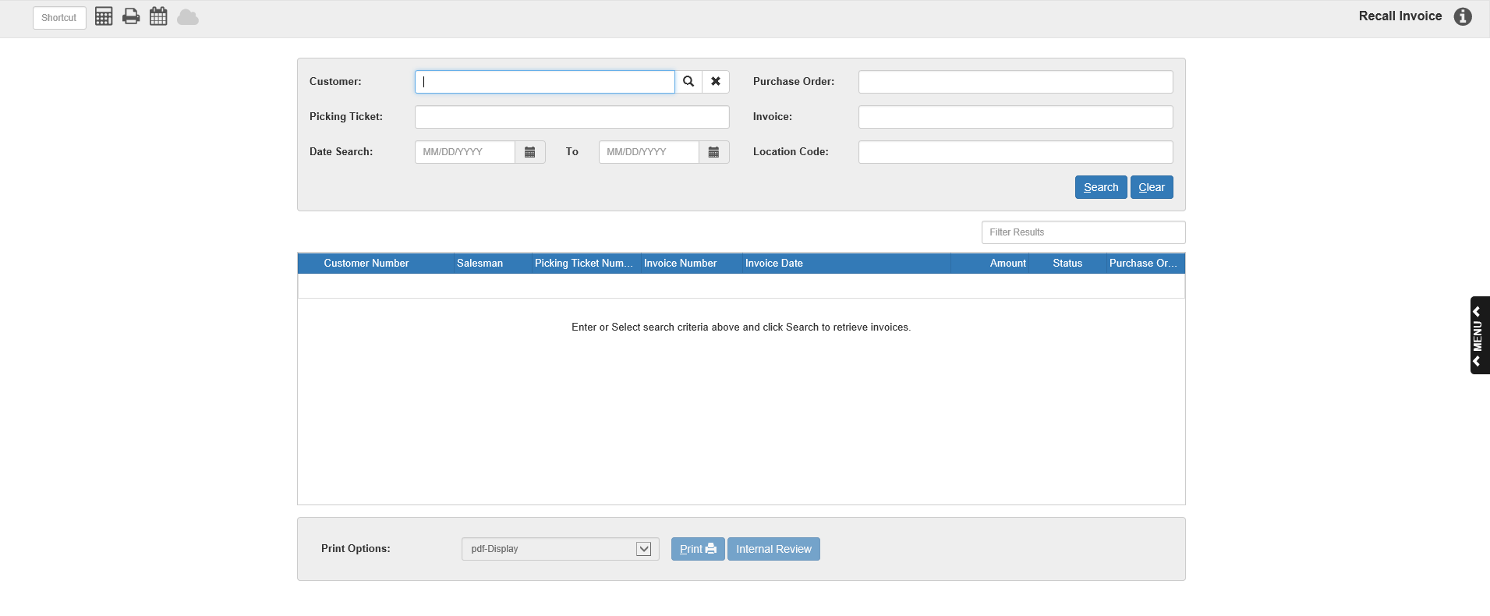

Point Of Sale History (POSH) retains parts and shop sales invoices generated by POS Invoicing (POS). POSH stores a maximum of approximately 100,000 invoices, which is roughly five to seven years of customer sales at many dealerships. After POS History fills the available storage, it deletes the oldest invoices as current ones are added to the system.

POS History lets you call up a POS invoice from within POS Invoicing, even if the invoice was written several years ago. You can choose to display the invoice or print it. You can search through past invoices by the following:

- Customer name or account number
- Date
- Invoice number
- Picking ticket number
- Purchase order number
- Invoice location code (multi-location only)

To access this function, you can either:

- Select “Inventory” from the menu and choose the “POS History” submenu. Click on “Recall Invoice.”
- Type “POSH” in the Shortcuts Bar.

The POS History package also includes two functions that let you generate reports based on POS History information. Customer Parts Sales History (CPSH) reports parts sales information for a selected customer and within a designated time period. Part Sales History Via Customers (SHVC) reports which customers bought a selected part and when. These reports can help you track fast-moving stock items and who buys them. You can use these reports to guide you in seasonally adjusting your parts stock or to indicate when to provide promotional offerings to your customers.

Field Definitions:

Customer: Click this field to search for past invoices by customer name or number. Enter the customer number or type a few letters of the customer name to search for the customer. Either click the “Search” icon to the right of the field or hit “Enter” to bring up the search window (see below image). You can use the Filter Results bar in the right-hand corner to narrow down your results. Select the name of your choice, which will then populate the field on the main page, while a list of their invoices will populate the Results Box. Select an invoice to view or print it.

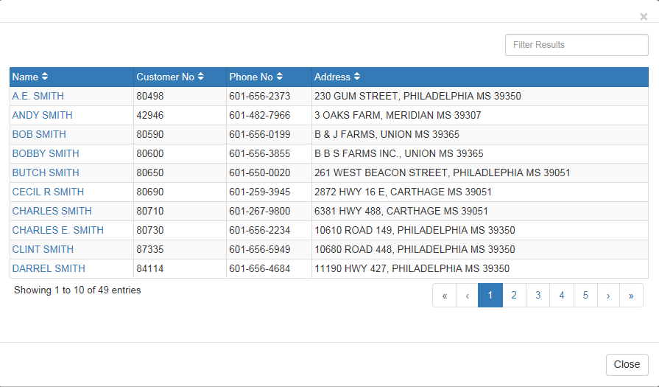

Purchase Order: Click this field to search for invoices by purchase order number. Type in the number and press either the “Search” button or the “Enter” key. A list of their invoices will fill the Results Box. Select an invoice to view or print it. NOTE: Not all invoices have purchase order numbers.

Picking Ticket: Click this field to search by picking ticket number. Type in the number and press either the “Search” button or the “Enter” key. Select an invoice to view or print it.

Invoice: Suppose you want to review an invoice opened sometime during the second week of July, 2004. You could repeatedly use Search By Date to list one day at a time, or you could search by partial invoice number. You can enter the first few numbers of a group of invoices and all will display.

The Invoice Number Search lists are in invoice number order. The system sorts in a left justified fashion, that is, beginning with the left-most number (3 in the example) and proceeding to the right until all invoices with numbers containing your partial entry are listed. For example, 34100B proceeds 34100C, 34100C proceeds 34101B, etc. If the list is extensive, you can use the Filter Results bar to narrow down your results. Select an individual invoice to print or display it.

Date Search: Use these fields to search by a range of invoice dates. The system will display only those invoices that fall within that range. You can type the dates into the fields or use the calendar icons to the right of each field to find the desired dates. The system will automatically display ALL invoices from that time-frame.

You can also use this field in tandem with the Customer search field by entering the customer number/part of their name first before entering a date range. The results displayed will thus be any of the particular customer’s invoices dated within the range.

TIP—Searching for Invoices from a Specific Year: To look for invoices in a specific year, type the number of the year into the first field and hit “Enter,” then do the same in the second field. The first field will fill with the first date of the year and the second field will fill with the last date. Hit “Search” to see all the invoices from that year.

Another way to perform this search is to type the desired year in the first field, then the following year in the second field. This will fill the first field with the first date of the desired year and the second with the first date of the following year, allowing you to search for all invoices in that year including those dated the first of the next year.

Location Code: If you are a multi-location dealership, you can use this field to search for invoices by their single-letter location code. Enter the code in this field, and the results will display only invoices from that particular location. For example, if you enter “B” in this field, you will only see invoice numbers ending with the loc code B.

Search: Click this button to start a search after filling in one of the fields. You can also begin a search by filling in a field and hitting the “Enter” key.

Clear: Click this button to clear any fields containing information.

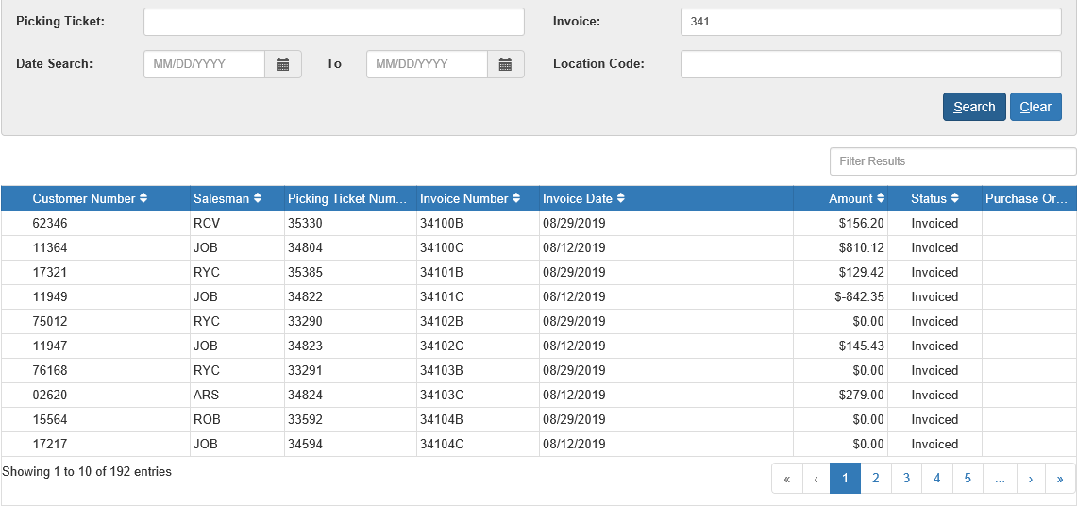

Results Box—Column Definitions: Regardless which search method you use, the results will fill in the Results Box. You can filter your results by typing in extra information featured in the columns into the Filter Results Bar, and you can use the column headers to alter the order in which the results are displayed. The columns in the box are as follows:

Customer Number: This column displays the customer number for the client who purchased parts or paid for labor for the invoice number shown.

Salesman: The salesperson’s initials for the invoice listed displays in this column.

Picking Ticket Number: This field holds the picking ticket number assigned to the invoice.

Invoice Number: This column shows invoice numbers. Invoice numbers that begin with an “R” indicate repair orders/shop tickets. Invoice numbers that begin with an “S” indicate HBS Service Management System (SMS) repair orders.

Invoice Date: This column shows invoice creation dates.

Amount: This column shows invoice total amounts.

Status: If an invoice has been voided, it is noted in this column.

Purchase Order: This column shows the invoice’s purchase order number (if any).

Filter Results: Use the Filter Results bar to narrow down your results by typing in more information from the columns, like the customer number, salesman initials, invoice number, etc.

Print Options/Print: When you have selected an invoice to print, use the drop-down Printer Options menu to select your desired printer, then click Print. If you simply want to view the invoice, use the pdf-Display printer option.

