POS—Making A Sale

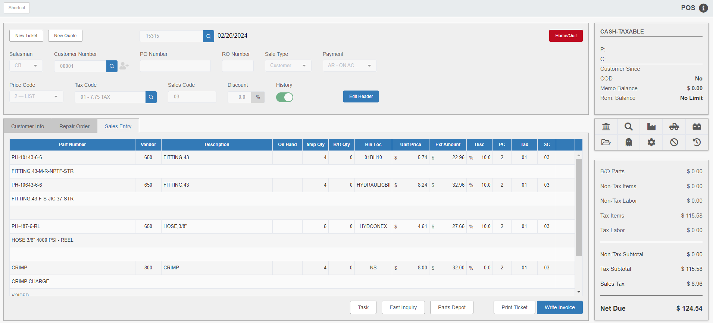

This chapter explains how to complete a basic sale and write an invoice, starting with the Sales Entry tab. It will explain how to complete an open picking ticket or how to create an entirely new ticket.

New Ticket: When you initially open POS, it will start you on blank screen so you can start by creating either a ticket from scratch or by opening an existing one. However, if you want to start a new ticket at any time while working in POS, just click New Ticket to reset the screen to a blank state to begin.

Salesperson: In this field, type the 3-character ID of the person who is opening the ticket or select it from the dropdown (depending on the available field type).

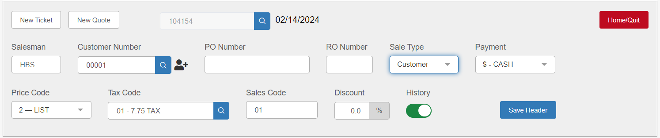

Customer #: Enter or select a customer account number here. If unknown, look it up by entering part of the customer’s name and clicking the “Search” icon. NOTE: You can also add a new customer if necessary by clicking on the New Customer  icon.

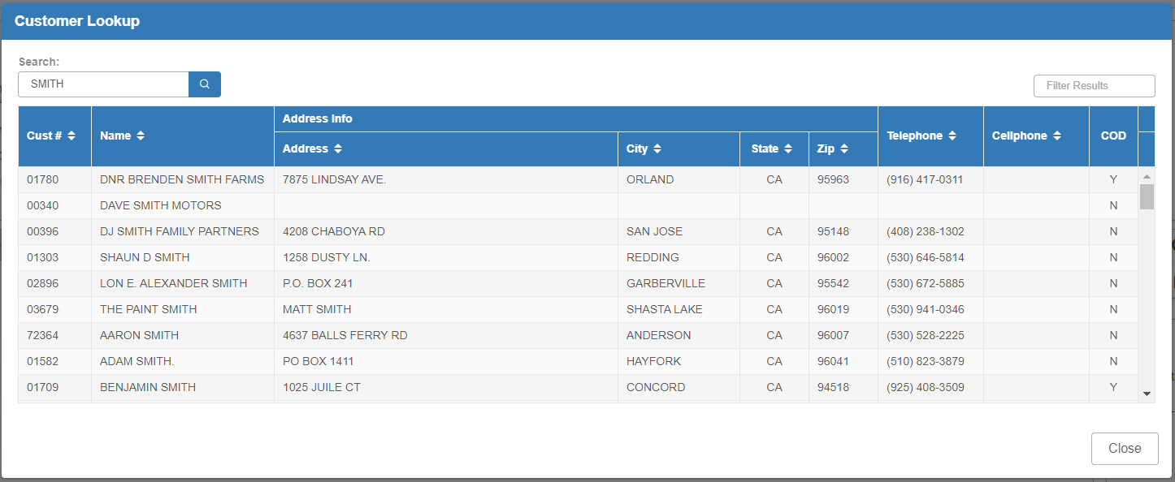

Once you make a search, select your desired customer from the results. The customer’s account information will auto-fill in the header.

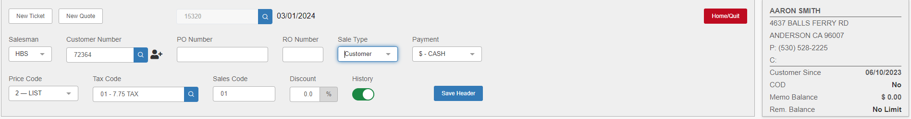

Creating the Ticket: Review the values in the header fields and make any needed changes. Click Save Header to create the ticket.

Open Picking Ticket: To start working in POS with an existing picking ticket, you can either click the “Search” icon next to the Picking Ticket Number field to view all open picking tickets or select a customer with open tickets to have the program display them.

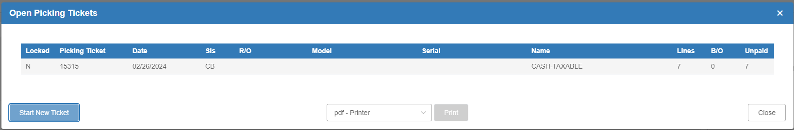

NOTE: In order to have the Open Picking Tickets list pop up after you select a customer with open tickets, make sure the “Display Open Tickets for Customer” option in the POS Defaults screen is set to Yes.

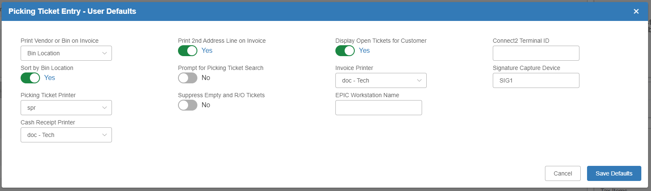

Adding Parts to the Ticket: Once you have created your new ticket or opened your existing one, the program will open the Sales Entry tab to allow you to add parts to the ticket. Enter the Part Number in the appropriate field.

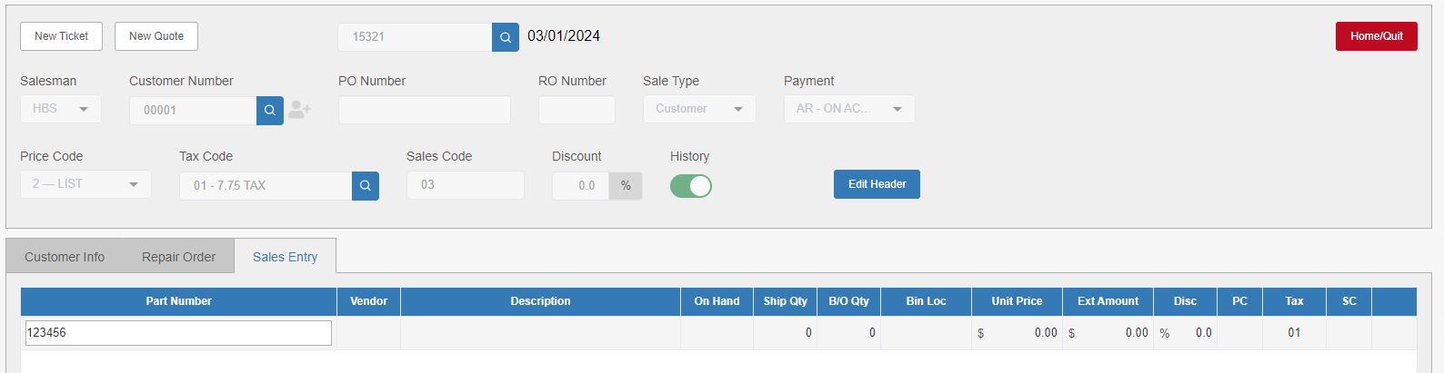

Hit the “Enter” key, and the remainder of the fields for this section will auto-fill.

Change the “Ship Qty” field value if needed. Hit the “Enter” key, and the “Ext Amount” field will fill. Tab the remainder of the way through the field to have the program save the ticket line and move on to the next empty one.

Printing a Picking Ticket: When all sales items have been entered, the picking ticket is ready for printing. Click Print Ticket to open the following window:

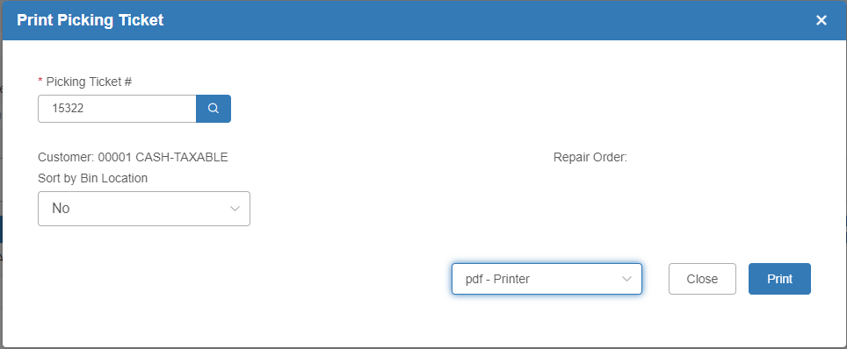

If there are multiple items on the picking ticket, sort the bin locations by selecting Yes or No. Set the printer and click Print to receive the ticket.

Closing the Ticket and Printing a Sales Invoice:
If you decide to close the ticket and write the invoice, click on the Write Invoice button on the main screen. The following window will appear:

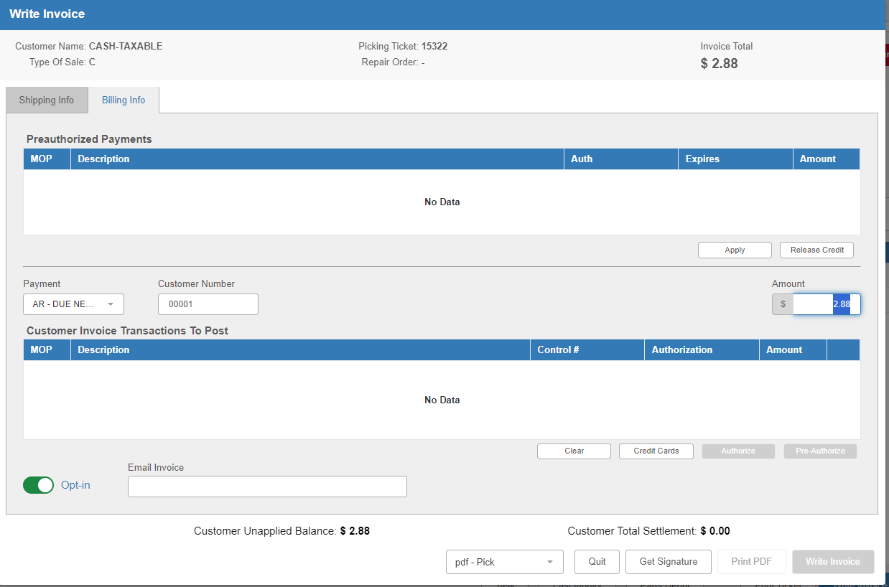

Shipping Info: On the Shipping Info tab, you have the opportunity to add freight (not recommended).

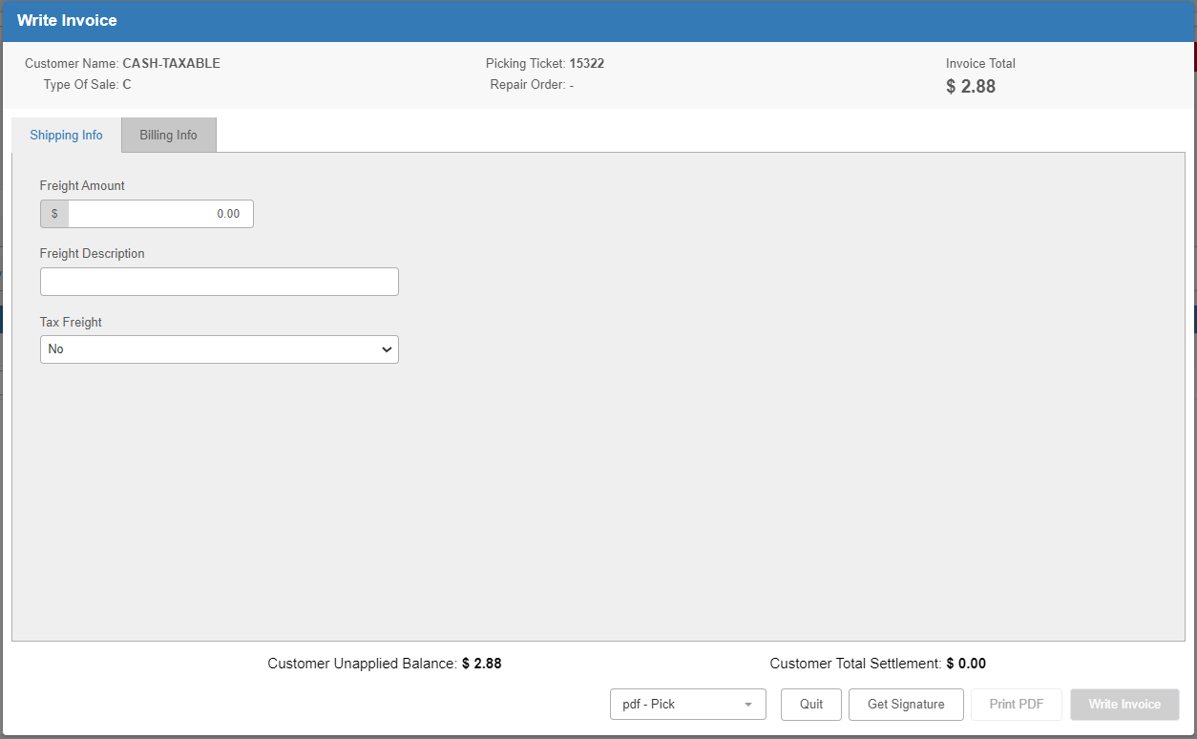

Billing Info: The Billing Info tab includes all of the information necessary to close and write the invoice, including the various Methods of Payment.

The top section, Preauthorized Payments, will be used only in the event a credit card or another pre-authorized payment is used.

Otherwise, the payment, customer number, and amount will auto-fill with information from the ticket screen. If you want to change the payment method, use the drop-down menu. Tab through the “Amount” field to add the payment line to the invoice.

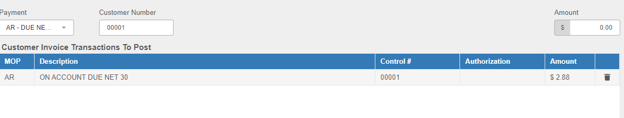

Void Invoice Line: If you want to delete a line from the invoice after adding one, click the Void icon shaped like a trash can at the right end of the line.

Paying with a Credit Card: To swipe, tokenize, or manually enter a credit card for payment, or if paying with a debit card, select a credit/debit card type at the “Payment” field and tab through the remaining fields to open EdgePay Input (EPIN) and process the card.
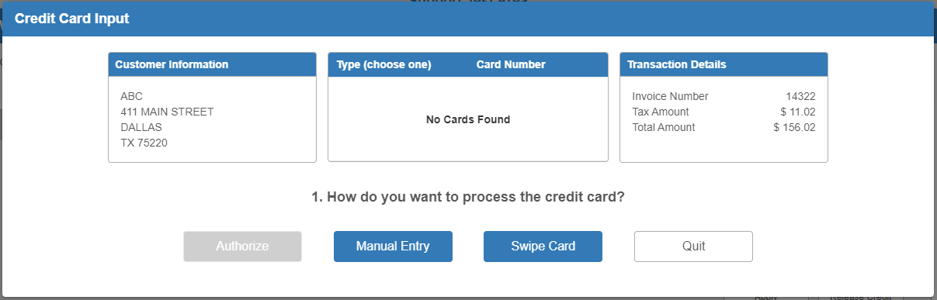

If the invoice will be paid by a stored credit card, click on the Credit Cards button. A list of any credit cards on file will pop up. Choose the credit card to be used and complete the credit card process via EPIN as normal.

For more information on using EdgePay, see “EdgePay Input (EPIN).”

Write: If all the invoice information is correct, press the Write Invoice button to print the invoice to the default printer. The accounting entry is created, but will be posted with the EOD (end of day) processes.

Print Invoice-Confirmation: The message below will appear after the invoice prints. If it printed successfully, press Yes.

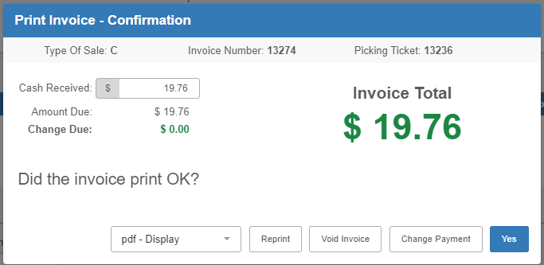

Reprint: Pressing this button will reprint the invoice. You can use it for additional copies, or if the invoice did not print successfully.

Void Invoice: If you wish to void the invoice, press this button.

Change Payment: To change the method of payment, click this button to return to the Write Invoice screen.

