Print Proof Sheet (PP)

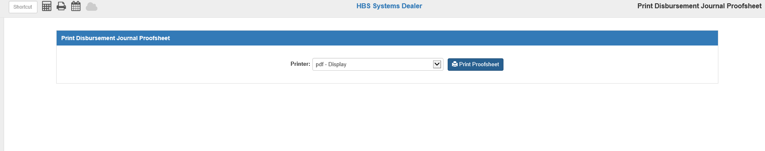

Print Proof Sheet (PP) produces a preview of the unposted entries for paid transactions for the Disbursement Journal.

To access this function, you can either:

- Select “Accounts Payable” from the menu and choose the “Process Checks” submenu. Click on “Print Proof Sheet.”
- Type “PP” in the Shortcuts Bar.

Printer: Select the printer to receive the printout. A default printer will be pre-filled, but you can change it.

Click “Print Proofsheet” to print the report.

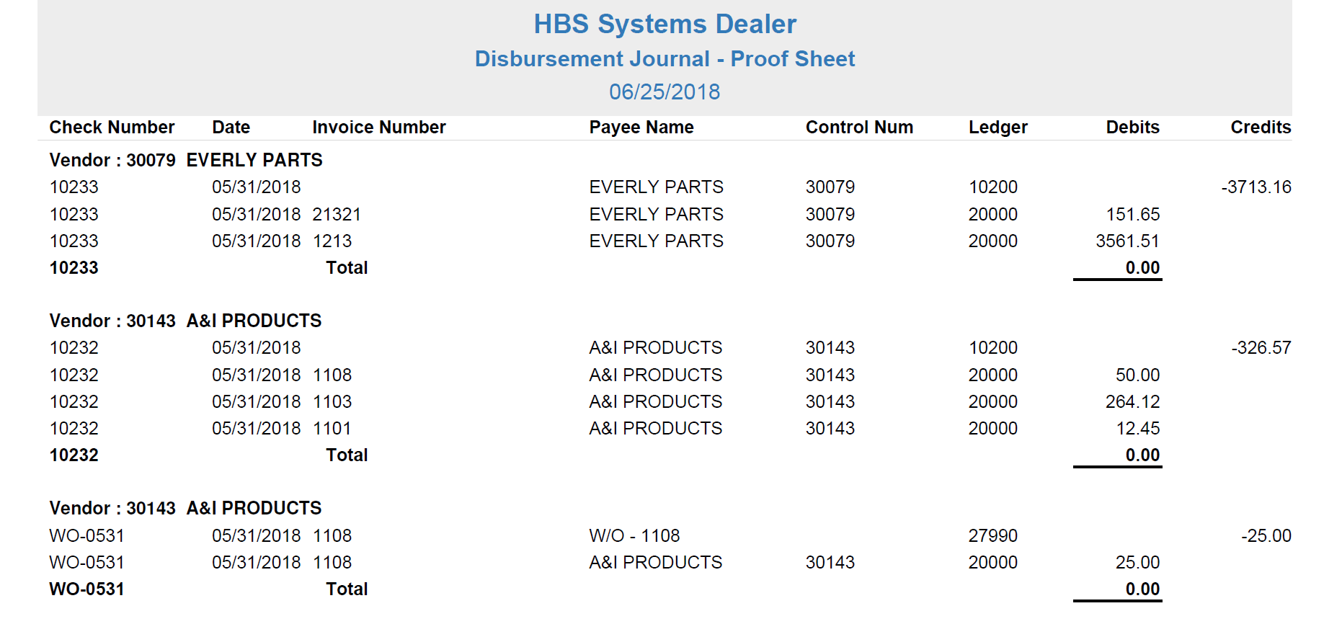

Proof Sheet-Report Descriptions: Like the Disbursement Journal (DJ), the proof sheet contains the following two sections:

- Document Detail
- Account Summary

Document Detail Section: Each payment is grouped into sections by Vendor that contain all line entries for each document number, listed in Check/Document Number order and organized into the following columns:

Vendor: The A/P vendor number and name appear on the first line of each vendor section.

Check Number: This is the document number assigned to this entry.

Date: This column shows the document date for the entry.

Invoice Number: This column shows the invoice number affected by the payment or write-off entry.

Payee Name: This column shows the vendor name.

Control Num: This column shows the control number for the entry, if applicable.

Ledger: This is the account number assigned to this line item.

Debits: Most of the A/P account number line entries (20000) typically are debits (except credit invoices) and these amounts are printed in this column.

Credits: Usually, this column contains the entries for the checking account and any discounts. Also printed in this column might be the offsets for any write-off documents.

Check Total Line: At the end of each document section, you will see a total line that summarizes the entries for the document. It should be 0.00.

Journal 10 Total Line: The last line of detail to print at the end of the Document Detail is the Journal total. It should be 0.00, indicating the Journal is in balance. If it is not, then you will need to make sure it is in balance before you actually run DJ.

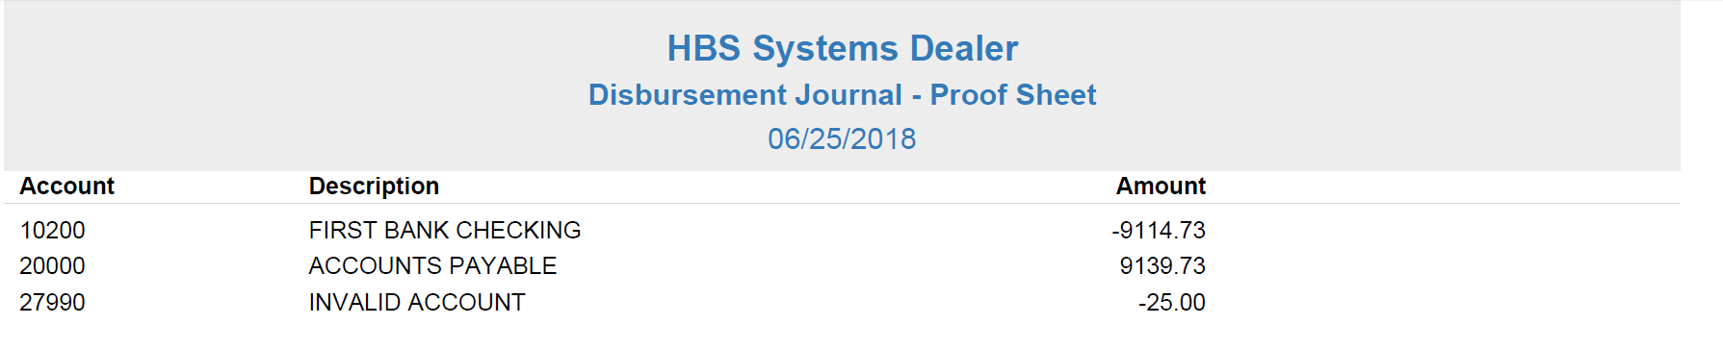

Account Summary Page: The last page of the proof sheet, as in DJ, summarizes and prints all of the account numbers recorded for any documents in the Journal.

Account: This lists the G/L account number.

Description: This shows the description of the G/L account number.

Amount: This column shows the net dollar amount for each of the account numbers listed on this page.

