Print Proof Sheets (PPS)

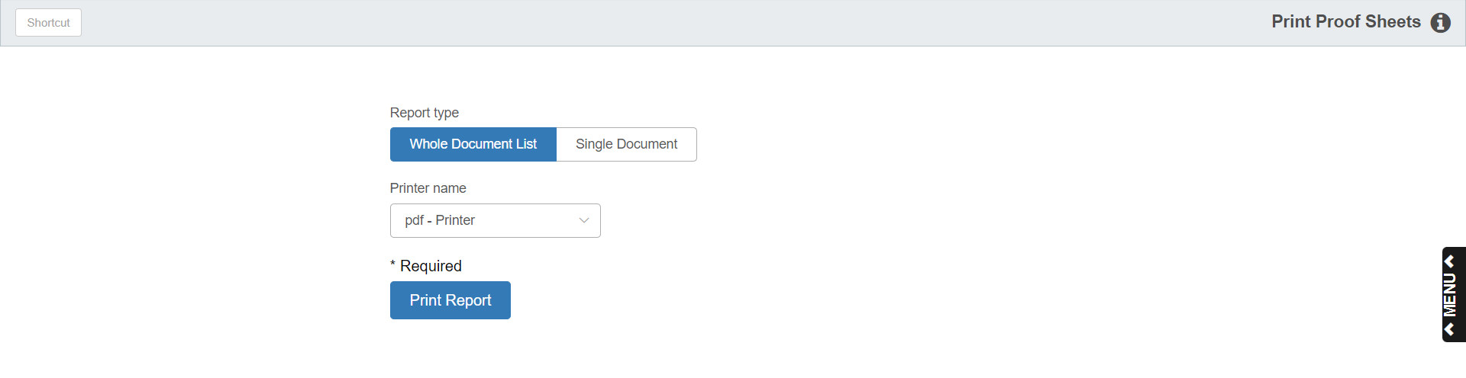

Print Proof Sheets (PPS) lets you print proof sheets of Units accounting documents before posting them to the appropriate journals. You can edit any documents listed in a proof sheet up to the point when you post the documents to journals.

- To access this function, you can either:
  - Select “Units” from the menu. Choose the “Data Entry” submenu and click “Print Proof Sheets.”
  - Type “PPS” in the Shortcuts Bar.

Field Definitions

Report Type: Choose from one of the following document list options to look at:

- Whole Document List for all unposted documents
- Single Document to choose only one document

Document Number: This field appears if you choose Single Document. Enter the document number in order to view just it on the report.

Printer Name: The default printer is shown, but you may choose a different one from the drop-down menu.

Print Report: Press this button to print the selected proof sheet(s).

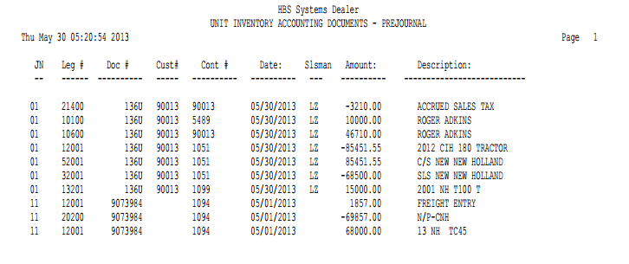

Report Column Definitions

JN: This column lists the Journal Numbers (01 through 27) where the individual entries are to be posted.

Leg #: This column lists the general ledger numbers referenced on each line of the transaction.

Doc #: This column lists the selected document number for the listed transactions, which could be:

Check number

Invoice number

Other reference

Cust#: This column may list the Customer Account Number or Vendor Number for selected lines of the transaction.

Cont #: For Units proof sheets, this column commonly shows the stock number affected by the transaction.

Date: This column lists the document dates of the transaction.

Slsman: This column may list the initials or ID code of the salesperson for the transaction, if it is a sales entry.

Amount: This column lists individual transaction line amounts (credits/debits).

Description: This column lists transaction line descriptions.

