Post Return Adjustments (PRA): Post Return Adjustments (PRA) lets you make adjustments to a Parts Return created in PRRT. PRA also lets you create a manual Return. When the manufacturer approves the Return, you may need to adjust the Return again through PRA to reflect only the parts the vendor accepted.

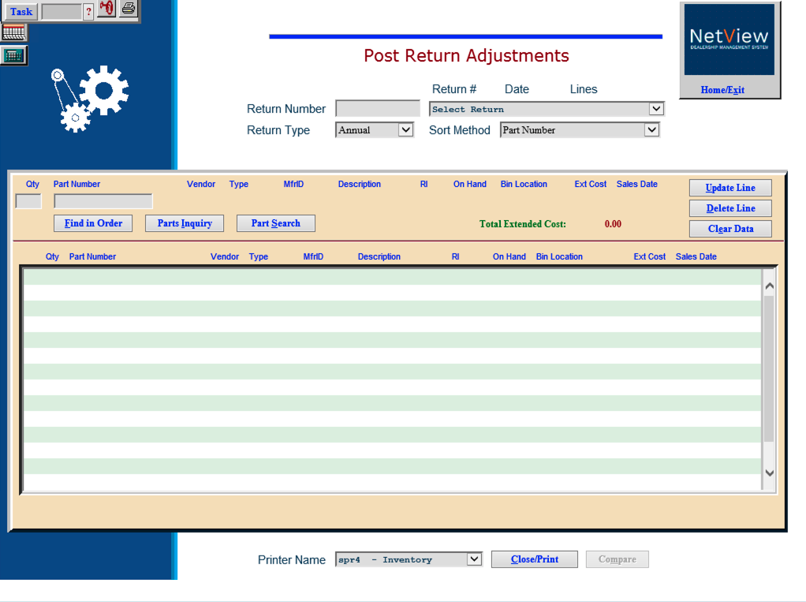

STEP 2—Edit the Return with Post Return Adjustments (PRA)

To access this function, you can either:

- Select “Inventory” from the menu. Choose the “Returns” submenu and click “Post Return Adjustments.”
- Type “PRA” in the Shortcuts Bar.

Field Definitions:

Return Number/Date/Lines: You can type in a Return Number or select one from the drop-down menu. If you type a number that does not exist, you will create a new Parts Return.

Return Type:

- If you are adjusting an existing Return, this field defaults to the Return Type used when you originally created the file.
- If you are creating a new one, make the choice of return type that fits the situation:
  - Annual

Closeout

Special

Dealer Trade

Sort Method: Choose how to sort the return:

Part Number

Bin Location

Return Indicator

Return Indicator then Bin Location

Quantity: Enter/adjust the number of parts you are returning.

Part Number: This field holds the Part Number for the parts you are returning.

Update Line: Press this button to save the new or changed information.

Delete Line: This button removes the selected part number line from the return.

Clear Data: Press this button to clear the part number and quantity fields.

Find In Order: This tool is useful if you have a large return and you want to find a specific part within the return. Type the part number into this field and it will be highlighted.

Parts Inquiry: Press this button to do a parts inquiry.

Part Search: Press this button to do a parts search.

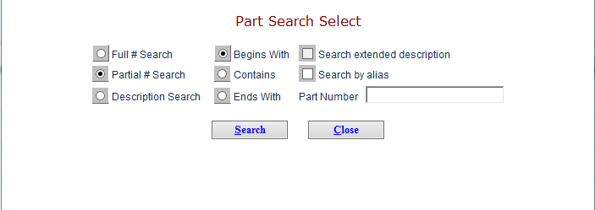

Part Number Detail: For each part number shown on the screen, the following info is displayed:

Qty: This column shows the Return Quantity.

Part Number: This column shows the numbers of the parts on this Return.

Vendor: This column shows the Vendor Number.

Type: This column lists Part Types for the part numbers listed:

- New
- Used

Reman

Core

Memo

RI: This column shows the Return Indicator.

On Hand: This column shows the current On Hand quantity for this part number.

Bin Loc: This column shows the Primary Bin Location.

Ext Cost: The Extended Cost in this column is calculated by multiplying the return quantity by the individual cost of each part.

Sales Date: Here you will find the date of the Last Sale of this item.

Compare: If you are a multi-location dealership, use this button to compare the return to returns at other dealer locations. Clicking the button opens Multi-store Inventory/Order Comparison (MIC):

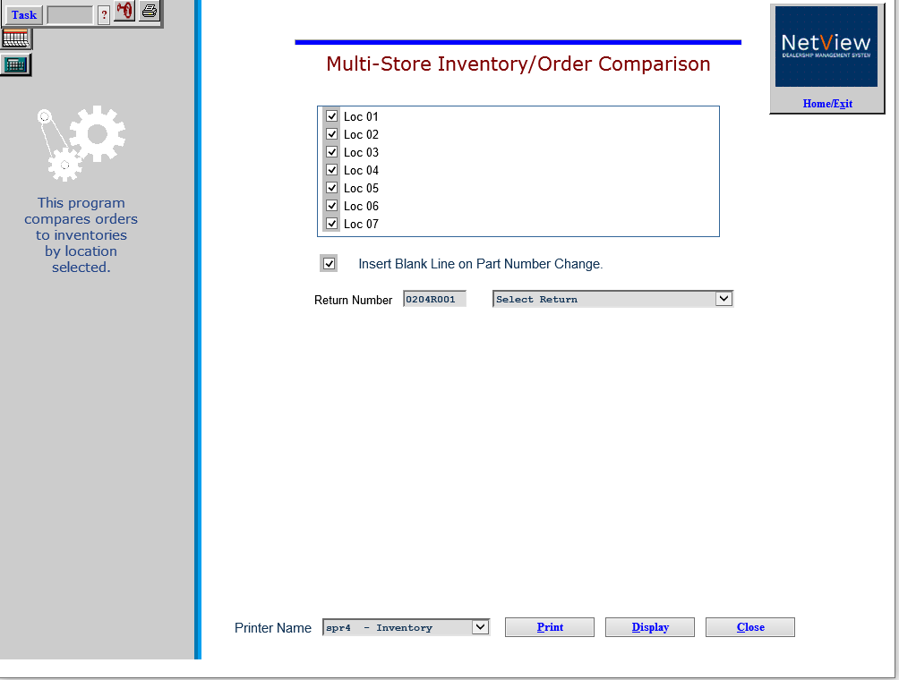

Print Return: To print the return and leave the program, select a printer from the dropdown menu at the bottom of the screen, then click Close/Print.

Any changes made in PRA are recorded on the proof sheet generated when you leave the screen.
